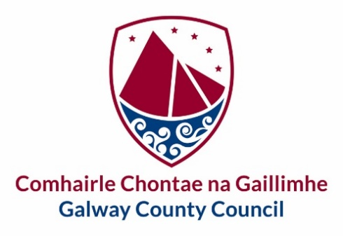

Oughterard Town Team – Expressions of Interest

Galway County Council would like to invite expressions of interest from the local community to create a dedicated Town Centre First (TCF) Town Team for Oughterard. A TCF Town Team is a group of local residents, businesspeople, community representatives and other stakeholders who come together to make their area a better place to live, work, study and visit. TCF Town Team members may come from diverse sectors and backgrounds. They have a unique position in the community to become ‘local experts’ on their area and to take a lead on the development of projects that can make positive long-term changes for the town.

The TCF Town Team will work closely alongside the Town Regeneration Officer and the Council’s multi-disciplinary Regeneration team. Members must work on behalf of the community as a whole and not in their own interests or in the interests of an individual or a specific group(s).

After the closing of this call for expressions of Interest a shortlist of applicants will be created.

Please register your interest by submitting the Expression of Interest Form via e-mail to regeneration@galwaycoco.ie or by post to Urban & Rural Regeneration Team, Economic Development and Planning, Rural Aras an Chontae, Prospect Hill, Galway H91 H6KX.

Closing date for applications is June 22nd, 2026

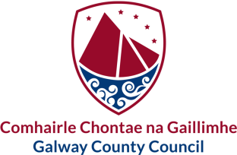 |  |  | 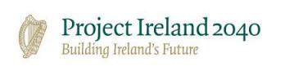  Oughterard Town Team - Participation Forum
Tá an fhoirm seo le fáil i gcló mór chomh maith |  | This form is also available in large print
Tá míle fáilte an fhoirm seo a líonadh i nGaeilge

Expression of Interest Form

Are you part of an existing Community/sport or other group? If yes, please give details below | Yes No  ☐ ☐
Name of Group/s: (as relevant)

Role of Nominee within existing group:

Please indicate your area of interest, select 1 only:  Culture & Built Heritage  Community & Sports and recreation  Economic Development & Tourism  Vacancy and Dereliction  Public spaces & streetscapes  Natural environment & Biodiversity | ☐  ☐  ☐  ☐  ☐  ☐
Please indicate why you want to be part of the Oughterard Town team?

Would be interested in a lead role within the Town Team,  Please select 1 role:  Chairperson  Secretary  Town Champion | ☐  ☐  ☐
Contact Telephone number for Nominee:
Contact E-mail for Nominee:

Name (in block capitals):
Signed:
Date:

Seol an fhoirm ar ais chuig:  Athghiniúint Tuaithe  Comhairle Chontae na Gaillimhe  Áras an Chontae  Cnoc na Radharc  Gaillimh  H91 H6KX | Return to:  Regeneration Team  Galway County Council  Áras an Chontae  Prospect Hill  Galway  H91 H6KX | regeneration@galwaycoco.ie  www.gaillimh.ie  www.galway.ie

