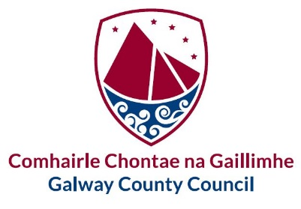
GALWAY COUNTY COUNCIL - SITE NOTICE

Planning and Development Acts 2000 (as amended)

Planning and Development Regulations 2001 (as amended) – Part 8

College Rd, Bovinion, Mountbellew, Co. Galway.
Pursuant to the requirements of the above, notice is hereby given that Galway County Council proposes to make alterations to existing two storey dwelling including 1) the demolition of a front porch/ Lobby, a shed and extension to side and rear extension 2) the construction a new large 2 storey extension to the rear of the dwelling and a new front porch, including all other ancillary site works and services at College Rd, Bovinion, Mountbellew, Co. Galway.

A Stage 1 ‘Appropriate Assessment’ screening was carried out for the proposed development and Galway County Council has concluded that a Stage 2 ‘Appropriate Assessment’ [Natura Impact Statement (NIS)] is not required.

Plans and particulars of the proposed development will be available for inspection or for purchase for a fee not exceeding the reasonable cost of making a copy, during normal office hours (Monday to Friday, 9.00am – 4.00pm, excluding Bank Holidays and Public Holidays) for a period of 4 weeks from Monday 20th July 2026 until Tuesday 18th August 2026, at the following locations:

- Galway County Council, Planning Department (Public Counter), Áras an Chontae, Prospect Hill, Galway, H91 H6KX,
- Galway County Council, Ballinasloe Area Office, Civic Offices, Ballinasloe, Co. Galway, H53 A7K7
- Galway County Council’s Consultation Portal at https://consult.galway.ie

Submissions or observations in relation to the proposed development, dealing with the proper planning and sustainable development of the area in which the development would be situated, may be made in writing to The County Secretary, Galway County Council, P.O. Box No. 27, Áras an Chontae, Prospect Hill, Galway, H91 H6KX; or through the LGMA Portal - https://planning.localgov.ie/. to arrive not later than Tuesday 01st September 2026.

Signed:  Damien Mitchell  Director of Services – Housing |  | Date:  17th July 2026

