 |  | Finisklin Business Park,  Co. Sligo,  Ireland,  F91 RHH9 |  |  |    | +353 71 91 61416  info@jodireland.com



FLOOD RISK ASSESSMENT
COSMONA, LOUGHREA, CO. GALWAY
MAY 2026 |  | Rev 00

DOCUMENT STATUS
Version | Purpose of document | Authored by | Reviewed by | Approved by | Review Date
00 | First issue - Draft | F. Harvey | D. Kiely | D. Kiely | 28/05/2026

APPROVAL FOR USE
D. Kiely |  | 28/05/2026
This document, and information or advice which it contains, is provided by JENNINGS O’DONOVAN & PARTNERS LIMITED solely for internal use and reliance by its Client in performance of JENNINGS O’DONOVAN & PARTNERS LIMITED’s duties and liabilities under its contract with the Client. Any advice, opinions, or recommendations within this document should be read and relied upon only in the context of the document as a whole. The advice and opinions in this document are based upon the information made available to JENNINGS O’DONOVAN & PARTNERS LIMITED at the date of this document and on current standards, codes, technology and construction practices as at the date of this document. Following final delivery of this document to the Client, JENNINGS O’DONOVAN & PARTNERS LIMITED will have no further obligations or duty to advise the Client on any matters, including development affecting the information or advice provided in this document. This document has been prepared by JENNINGS O’DONOVAN & PARTNERS LIMITED in their professional capacity as Consulting Engineers. The contents of the document does not, in any way, purport to include any manner of legal advice or opinion. This document is prepared in accordance with the terms and conditions of JENNINGS O’DONOVAN & PARTNERS LIMITED contract with the Client. Regard should be had to those terms and conditions when considering and/or placing any reliance on this document. Should the Client wish to release this document to a Third Party for that party's reliance, JENNINGS O’DONOVAN & PARTNERS LIMITED may, at its discretion, agree to such release provided that:
(a) JENNINGS O’DONOVAN & PARTNERS LIMITED written agreement is obtained prior to such release, and
(b) By release of the document to the Third Party, that Third Party does not acquire any rights, contractual or otherwise, whatsoever against JENNINGS O’DONOVAN & PARTNERS LIMITED and JENNINGS O’DONOVAN & PARTNERS LIMITED, accordingly, assume no duties, liabilities or obligations to that Third Party, and
(c) JENNINGS O’DONOVAN & PARTNERS LIMITED accepts no responsibility for any loss or damage incurred by the Client or for any conflict of JENNINGS O’DONOVAN & PARTNERS LIMITED’s interests arising out of the Client's release of this document to the Third Party.
PREPARED BY | PREPARED FOR
Jennings O’Donovan and Partners Ltd.  Finisklin Business Park,  Co. Sligo,  Ireland,  F91 RHH9  +353 71 91 61416  info@jodireland.com         | Galway County Council  Aras an Chontae,  Prospect Hill,  Galway.  091 509043  planning@galwaycoco.ie

TABLE OF CONTENTS
TABLE OF CONTENTS ii
1 INTRODUCTION 3
1.1 General 3
1.2 Scope 4
2 PLANNING GUIDELINES 4
3 PROPOSED DEVELOPMENT SITE 6
3.1 Site Description 6
4 FLOOD RISK REVIEW 6
4.1 Approach 6
4.2 OPW Catchment Flood Risk Assessment and Management (CFRAM) 7
4.3 Fluvial Flood Risk. 7
4.4 Historical Flood Risk. 10
4.5 Pluvial Flood Risk 11
4.6 Groundwater Flood Risk 12
4.7 Impact of Development on current Flood Regime 12
4.8 Summary of Flood Risk 12
5 CONCLUSION 13
6 APPENDICES 14
6.1 CFRAM Mapping 14
6.2 GSI Mapping 15

INTRODUCTION

General
This Flood Risk Assessment (FRA) Report has been prepared by Jennings O’Donovan & Partners Limited for Galway County Council to assess the flood risk associated with the site located at Cosmona, Loughrea, Co. Galway. It is proposed to construct residential housing on the site.
The site is located off the R350 in Loughrea as outlined in red in Figure 1.1 below.
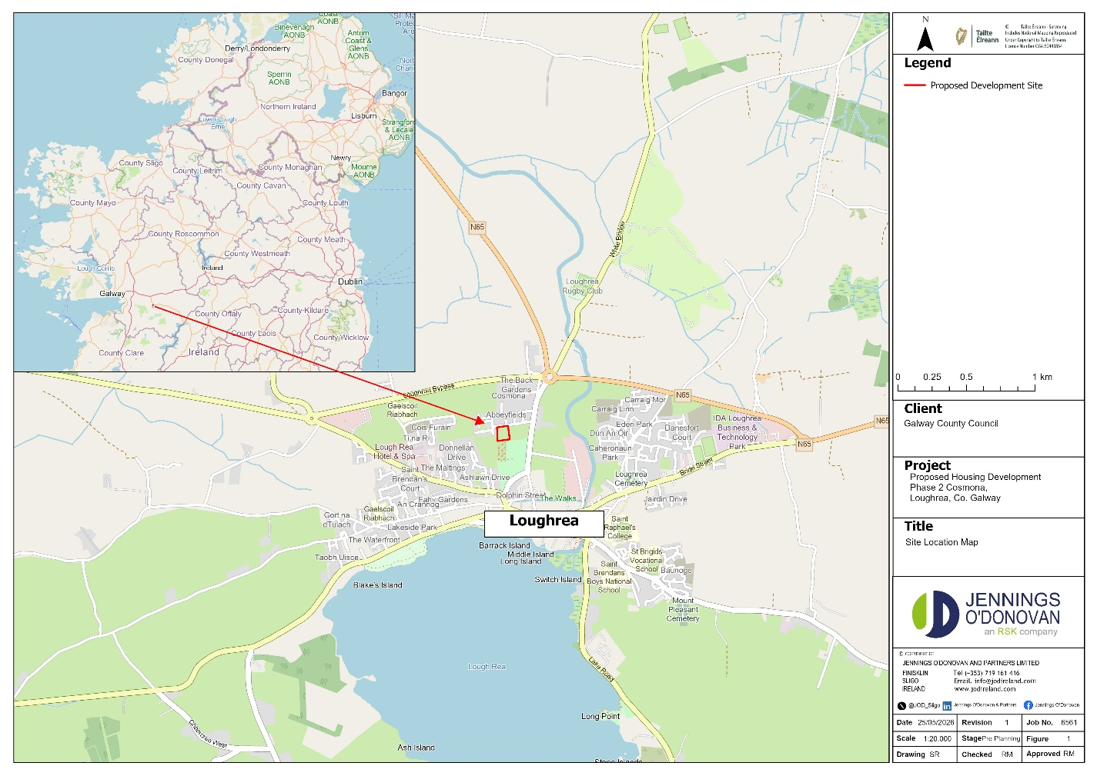
Figure 1.1: Site Location Map
Details of the site are outlined in Table 1.
Table 1: Proposed Development Works
Component | Proposed Works
Site Area (total) | - Approx. 0.65 ha
Site Area (for the development) | - Approx. 0.65 ha

This Flood Risk Assessment covers the site off the R350 in Loughrea. It was prepared in accordance with the report ’The Planning System and Flood Risk Management - Guidelines for Planning Authorities’ issued by the Department of Environment, Heritage and Local Government in November 2009. Flood risk from fluvial, surface water and ground water sources have been assessed based on existing available information. The assessment methodology involved researching and collating flood related information from the following data sources:
• Base maps – Ordnance Survey of Ireland;
• Flood Hazard Maps and flooding information for Ireland, (www.floodmaps.ie);
• Office of Public Works (OPW);
• Geological Survey of Ireland (GSI) maps on superficial deposits;
• EPA hydrology maps;
• CFRAMS (Catchment Flood Risk Assessment & Management Study);
• Strategic Flood Risk Assessment for the Draft Galway County Development Plan 2022-2028

Scope
This Flood Risk Assessment is based on the following:
• Department of Environment, Heritage and Local Government guidelines for Planning Authorities covering Flood Risk Management (The Planning System and Flood Risk Management: Guidelines for Planning Authorities 2009’)
• Risk of flooding to the Proposed Development Site from flood flow from neighbouring watercourses.
• Risk of flooding resulting from direct rainfall.
• Risk of flooding from groundwater.
In addition to the above, the study also examined any possible impact the proposed works may have on the existing drainage regime locally adjacent to the Proposed Development Site. The impacts addressed under this heading comprise:
• The impact of surface water runoff on the flow regimes in neighbouring watercourses.
• Loss of floodplain.
• Review of historical flood records.

PLANNING GUIDELINES
In November 2009, the Department of Environment, Heritage and Local Government issued a guidance document to planning authorities in relation to flood risk management, titled ‘The Planning System and Flood Risk Management’. These guidelines set out the policy on development and flood risk in Ireland and provide a framework for the integration of flood risk assessment into the planning process. The objective is to ensure that flood risk is considered at all stages in the planning process and, as a result, to:
• Avoid inappropriate development in areas at risk of flooding,
• Avoid new developments increasing flood risk elsewhere,
• Ensure effective management of residual risks for development permitted in flood plains.
The guidelines set out a staged approach for the consideration of flood risk in relation to developments as follows:
Stage 1: Flood risk identification – to identify whether there may be any flooding or surface water management issues related to either the area of regional planning guidelines, development plans and Local Area Plans (LAP’s) or a proposed development site that may warrant further investigation at the appropriate lower level plan or planning application levels;
Stage 2: Initial flood risk assessment – to confirm sources of flooding that may affect a plan area or proposed development site, to appraise the adequacy of existing information and to scope the extent of the risk of flooding which may involve preparing indicative flood zone maps. Where hydraulic models exist, the potential impact of a development on flooding elsewhere and of the scope of possible mitigation measures can be assessed. In addition, the requirements of the detailed assessment should be scoped; and
Stage 3: Detailed flood risk assessment – to assess flood risk issues in sufficient detail and to provide a quantitative appraisal of potential flood risk to a proposed or existing development or land to be zoned, of its potential impact on flood risk elsewhere and of the effectiveness of any proposed mitigation measures.
The guidelines classify developments into three vulnerability classes based on the effects of flooding:
• Highly vulnerable development,
• Less vulnerable development,
• Water compatible development.
Residential housing is classed as being highly vulnerable.
The guidelines also classify land areas into three flood zones based on the probability of flooding. Flood zones are defined as follows in the guidelines:
• Zone A is at highest risk. In any one year, Zone A has a 1 in 100 year (1%) chance of flooding from rivers and a 1 in 200 year (0.5%) chance of flooding from the sea.
• Zone B is at moderate risk. The outer limit of Zone B is defined by the 1 in 1,000 year (or 0.1%) flood from rivers and the sea.
• Zone C is at low risk. In any one year, Zone C has less than 1 in 1,000 year (<0.1%) chance of flooding from rivers, estuaries or the sea.
It is stated in the guidelines that during the identification of flood zones, no account should be taken of any flood relief walls or embankments.
Table 2.1: Matrix of Vulnerability versus flood zone to illustrate appropriate development and that required to meet the Justification Test (reproduced from Table 3.2 of Planning Guidelines)
 | Flood Zone A | Flood Zone B | Flood Zone C
Highly vulnerable  development (including essential infrastructure) | Justification Test | Justification Test | Appropriate
Less vulnerable development | Justification Test | Appropriate | Appropriate
Water-compatible development | Appropriate | Appropriate | Appropriate

Table 2.1, which is reproduced from the guideline document to Planning Authorities in relation to Flood Risk Management, states that dwelling houses should be located within Flood Zone C. Section 4 of this Flood Risk Assessment document will consider the Flood Zone assignment for the proposed site.
Table 2.1 refers to the use of a Justification Test under certain circumstances. In cases where there are insufficient sites available to locate a development in the appropriate low flood risk zone, the guideline documents allow for consideration of sites within flood risk zones. A Justification Test is then required to assess such proposals in light of proper planning and sustainable development objectives.
This report considers the Flood Risk of the proposed development site in relation to Stages 1 and 2 of the staged approach outlined above.

PROPOSED DEVELOPMENT SITE

Site Description
The proposed development site is located within Loughrea, Co. Galway, just off the R350.
A topographical map of the proposed site and surrounding areas levels are shown in Figure 3.1 below.
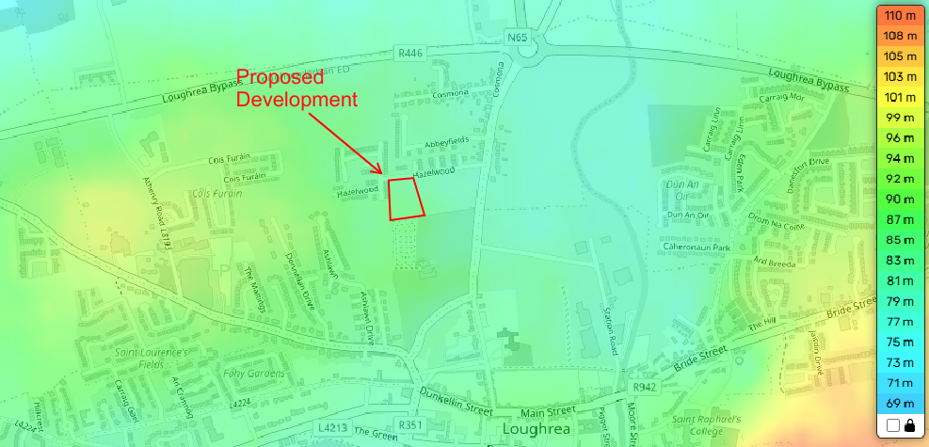
Figure 3.1: Topographical map of the proposed development site.
The Proposed Development site is relatively flat with ground levels consistently between approximately 86m and 84m OD. The ground level drops from c.86m OD at the southern and eastern boundary to c. 84m OD at northwest corner of the site, a drop of c. 2m.

FLOOD RISK REVIEW

Approach
The risk of flooding to the proposed development site shall be assessed in relation to the following criteria:
• Fluvial Risk: Inundation from flow from neighbouring watercourses
• Pluvial Risk: Flooding due to direct rainfall.
• Flooding from the sea
• Groundwater Risk: Flooding due to a high-water table.
• History of Flooding
• Available Predictive Flood Risk Mapping
• Impact of presence of the proposed development on the existing flood risk regime at the proposed development site.

OPW Catchment Flood Risk Assessment and Management (CFRAM)
As identified in Figure 4.1 below, the Kilgogan River (Segment Code:29-513) flows from Loughrea initially in a Northern direction before flowing Westword, as the Dunkellin River, to the Atlantic Ocean at Kilgogan. The proposed development site is approximately 20km form the Atlantic Ocean lies 450m West of the river.
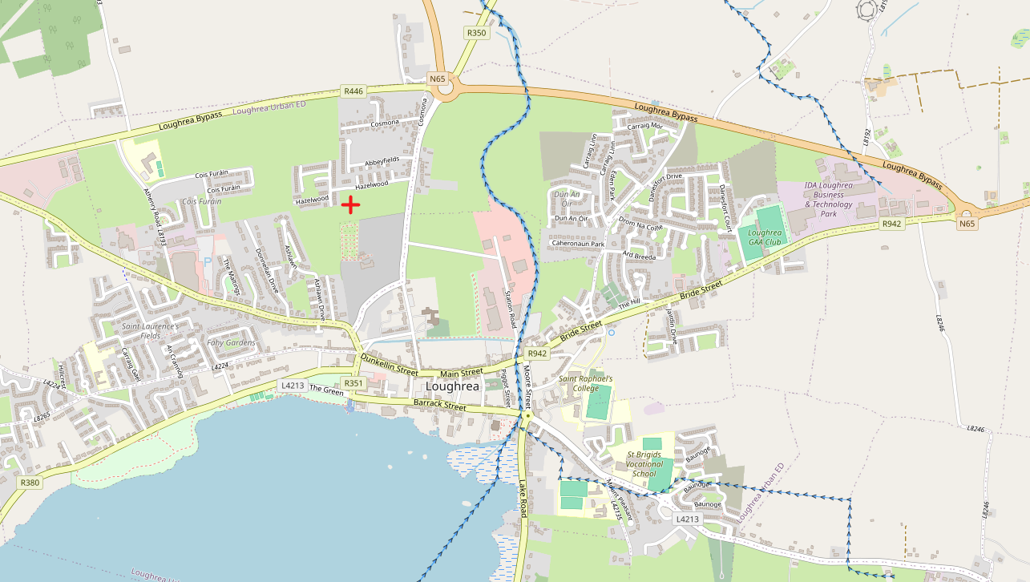
Kilcolgan (Segment Code: 29_513)

Project Site
Lough Rea
Figure 4.1: EPA watercourses and waterbodies in the vicinity of the Project.
The Loughrea Catchment has been identified as a High Priority Watercourse (HPW) during the preparation of the PFRA to be modelled under the Western CFRAM Study. As a result, the accuracy of the modelling increased significantly. In channel and structures cross sections were surveyed and incorporated into a hydraulic river model. The hydrological inputs were produced using a full Flood Studies Update (FSU) methodology. The CFRAM mapping also takes account possible flood risk scenarios associated with climate change. As such the CFRAM mapping produced from this model is the most appropriate source of flood risk information currently available for the proposed development site.
The Loughrea CFRAM mapping is included in Appendix B.

Fluvial Flood Risk.
At the time of writing (May 2026) the CFRAM mapping, as shown in Figure 4.2 below, predicted that fluvial flooding would not occur within the development site for all modelled flood AEP probabilities. Therefore, the proposed development site is in Flood Zone C, as referenced in the OPW Planning Systems and Flood Risk Management Guidelines for Planning Authorities, and the proposed development is considered to not be at risk of fluvial and tidal flooding.
The CFRAM outputs also described flow and water levels at a node slightly downstream of the proposed development site. These have been summarised in Table 4.1 below. It can be seen that the lowest existing ground level on site is c. 7.52m above the 0.1% (1 in 1000 year) flood level.
Table 4.1: CFRAM Water Levels and Flow Data for Cross Section Node_75

Source | Location | 10% AEP  mOD | 1% AEP  mOD | 0.1% AEP  mOD | Lowest G.L
Fluvial | Immediately downstream of the site | 76.16 | 76.31 | 76.48 | 82

Note that the CFRAM mapping shows the extent of flooding does not come within approximately 430m of the proposed development site.
The OPW National Flood Hazards Map www.floodinfo.ie/maps/floodmaps was accessed (May 2026) and shows that fluvial flooding will not occur within the proposed development site. The Kilcolgan River is approximately 450m to the east of the development boundary and is a high flood risk. High Probability flood events have approximately a 1-in-a-10 chance of occurring or being exceeded in any given year. This is also referred to as an Annual Exceedance Probability (AEP) of 10%. However, the extent of flooding is contained within the watercourse and will not extend to the development site.
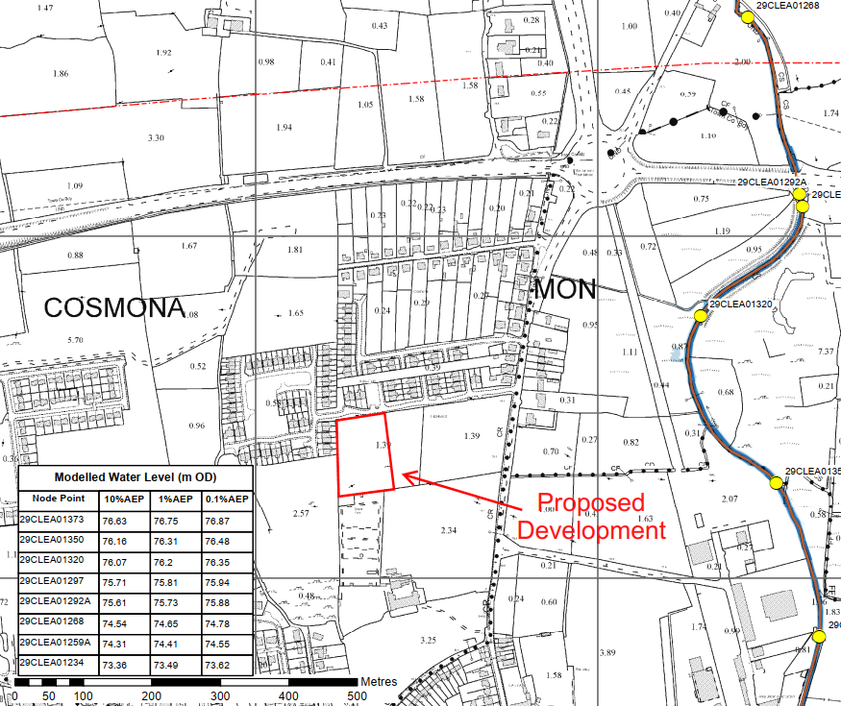
Figure 4.2: Loughrea Fluvial CFRAM Mapping (Source: Floodinfo.ie)
The following Table summarizes OPW Flood Events Probabilities.

Table 4.2: OPW Flood Event Probabilities

Annual Exceedance  Probability (%) | Odds of Occurrence in a  Given Year | Return Period Years
10 (High Probability) | 10:1 | 10
1 (Medium Probability) | 100:1 | 100
0.5 (Medium Probability –  Coastal Flood Map) | 200:1 | 200
0.1 Low Probability | 1000:1 | 1000

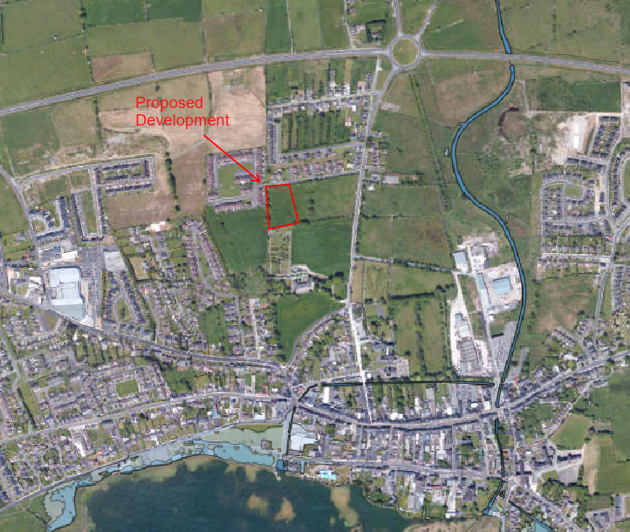
Lough Rea
Figure 4.3: Flood Map for the Proposed Site (Source: FloodInfo.ie)

Historical Flood Risk.
The OPW’s online Flood maps portal provides information on reported floods, in the form of reports, photos, and newspaper articles.
The closest recorded flood event occurred approximately 2.8 km from the development site on the Southern shore of Lough Rea. Th elocation of this flood is shown below in Figure 4.4.
Local Knowledge of the Earlspark, Loughrea Flood events, states that this is a recurring flood caused by lake level rises every year.

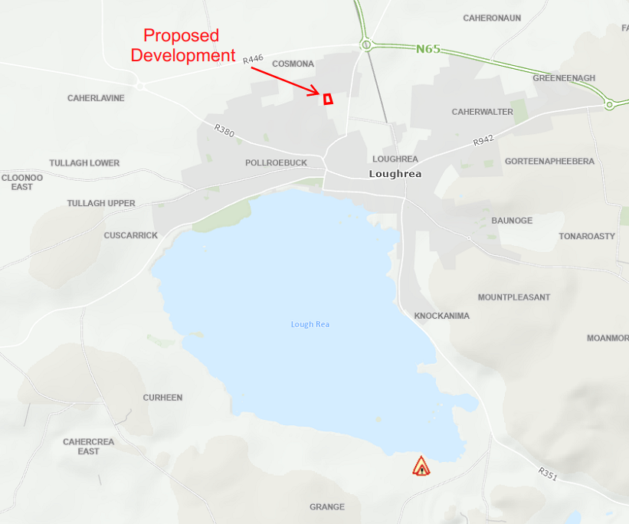
Figure 4.4: Loughrea Historical Flood Events (Source: Floodinfo.ie)

Pluvial Flood Risk
As mentioned in Section 3 above, the proposed development site is relatively flat. The proposed development and associated works has the potential to increase the impermeable area of the existing site and consequently, surface water runoff from the site would be increased. As a result, pluvial flooding on site and downstream can occur if the proposed design and subsequent works are not managed correctly.
The average annual rainfall for this region is 1385.9mm, (https://www.met.ie/climate/available-data/monthly-data, Athenry, 2023-2025). The mean Potential Evapotransporation (PE) for Athenry for the past three years is 530mm (https://www.met.ie/climate/available-data/monthly-data). Actual evapotransporation is estimated at 0.95 x PE = 503.5mm. The effective rainfall represents the water available for run-off and groundwater recharge and equals the annual rainfall less the actual evaporation or 1385.9 – 503.5 = 882.4mm.
The proposed site, which is currently a greenfield, would have an impermeable area of 0.4 hectares when developed out of a total site area of 0.65 hectares, resulting in approximately 61% of the existing greenfield becoming impermeable. This represents a substantial increase in hardstanding across the site. However, the associated pluvial flood risk is considered manageable subject to the implementation of an appropriate surface water drainage strategy in accordance with best practice Sustainable Drainage Systems (SuDS) principles, relevant Galway County Council guidance, and the requirements of Uisce Éireann.
The use of gravel surfacing and appropriately designed grassed areas within the amenity spaces will facilitate infiltration of surface water to ground, where site conditions permit. The proposed surface water drainage system serving roof and hardstanding areas will be designed in accordance with SuDS principles to provide protection against pluvial flooding. A range of SuDS measures, including attenuation storage and soakaway systems will be considered as part of the overall drainage strategy.
The drainage system will be designed to accommodate short-duration, high-intensity rainfall events and to limit peak discharge rates to greenfield runoff levels where practicable. The implementation of SuDS measures will ensure that natural drainage patterns are largely replicated, thereby reducing runoff volumes and attenuating flows on site. As a result, no adverse impacts on downstream areas are anticipated in terms of surface water quantity or quality.

Groundwater Flood Risk
The Geological Survey of Ireland mapping website indicates that the Proposed Development Site is underlain by Waulsortian Limestone that comprises of massive unbedded lime-mudstone. The bedrock indicated is a locally important aquifer, (LI), with one spring / well drawing from within the vicinity of the site. The groundwater vulnerability was determined to be high. Appendix B includes the downloaded GSI mapping for the above.
The OPW’s groundwater flood mapping was examined to determine if there was an existing risk from groundwater flooding at the site. This typically occurs in karst limestone areas in the vicinity of turloughs. Given that the bedrock is not karst limestone, and there are no known turloughs in the region, therefore, there is little or no risk from groundwater flooding. The groundwater flood mapping, shown in figure 4.5 below, confirmed that the site is not at risk from groundwater flooding.
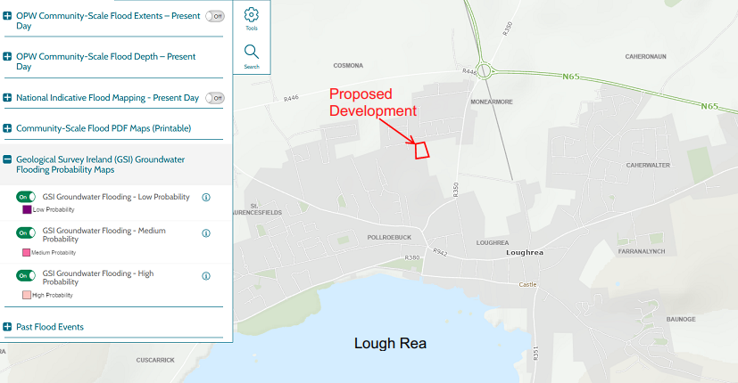
Figure 4.5: OPW Groundwater Flood Mapping

Impact of Development on current Flood Regime
All surface water runoff from proposed impermeable surfaces within the proposed development site will be collected in a dedicated drainage network. Sustainable Drainage Systems (“SuDS”) will be implemented to provide elements of source control of surface water, attenuation of runoff and water quality improvements. The site surface water drainage system will be designed to best practice to provide protection from surface runoff due to direct rainfall. The proposed development site is not located in a floodplain, ensuring that the Development will not result in any loss of floodplain.

Summary of Flood Risk
Table 4.2 below provides a summary of the flood risk at the Proposed Development Site.
Table 4.2: Flood Risk Summary Table

Source | Pathway | Receptor | Comment
Tidal | - | - | There is no risk of Tidal flooding at the proposed development site.
Fluvial | Overbank | Proposed Development | There is no apparent risk of fluvial flooding at the proposed development site.
Pluvial | Ponding of Rainwater on site | Proposed Development | There is no apparent risk of pluvial flooding at the proposed development site. However, it is recommended that the proposed storm drainage is designed with SuD’s principles, to ensure best practices are upheld and the increase in flows from the development site are catered for.
Groundwater | Rising Groundwater Levels | Proposed Development | Based on the GSI mapping and OPW mapping, there is no apparent risk from groundwater flooding at the proposed development site.

CONCLUSION
There is no apparent risk of fluvial or tidal flooding at the proposed development site. It is reasonable to conclude that the site lies within Flood Zone C as defined by the guidance document ‘The Planning System and Flood Risk Management’. There is no apparent risk of pluvial flooding at the Proposed Development Site. However, the provision of a stormwater run-off collection system incorporating SUDs features is recommended. There is no apparent risk of groundwater flooding at the proposed development site.
This research has concluded that there is no record of flooding previously occurring on the proposed development site. The proposed development site is not located in a floodplain; therefore, the proposed works will not result in a loss of floodplain. The proposed works are unlikely to increase the current flood risk in this catchment.
The conclusion of this FRA is that the proposed development site is not at risk of flooding (fluvial, tidal. pluvial or groundwater) and the proposed works will not result in any significant change in risk or flooding regime. Additionally, the Development is deemed to be appropriate (as set out in Table 3.2 of the guidelines for Flood Risk Management (DoEHLG/OPW, 2009). As such, no further stages of flood risk assessment are therefore required.

APPENDICES

CFRAM Mapping
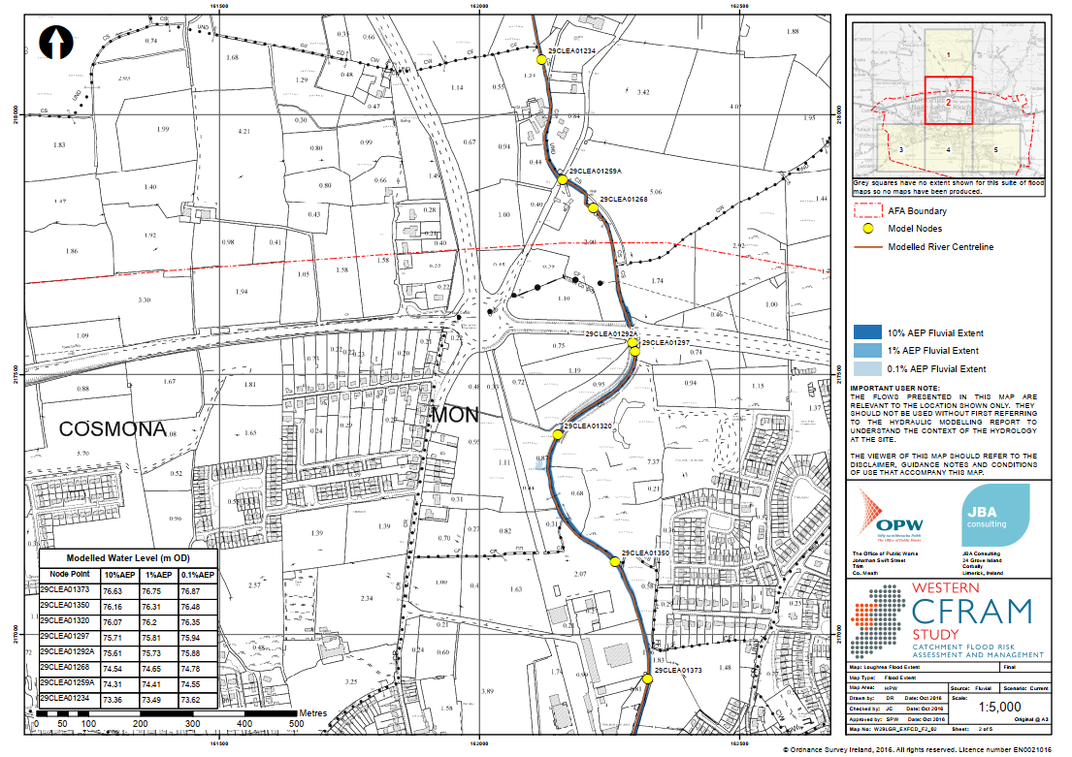

GSI Mapping
