 |  | Finisklin Business Park,  Co. Sligo,  Ireland,  F91 RHH9 |  |  |    | +353 71 91 61416  info@jodireland.com


SCREENING FOR APPROPRIATE ASSESSMENT
6561: 18 UNIT RESIDENTIAL DEVELOPMENT AT COSMONA, LOUGHREA, CO. GALWAY
May 2026 |  | Rev 00

DOCUMENT STATUS
Version | Purpose of document | Authored by | Reviewed by | Approved by | Review Date
00 | First issue – Draft | R. Mitchell | M. Garvey | M. Garvey | 26/05/26

APPROVAL FOR USE
M. Garvey |  | 26/05/26
This document, and information or advice which it contains, is provided by JENNINGS O’DONOVAN & PARTNERS LIMITED solely for internal use and reliance by its Client in performance of JENNINGS O’DONOVAN & PARTNERS LIMITED’s duties and liabilities under its contract with the Client. Any advice, opinions, or recommendations within this document should be read and relied upon only in the context of the document as a whole. The advice and opinions in this document are based upon the information made available to JENNINGS O’DONOVAN & PARTNERS LIMITED at the date of this document and on current standards, codes, technology and construction practices as at the date of this document. Following final delivery of this document to the Client, JENNINGS O’DONOVAN & PARTNERS LIMITED will have no further obligations or duty to advise the Client on any matters, including development affecting the information or advice provided in this document. This document has been prepared by JENNINGS O’DONOVAN & PARTNERS LIMITED in their professional capacity as Consulting Engineers. The contents of the document does not, in any way, purport to include any manner of legal advice or opinion. This document is prepared in accordance with the terms and conditions of JENNINGS O’DONOVAN & PARTNERS LIMITED contract with the Client. Regard should be had to those terms and conditions when considering and/or placing any reliance on this document. Should the Client wish to release this document to a Third Party for that party's reliance, JENNINGS O’DONOVAN & PARTNERS LIMITED may, at its discretion, agree to such release provided that:
(a) JENNINGS O’DONOVAN & PARTNERS LIMITED written agreement is obtained prior to such release, and
(b) By release of the document to the Third Party, that Third Party does not acquire any rights, contractual or otherwise, whatsoever against JENNINGS O’DONOVAN & PARTNERS LIMITED and JENNINGS O’DONOVAN & PARTNERS LIMITED, accordingly, assume no duties, liabilities or obligations to that Third Party, and
(c) JENNINGS O’DONOVAN & PARTNERS LIMITED accepts no responsibility for any loss or damage incurred by the Client or for any conflict of JENNINGS O’DONOVAN & PARTNERS LIMITED’s interests arising out of the Client's release of this document to the Third Party.
PREPARED BY | PREPARED FOR
Jennings O’Donovan and Partners Ltd.  Finisklin Business Park,  Co. Sligo,  Ireland,  F91 RHH9  +353 71 91 61416  info@jodireland.com         | Galway County Council  Aras an Chontae,  Prospect Hill,  Galway.  091 509043  planning@galwaycoco.ie

table of Contents
1 INTRODUCTION 1
1.1 BACKGROUND 1
1.2 AUTHOR’S QUALIFICATION AND EXPERTISE 1
1.3 Regulatory Context 2
1.4 STAGES IN AN APPROPRIATE ASSESSMENT 4
1.5 SCREENING METHODOLOGY 4
1.6 DESK STUDY 5
1.7 FIELD STUDY 5
1.8 FLOODING 5
2 PROJECT DESCRIPTION 7
2.1 SITE LOCATION 7
2.2 PROPOSED WORKS 8
3 RECEIVING ENVIRONMENT 8
3.1 GEOLOGY AND SOILS 8
3.2 HYDROLOGY AND HYDROGEOLOGY 8
3.3 Habitats 11
3.4 invasive species 16
4 screening for appropriate assessment 16
4.1 EUROPEAN SITES WITHIN THE ZONE OF INFLUENCE (ZOI) OF THE PROJECT 17
4.2 IN-COMBINATION EFFECTS 24
5 screening assessment conclusion 30
6 references 30
7 APPENDICES 32
7.1 APPENDIX I – – Flood Risk ASSESSMENT 32
7.2 APPENDIX II – DRAWINGS 33

INTRODUCTION

BACKGROUND
Jennings O’Donovan & Partners Limited have been commissioned by VHA Architects to carry out a Stage I Appropriate Assessment Screening under Article 6(3) of Council Directive 92/43/EEC (Habitats Directive) for the Provision of a 12-unit residential development at Cosmona, Loughrea Co. Galway. The works hereafter in this report will be identified as ‘the Project’.
The purpose of this report is to assess the various elements of the Project in terms of potential impacts to European Sites within the Zone of Influence (ZoI) of the Project. Potential cumulative impacts of the overall project, individually and in-combination with other plans and projects within the area of the waterbody catchment were also assessed. Locations where works were carried out were surveyed for the presence of protected habitats and species as set out in the Birds and Habitats Directives.
This proposal is not necessary for the conservation management of a European Site.

AUTHOR’S QUALIFICATION AND EXPERTISE
This Screening for this EIA Report has been prepared by a qualified and accredited experts as follows:
Ryan Mitchell BSc who is an Environmental Scientist and Ecologist at Jennings O’Donovan & Partners Limited. He has a Bachelor of Science in Animal Conservation and Biodiversity from Greenwich University. He is an Associate Member of the Chartered Institute of Ecology and Environmental Management (ACIEEM). His ecological experience includes Phase 1 Habitat surveys, report writing, preparing chapters for Environmental Impact Assessments, Appropriate Assessments, Natura Impact Statements and Construction Environmental Management Plans. In addition, he is an experienced Badger and Bat surveyor and carries out Preliminary Bat Roost Survey Assessment Reports and Bat Activity surveys on structures which are to be impacted by a development. More recently, he has obtained a license for freshwater pearl mussel monitoring (Margaritifera margaritifera) with NWPS on a certified training course Phase 1 & Phase 2.
In addition, he is an experienced entomologist his fieldwork experience includes working with/for Buglife NI, Natural History Museum London, Oxford University and National Museums Northern Ireland. His most recent fieldwork (2024) includes conducting Common Standards Monitoring of Invertebrates for NEIA in Northern Ireland on ASSI sites, Marsh Fritillary surveys in both Northern Ireland and the Republic of Ireland. He has published 91 publications in peer reviewed journals on terrestrial invertebrates in Britain and Ireland, added species to the Irish list (20) and rediscovered a rare species of Sphaeoroceridae Minilimosina secundaria (Duda, 1918) which was thought to be extinct in Britain.
This report has been reviewed by Michael Garvey he holds a B.Eng in Civil Engineering and a diploma in Project management. He is an experienced Chartered Professional Engineer (Ontario - Engineers Canada) with over 15 years of client-side and contractor/consultant experience on various Major Multi-Discipline Infrastructure Projects. Experienced in all stages of project life cycles from inception to operations. Projects varied from Design/Build, EPC, EPCM and P3 projects in Ireland, Australia and North America.

Regulatory Context
Under Section 177U (1) of the Planning Acts, a Screening for AA of the Project shall be carried out by the competent authority (in this case, Jennings O Donovan on behalf of Galway County Council to assess in view of best scientific knowledge, if the Project, individually or in combination with other plans or projects, is likely to have a significant effect(s) on any European Sites.
Collectively, Special Areas of Conservation (SACs) and Special Protection Areas (SPAs) are referred to as the Natura 2000 Sites. The legal basis on which SACs are selected and designated is the EU Habitats Directive, 92/43/EEC transposed into Irish law by the European Communities (Birds and Natural Habitats) Regulations 2011 (S.I. No. 477 of 2011), as amended. The designation features of SACs are referred to as Qualifying Interests (QI) and include both species (excluding birds) and habitats. Similarly, Special Protection Areas (SPA’s) are legislated in the Birds Directive 2009/147/EC. The designation features of SPAs are referred to as Special Conservation Interests (SCIs) which comprise bird species as well as wetland bird habitats.
In general terms, SACs and SPAs are considered to be of exceptional importance in terms of rare, endangered or vulnerable habitats and species within the European Community.
Article 6, paragraph 3 of the Habitats Directive states that:
“Any plan or project not directly connected with or necessary to the management of the site but likely to have a significant effect thereon, either individually or in-combination with other plans or projects, shall be subject to appropriate assessment of its implications for the site in view of the site's conservation objectives. In the light of the conclusions of the assessment of the implications for the site and subject to the provisions of paragraph 4, the competent national authorities shall agree to the plan or project only after having ascertained that it will not adversely affect the integrity of the site concerned and, if appropriate, after having obtained the opinion of the general public”.
The statutory agency responsible for the European Sites is the National Parks and Wildlife Service of the Department of Culture, Heritage and the Gaeltacht.
This report has been prepared in accordance with current guideline documents:
• Assessment of plans and projects significantly effecting Natura 2000 sites: Methodological guidance on the provisions of Article 6(3) and (4) of the Habitats Directive 92/43/EEC (EC, 2001).
• Appropriate Assessment of Plans and Projects in Ireland - Guidance for Planning Authorities (DEHLG 2009, Revised February 2010).
• Appropriate Assessment of Plans and Projects in Ireland Guidance for Planning Authorities. Department of the Environment, Heritage and Local Government (DoEHLG, 2009, revised 2010).
• OPR Practice Note PN01: Appropriate Assessment Screening for Development Management, March 2021, Office of the Planning Regulator.
• Methodological Guidance on Articles 6(3) and 6(4) of the Habitats Directive (Commission, 2021).
• Communication from the Commission on the Precautionary Principle. Office for Official Publications of the European Communities, Luxembourg, (EC, 2000a).
• Methodological Guidance on Articles 6(3) and 6(4) of the Habitats Directive (Commission, 2021)
• Guidance on strict protection of animal species of Community interest under the Habitats Directive (Commission, 2021)
• European Communities (Birds and Natural Habitats) Regulations, 2011 (S.I. No.477 of 2011).
• Interpretation Manual of European Union Habitats. Version EUR 28. European Commission (EC, 2013).
• EU Guidance document on Article 6(4) of the 'Habitats Directive' 92/43/EEC (EC, 2007)
• Managing Natura 2000 Sites: The provisions of Article 6 of the ‘Habitats’ Directive 92/43/EEC (EC, 2018)
• Strict Protection of Animal Species, NPWS, 2021
The following European Court and Irish High Court rulings have been considered:
• C-721/21 Eco Advocacy CLG v An Bord Pleanála and Keegan Land Holdings Limited
• C-127/02 Waddenzee v Staatssecretaris
• C-258/11 Sweetman v An Bord Pleanála
• C-512/12 Briels
• C-387/12 & C388/15 Orleans and others v Vlaams Gewest
• C-142/15 Moorbug
• C-323/17 People Over Wind and Peter Sweetman v Coillte
• C-162/17 Grace and Sweetman
• C-883/18 Holohan and others v An Bord Pleanála
• IEHC 84 (2019) - Kelly v An Bord Pleanála
• C-721/21 Eco Advocacy CLG v an Bord Pleanála
Relevant plans from national to local scales are critical to inform a robust assessment of in-combination impacts; these are listed below:
• National Biodiversity Action Plan, for the period 2023-2030
• River Basin Management Plan for Ireland 2022-2027
• Galway County Development Plan 2022-2028

STAGES IN AN APPROPRIATE ASSESSMENT
There are 4 stages in an Appropriate Assessment as outlined in the European Commission Guidance document (2001). The following is a brief summary of these steps:
Stage 1 - Screening: This stage examines the likely effects of a project either alone or in- combination with other projects upon a European Site and considers whether it can be objectively concluded that these effects will not be significant.
Stage 2 - Appropriate Assessment: In this stage, the impact of the project on the integrity of the European Site is considered, with respect to the conservation objectives of the site and to its structure and function.
Stage 3 - Assessment of Alternative Solutions: Should the Appropriate Assessment determine that adverse impacts are likely upon the European Site, this stage examines alternative ways of implementing the project that, where possible, avoid these adverse impacts.
Stage 4 - Assessment where no alternative solutions exist and where adverse impacts remain: Where imperative reasons of overriding public interest (IROPI) exist, an assessment to consider whether compensatory measures will or will not effectively offset the damage to the European Site will be necessary.
As part of this Screening for Appropriate Assessment, a desk-based study of European Sites within the ZoI of the Project is required.

SCREENING METHODOLOGY
The function of the Screening Assessment is to identify whether or not the project will have a likely significant effect on any European Site. In this context “likely” refers to the presence of doubt with regard to the absence of significant effects (ECJ case C-127/02) and “significant” means not trivial or inconsequential but an effect that has the potential to undermine the site’s conservation objectives (ECJ case C-127/02). In other words, any effect that compromises the functioning and viability of a site and interferes with achieving the conservation objectives for the site would constitute a significant effect.
The nature of the likely interactions between the Project and the integrity of a European Site will depend upon the sensitivity of the European Site’s qualifying features to potential impacts arising from the Project; the current conservation status of the European Site and its qualifying features; and any likely changes to key environmental indicators (e.g. water quality) that underpin the conservation status of European Sites and their qualifying features, in-combination with other plans and projects.
The European Commission (2018) Guidelines outline the stages involved in undertaking a Screening Assessment of a project that has the potential to have likely significant effects on European Sites. The methodology adopted for this Screening Assessment is informed by these guidelines and was undertaken in the following steps:
1. Define the project and determine whether it is directly connected with or necessary for the conservation management of European Sites.
2. Identify other plans or projects that, in-combination with the project, have the potential to effect European Sites.
3. Assess whether or not the project is likely to have significant effects on European Sites in the view of its conservation objectives.

DESK STUDY
A desk study was carried out to collate the available information on the ecology of the project area. The National Parks and Wildlife Service (NPWS) database was consulted concerning designated conservation areas and records of rare and protected plant and animal species in the vicinity of the Project. The National Biodiversity Data Centre (NBDC) website was also consulted.
The Project is wholly contained within the one-kilometre Grid square ‘M6117’. Five protected species have been recorded in this square namely, the House Martin (Delichon urbicum), Swallow (Hirundo rustica),
Wheatear (Oenanthe oenanthe), Willow Warbler (Phylloscopus trochilus), and Hegdehog (Erinaceus europaeus). Two near threatened species, namely Red-tailed Bumblebee (Bombus lapidarius) and Tissue (Triphosa dubitata) are also recorded. No watercourse is present on site. The closest water feature is the Kilcogan (EPA Code: IE_WE_29K010100), a second order river located about 260m to the east of the proposed development and Lough Rea (Segment Code: 29_194), 580m to the south.
The Galway County Development Plan 2022-2028, and the Galway County Council planning enquiry website were reviewed to identify any proposed plans or projects which may have a direct, indirect or cumulative impact with the Project.

FIELD STUDY
A site visit was carried out on May 6th, 2026, the weather was sunny and clear sky and the temperature was around 11 degrees Celsius. The survey consisted of traversing the entire Project site, being conscious of adjacent lots and any potential invasive species either overhanging the Project or rooted near/within the site. Habitat classification followed Fossitt (2000), and the floral nomenclature used followed Parnell and Curtis (2012) and Scannell and Synnott (1987). The locations where works will be carried out were also surveyed for the presence of invasive species (as listed in the Third Schedule of S.I. No. 477 of 2011, EC (Birds and Natural Habitats) Regulations 2011).
During the site visit carried out in April 2025, no badger setts were identified within or adjacent to the redline line boundary.
Other points of note during the site inspection, no conspicuous colonies of ground nesting bees were identified in areas of bare ground within the redline boundary.

FLOODING
A desktop Flood Risk Assessment was undertaken for the site. Figure 1.1 illustrates an extract from the above OPW National Indicative Fluvial Mapping (NIFM) at and in the vicinity of the proposed development site for the current scenario 10% AEP (1 in 10 year), 1% AEP (1 in 100 year) and 0.1% AEP (1 in 1000 year) fluvial flood events. The site does not fall within an OPW NIFM present-day scenario 10% AEP (1 in 10 year), 1% AEP (1 in 100 year) or 0.1% AEP (1 in 1000 year) fluvial flood zone.
The Project itself has no surface and groundwater records of flooding events (including winter 2015/2016 Geological Survey Ireland surface water flooding records). The nearest historical previous flood event occurred in Winter 2015/2016(Single Event), at a point (grid reference: M 61658 16487) approximately 560m south of the Project. There is no foreseen risk of a flood event extending to the Project.
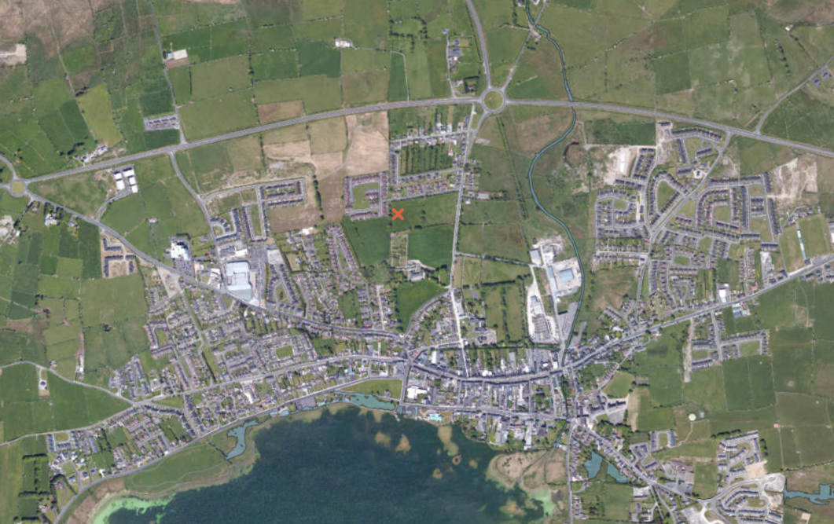 Figure 1.1 Flood map in the vicinity of the proposed Project, Co. Galway Source: OPW Floodmap.ie, 15/05/2026)
Project Site

The Geological Survey Ireland (GSI) Groundwater Flooding Probability Maps were also examined (May, 2026) to determine if there was an existing risk from groundwater flooding at the site. The groundwater flood mapping confirmed that the site is not at risk from groundwater flooding. In addition, there is no risk of tidal or pluvial flooding at this site.
The associated ground waterbody (GWB) GWDTE-Rahasane Turlough (SAC000322) (EPA Code IE_WE_G_0100) is ‘Locally important’ and covers an overall area of approximately 330km². It is located on ‘poorly productive bedrock’ and protected for drinking water abstraction under article 7. The Water Framework Directive (WFD) latest status for this GWB is ‘Good’. The 2016-2021 overall groundwater status is ‘Good’, indicating no change from the previous monitoring period 2013-2018 status.
As part of the project design groundwater will be pumped out of excavations (as necessary) to permit the construction of foundations and rising walls. The quantity of water which will be pumped out will be limited and is not expected to noticeably lower the groundwater table. Standard procedure includes keeping the pumps active until the concrete has cured. Site control measures will be in place to ensure hydrocarbons and chemicals are kept away from groundwater and surface water in line with best practice guidance including “Guidelines on protection of fisheries during construction works in and adjacent to waters, IFI 2016”. Spill kits will be onsite at all times and site personnel will be trained in their use.
A more detailed Flood risk assessment was carried out by Jennings O’Donovan and located in Appendix 1.
The conclusion outlined there is no apparent risk of fluvial or tidal flooding at the proposed development site. It is reasonable to conclude that the site lies within Flood Zone C as defined by the guidance document ‘The Planning System and Flood Risk Management’. There is no apparent risk of pluvial flooding at the Project Site. However, the provision of a stormwater run-off collection system incorporating SUDs features is recommended. There is no apparent risk of groundwater flooding at the proposed development site.

PROJECT DESCRIPTION

SITE LOCATION
The Project is located approximately 520m northwest of Loughrea town centre, south from the N65 road which connects Borrisokane Co. Tipperary to the M6 7.4km north of Loughrea. The housing development is located to the west of the Mount Carmel Crescent, which goes off the N59/R446 roundabout. The Project is approximately a two-minute drive from Loughrea town. All of Loughrea is classified as discontinuous urban fabric under Corine land cover, the study site is denoted as pastureland. There is a residential area north of the site, a field and more housing estates to the west and primarily agricultural areas in the east. South of the proposed development there is a monastery, another field and Loughrea town.
The site is not located near the coast. The closest SAC is Lough Rea SAC (000304) located 680m to the south and Lough Rea SAC (004134) 680m to the south is the nearest SPA.
The Project covers an area of approximately 0.85 hectares.
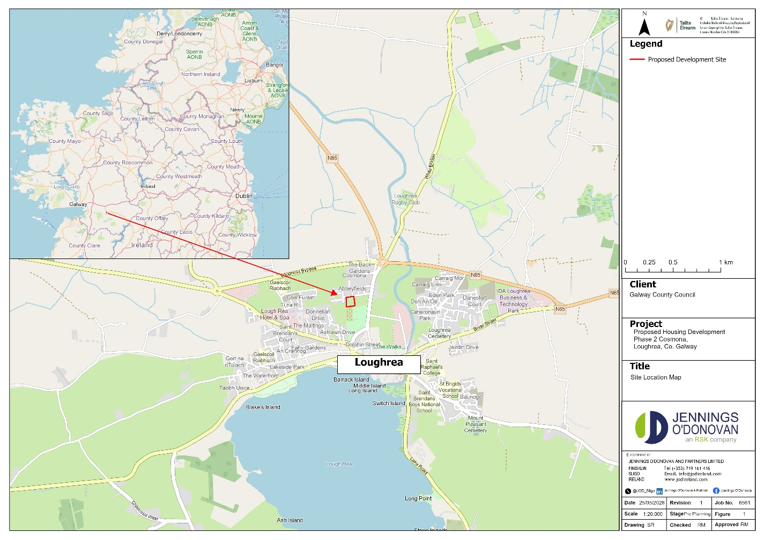Figure 2.1: Site Location Map

PROPOSED WORKS
The proposed development at Cosmona Phase 2, Loughrea, Co. Galway consists of 18 two storey three-bedroom residential units on a site area of approximately 0.65ha and site development works. The housing mix is comprised of:
• Two 3-bedroom, single-story units (Type 3B 1S), each with an area of 92.8m2.
• 16 3-bedroom, two-story units (Type 3B 2S), each with an area of 104m2.

RECEIVING ENVIRONMENT

GEOLOGY AND SOILS
The quaternary sediments at the site of the Project are classified as ‘Till derived from limestones’ (01/05/26).
The Project is located within the Waulsortian Limestones. This bedrock formation is described by the Geological Survey of Ireland as ‘Massive unbedded lime-mudstone’. The EPA maps indicate that the subsoil found onsite is characterised as Tills (diamictons). The soil type found onsite is classified as Mullabane, a well-drained mineral soil that belongs to the brown earths, the texture is ‘coarse loamy drift with limestones’. Corine 2018 denotes the project area as pastures.

HYDROLOGY AND HYDROGEOLOGY
The site overlies bedrock which is classified as a ‘Locally Important Aquifer – Bedrock’ which is ‘Moderately Productive only in Local Zones.’ The groundwater vulnerability at the site ranges between ‘Moderate’ and ‘High’.
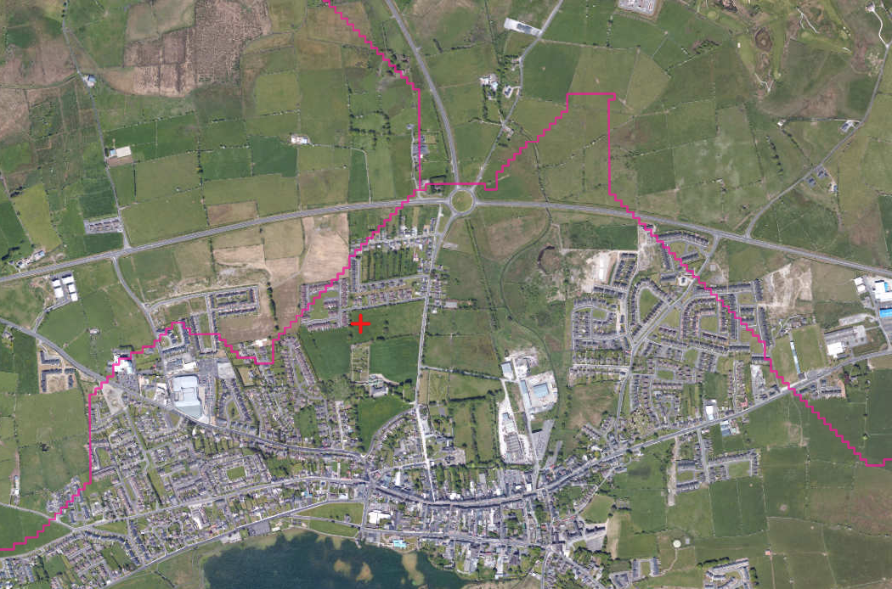
Project Site

KILCOLGAN_020
KILCOLGAN_010
KILCOLGAN_030
Figure 3.1: River Sub Basins (RSB) in the vicinity of the Project
The Project is wholly located within the KILCOLGAN_010 WFD River Sub Basin (RSB) covering an area of approximately 17km² (Figure 3.1). The nearest downstream river monitoring station is the White Mill N. of Loughrea river station (Station Code: RS29K010100). The closest relevant water course is the order 2 Kilcolgan_010 stream (Segment Code: 29_513) lies approximately 260 metres east of the Project (Figure 3.2). During 2019-2024 and 2016-2021 monitoring periods it had a ‘moderate’ WFD status showing an improvement from the previously ‘poor’ status from the 2013-2018 monitoring period. In 2000 A Q value of 3 which refers to ‘poor’ water quality was assigned to Kilcogan_010. Originating from Lough Rea (Segment Code: 29_194) which is about 630m from the study site, this stream flows in a northern direction of the site for approx. 2.6km before joining the Raruddy_East (Segnent Code: 29_4967) and Raruddy_West (29_617) to form the third order Kilcogan River (Segment Code: 29_519). As a fifth order stream the Kilcogan ultimately flows into Rahasane Turlough SAC (Site Code: 000322) and SPA (004068) 11.6 and 11.7km from the site. There are three more order 1 streams near the site. Namely the Doogarraun (Segment Code: 29_618) 965m to the north and 845m to the northwest from the site boundary, the Raruddy_West (Segment Code: 29_617) approximately 1.2km to the north and the Carrowmore 29 stream (Segment Code: 29_506) which is located 1.4km to the west of the site. Lough Rea SAC (Site Code: 000304) and SPA (004134) achieved a moderate water quality status in the 2019-2024 monitoring period showing deteriorating water quality compared to the 2016-2021 and 2013-2018 periods when the lake’s water quality was ‘good’.
The site has no hydrological connections to any these watercourses.
The area immediately surrounding the Project supports both residential (north/west/south) and agricultural (east/west) land use. The wider surrounding landscape includes mostly agricultural areas (all directions), Forest and semi-natural areas in the south and few peat bogs (north/northwest/south).
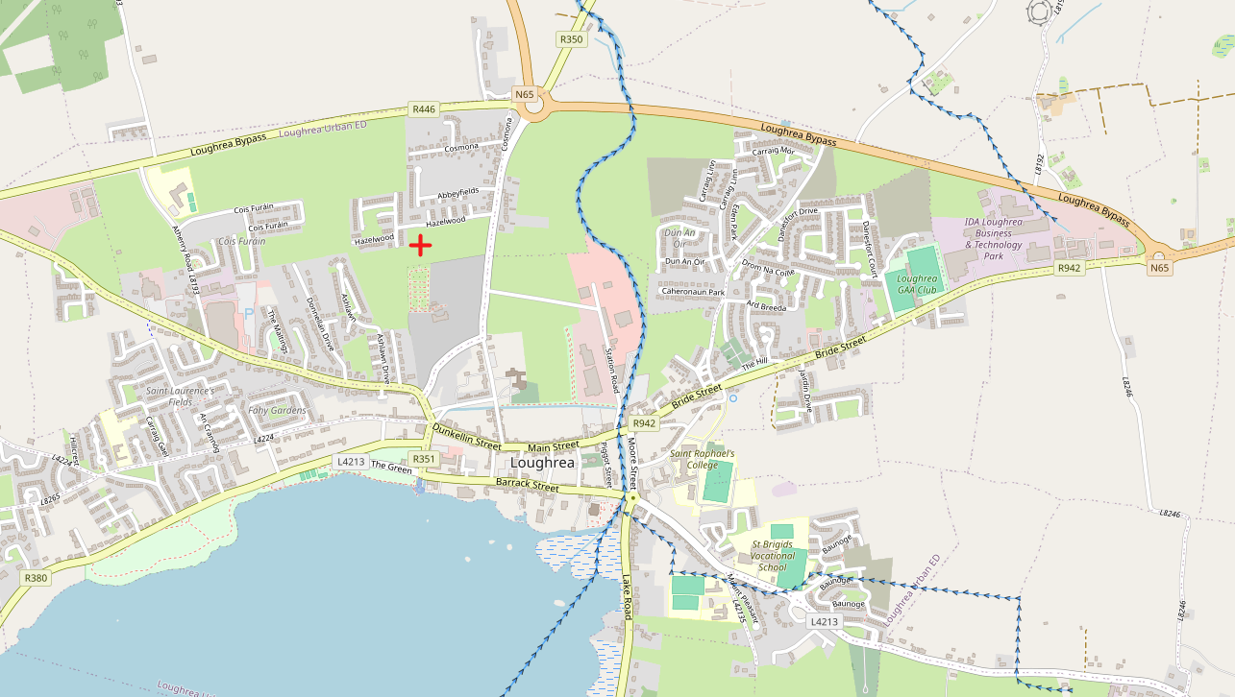
Project Site
Kilcogan (Segment Code: 29_513)

Figure 3.2: EPA watercourses and waterbodies in the vicinity of the Project
Currently, the ground waterbody GWDTE-Rahasane Turlough (SAC000322) (Segment code: IE_WE_G_0100) is under pressure from agriculture, domestic wastewater (EPA Water Maps, accessed May 5th, 2026).
The Project is within the GWDTE-Rahasane Turlough (SAC000322) groundwater body for the abstraction of drinking water (Article 7- EPA code IEPA1_SH_G_0100). Most rivers surrounding the site are part of the ZOC Rhynn Killeeneen NFGWS Group Scheme Source Protection Area.
There are significant agricultural, hydromorphological, domestic and urban wastewater, industrial and urban run-off pressures impacting on the surrounding rivers (Code:IE_WE_29K010400).
Most of the site is within the Lough Rea urban wastewater treatment agglomeration boundary but there are no other EPA licenced activities recorded for the area. Loughrea Sewage works (RegCD: D0194) is the closest urban wastewater treatment plant to the site. It is located approximately 1.2km northeast from the site and was designed for a population equivalent (PE) of 9500. There is a primary effluent emission point 470m northwest from the plant discharging to KILCOGAN_020.
The EPA Maps (Water) website was accessed (May 2026) to examine the Project area and its environs for nitrate and phosphorus loading and Pollutant Impact Potential (PIP). PIP maps for Nitrogen (N) and Phosphorus (P) have been generated by the EPA to show the highest risk areas in the landscape for losses of N and P to waters. The PIP model estimates the annual nutrient losses from agricultural land at specific locations, using spatial data from farm management, soils and hydrogeology. This model estimates loads at an annual temporal resolution.
Most of the project site and the adjacent agricultural land to the west and east has a phosphorous ranking of 7. Pollution Impact Potential Nitrate (PIP N) for the lands of the area adjacent to the east have a ranking of 7. Agricultural areas to the west and south of the site have a PIP N ranking of 6. Buildings and artificial surfaces such as the residential areas surrounding the site are not rated. The overall ranking range likely reflects fertiliser use on the land in the past, with low-level stock.
Overall, the Critical Source Areas Maps for the Project and adjacent lands do not indicate that phosphorus or nitrates are a significant issue.
As noted earlier in Section 3.2, the Project is within the WFD River Sub Basin KILCOGAN_010. Currently, there are no significant nitrogen or phosphorus pressures from the Project site on this RSB.

Habitats
A site visit was carried out on May 6th, 2026, the weather was sunny and clear sky and the temperature was around 11 degrees Celsius. The survey consisted of traversing the entire Project site being conscious of any invasive species either overhanging the Project or rooted near/within the site.
Five habitats (according to Fossitt, 2000) were noted in the survey area, namely GS2: Dry Meadows and Grassy Verges, WL1: Tree line, WS1 Scrub, BL1 Stone Walls and Other Stonework and ED2 Spoil and Bare Ground. No Annex I habitat occurs within or adjacent to the Project.
No rare, threatened, or protected species of plants as per the Red Data Book (Curtis and McGough, 1988) were found. No species listed in the Flora Protection Order (2022) were found to be growing within or adjacent to the Project works.
GS2: Dry Meadows and Grassy Verges
The survey area consists of a large open field supporting predominantly semi-improved dry grassland vegetation (Figure 3.3) with areas of local disturbance and scrub encroachment. The site was previously inspected in 2023 and was confirmed at that time to comprise a continuation of the same grassy meadow habitat present across the wider area, characterised by relatively limited species diversity. Review of aerial imagery also confirms that this habitat was present prior to the construction of Phase 1 of the housing development, indicating that the site historically formed part of a larger continuous grassland field system. More recently, sections of the site have been subject to disturbance associated with the adjacent development works, including the temporary storage of topsoil within parts of the field.The southern portion of the site retains characteristics of a species-poor to moderately species-rich meadow, with a grass sward dominated by foxtail and sweet vernal grass. The grassland structure is variable across the site, with some sections appearing relatively intact while others show signs of disturbance, approximately 30% of the original grassland habitat remains in comparatively intact condition, while the remainder has become fragmented by Rubble and earth piles associated with the construction works of Phase 1. The herbaceous layer is composed of a mixture of meadow and ruderal species. Recorded flora include meadowsweet, cuckoo flower (Cardamine pratensis), creeping buttercup (Ranunculus repens), meadow buttercup (Ranunculus acris), common dock (Rumex obtusifolius), broad-leaved dock (Rumex obtusifolius), curly dock (Rumex crispus), creeping thistle (Cirsium arvense and hogweed (Heracleum sphondylium).
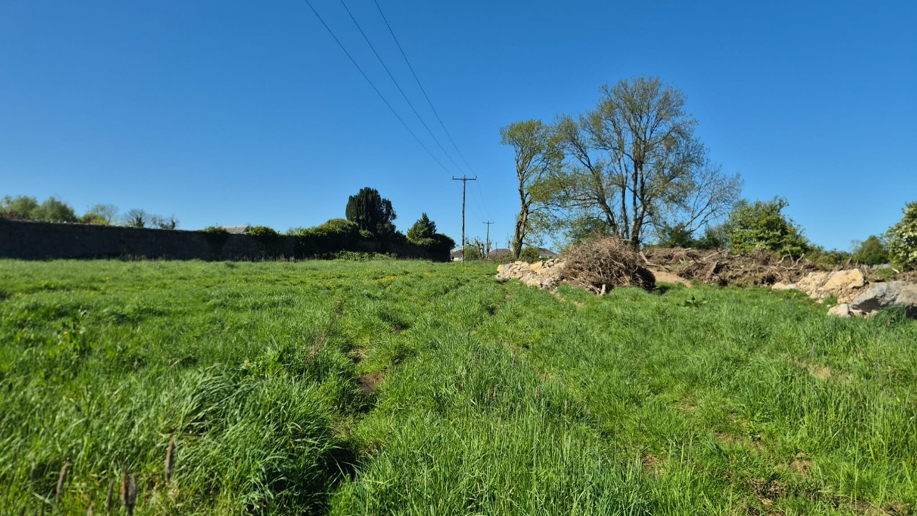Figure 3.3: The field meadow habitat located at Phase 2 some rubble and brash in the background of the image
ED2 Spoil and Bare Ground
The rubble and earth piles (Figure 3.4) between approximately 2–4m in height are distributed across parts of the field and appear to result from previous site disturbance or clearance activity. These features support early successional vegetation and patches of exposed substrate. Species recorded in the disturbed areas include silverweed (Argentina anserina), hairy bitter-cress (Cardamine hirsuta), eyebright (Euphrasia spp.) and ribwort plantain (Plantago lanceolata).
The exposed ground and loose substrate create additional microhabitats which may be of value to invertebrates, particularly ground-dwelling species. Two solitary bee species were noted onsite: Andrena scotica and Nomada marshamella, both of which are common species. No noticeable large aggregations of mining bee nests were recorded during the site inspection, and weather conditions were particularly favourable for observing invertebrate activity onsite.

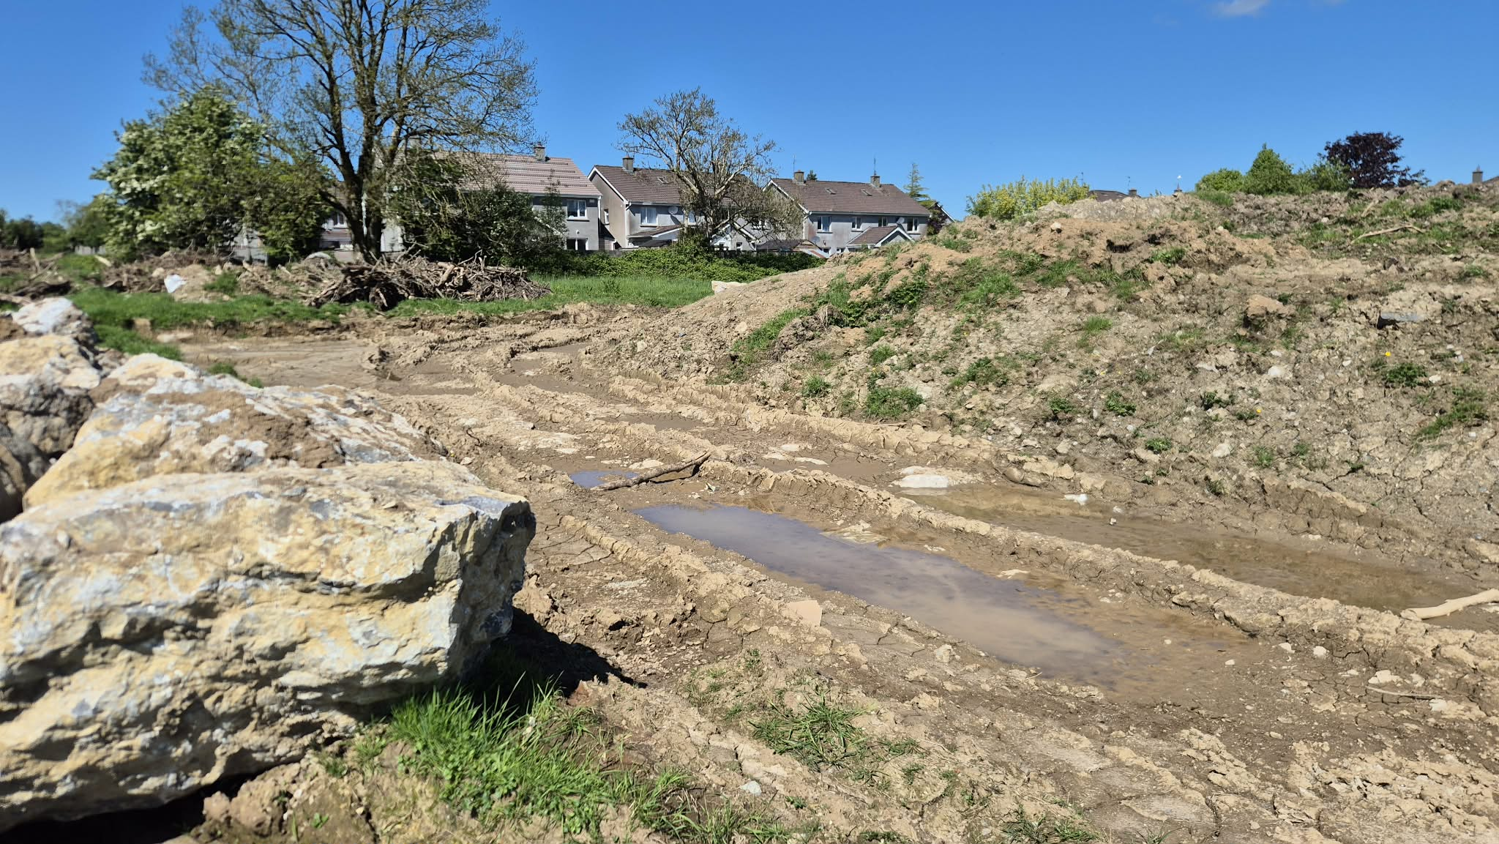
Figure 3.4: Areas of spoil and bare ground within the redline boundary

WL2 Treelines
A small treeline (Figure 3.5) comprised by mature ash trees (Fraxinus excelsior) approximately 12–15m in height is present along parts of the site boundary. Dense ivy (Hedera spp) growth was noted both within the scrub layer and climbing over mature trees.

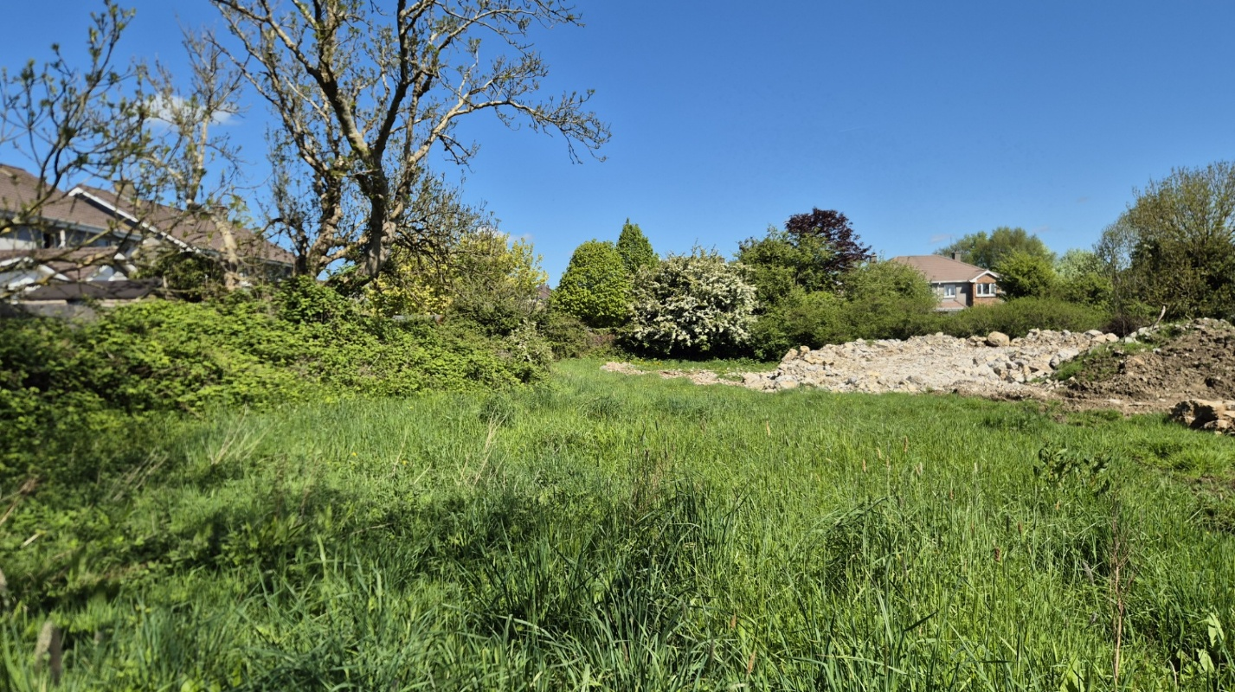
Figure 3.5: Ash tree line along the western perimeter of the field boundary

WS1 Scrub
Scrub vegetation (Figure 3.6) is well developed in places, particularly around the field edges and along the northern boundary. The scrub is dominated by bramble (Rubus fruticosus agg.) and hawthorn (Crataegus monogyna), typically reaching heights of 3–4m, with occasional blackthorn (Prunus spinosa) occurring within denser sections. Associated ground flora and climbers include nettle (Urtica dioica), bindweed (Calystegia sepium), ivy (Hedera spp), cleavers (Galium aparine), and lesser celandine (Ficaria verna).
The northern perimeter contains a particularly dense belt of scrub approximately 4m high and extending up to 10m deep in places. The scrub was dominated by blackthorn (Prunus spinosa), bramble (Rubus fruticosus agg.), nettle (Urtica dioica), broad-leaved dock (Rumex obtusifolius), cleavers (Galium aparine), ivy (Hedera spp), and hogweed (Heracleum sphondylium) beneath a treeline of ash (Fraxinus excelsior) and hawthorn (Crataegus monogyna) exceeding 5m in height.

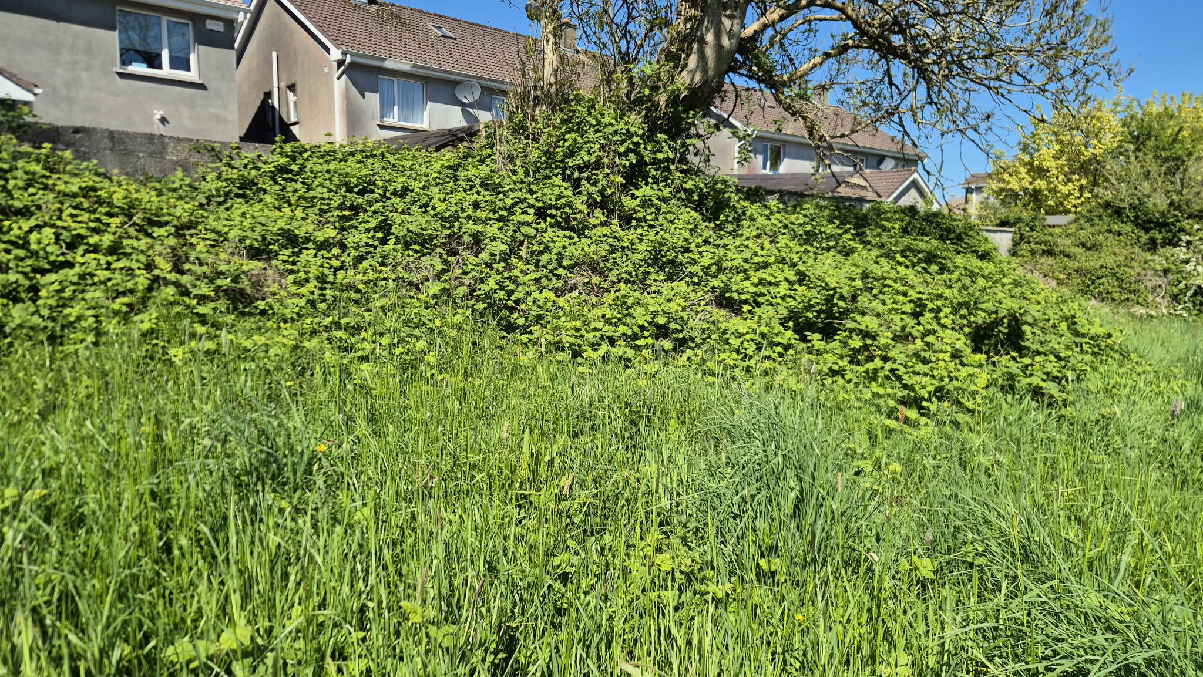
Figure 3.6: Area of scrub comprised of bramble along the western field boundary

BL1 Stone Walls and Other Stonework
The perimeter of the field contained walls demarcating the field boundary, including a small stone wall along the western perimeter and a single strand of barbed wire approximately 1.2m in height. The wall was comprised of large loose stones. Some vegetation was growing amongst the wall, including bramble (Rubus fruticosus agg.), cleavers (Galium aparine), and ivy (Hedera sp).
On the northern and some of the western perimeter a substantial breeze block brick wall approximately 2.5m high. The wall has occasional Ivy growth though the vegetation cover was largely limited.

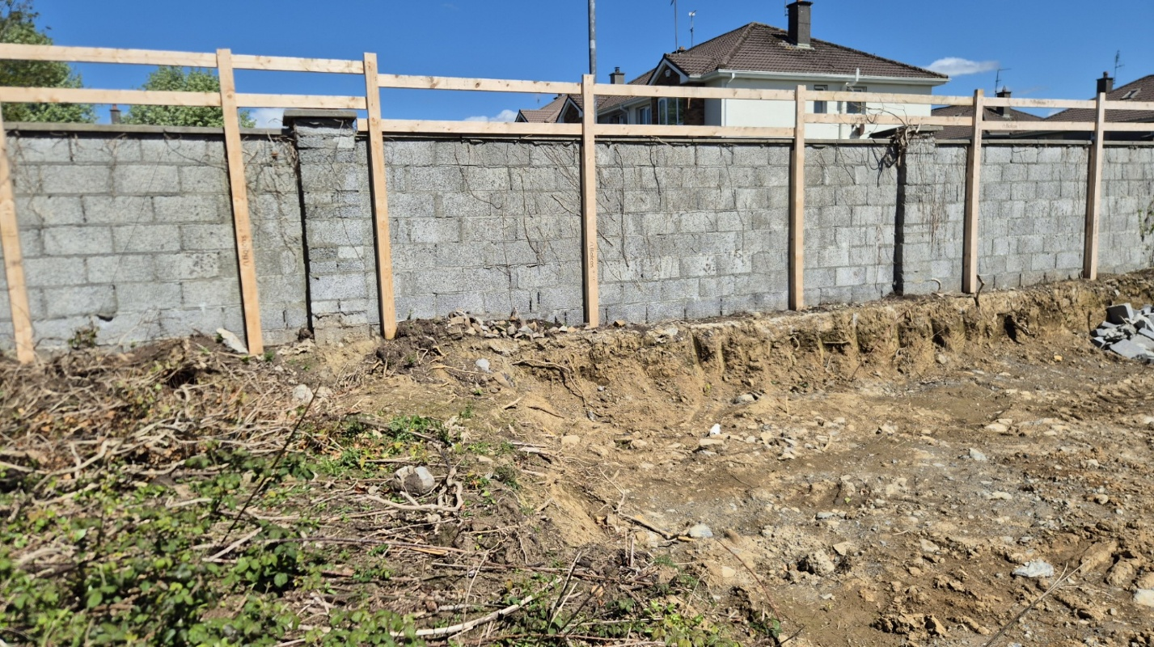 Figure 3.7: Area of exposed breezeblock wall along the northern perimeter

invasive species
No invasive alien species as listed on the Third Schedule of the European Communities (Birds and Natural Habitats) Regulations, 2011 (S.I. No. 477 of 2011) Part 1 or 2 or of Union Concern were recorded within the Project or its close environs (incorporating 7m in all directions, to allow for any Japanese knotweed root system).

screening for appropriate assessment
This AA Screening examined the likely significant effects of the Project, either alone or in-combination with other projects or plans on European Sites, that were situated within a ZoI, or a distance that has a potential source-pathway-receptor (SPR), both direct and indirect with the Project.
Seven European Sites occur within a wider 15km radius of the Project. The designated areas closest to the Project are listed below in Table 4.1, any other European sites in the area are located further than 15km from the study site.
Table 4.1: European Sites closets to the study area within the zone of influence
No. | European Sites near the study area | Distance between the Project and European Sites
SAC
1 | Lough Rea SAC (000304) | 680m
2 | Rahasane Turlough SAC (000322) | 11.6 km
3 | Sonnagh Bog SAC (001913) | 8.7 km
4 | Peterswell Turlough SAC (000318) | 12.1 km
SPA
1 | Lough Rea SPA (004134) | 680m
2 | Slieve Aughty Mountains SPA (004168) | 4.5 km
3 | Rahasane Turlough SPA (004089) | 11.7 km

EUROPEAN SITES WITHIN THE ZONE OF INFLUENCE (ZOI) OF THE PROJECT
The European Sites identified as being within the Project Zone of Influence (ZoI) using the Source Pathway Receptor (SPR) principle, will be assessed to examine the likelihood of significant effects of the Project either alone or in-combination with other plans or projects, on any European Sites.
Terrestrial
The Environmental Protection Agency (EPA) maps were used to identify European Sites that could potentially be located within the ZoI and possibly be connected to the Project site via pathways. In this instance, given the size and scale of the Project, the short-term temporary nature of the works, works will be contained within the Project site, a distance of 5km from the Project has been identified as the terrestrial ZoI for any European Site. Other European Sites with a hydrological link either upstream or downstream are considered to have a potential wider ZoI and are assessed separately in Section 4.2.
Three European sites fall within the 5km ZoI of the Project, the closest European sites to the Project are Lough Rea SAC (000304) located 520m south, Lough Rea SPA (004134) also located 520 m south, and Slieve Aughty Mountains SPA (004168) located 4.5km to the south.
These European Sites were therefore considered to occur inside of the terrestrial based ZoI.
Table 4.1: Relevant European Sites, reasons for designation and data for Screening
Designated Site | Reasons for designation (information correct as of 03rd July 2024) (*denotes a priority habitat) | Distance from Proposed Development (km) | Source-Pathway-Receptor Linkage
SPECIAL AREAS OF CONSERVATION (SACs)
Lough Rea SAC (000304) | Habitats  Hard oligo-mesotrophic waters with benthic vegetation of Chara spp. [3140]  According to this SAC’s site Conservation Objectives document (Version 1.0. Department of Culture, Heritage and the Gaeltacht, 2019) for each of the listed QIs, the Conservation Objective is to maintain or restore the favourable conservation condition of the Annex I habitat(s) and/or the Annex II species for which the SAC has been selected. | Approximately 680m south of the Proposed Development. | Construction phase  No hydrological link or SPR to any European site, therefore no significant effects anticipated.  Operation phase  No hydrological link or SPR to any European site, therefore no significant effects anticipated during the operation phase.
Sonnagh Bog SAC (001913) | Habitats  Blanket bogs (*if active) [7130]  According to this SAC’s site Conservation Objectives document (Version 1.0. Department of Culture, Heritage and the Gaeltacht, 2019), for each of the listed QIs, the Conservation Objective is to maintain or restore the favourable conservation condition of the Annex I habitat(s) and/or the Annex II species for which the SAC has been selected. | Approximately 10.2km south east of the Proposed Development. | Construction phase  No hydrological link or SPR to any European site, therefore no significant effects anticipated.  Operation phase  No hydrological link or SPR to any European site, therefore no significant effects anticipated during the operation phase.
Rahasane Turlough SAC (000322) | Habitats  Turloughs [3180}  According to this SAC’s site Conservation Objectives document (Version 1.0. Department of Culture, Heritage and the Gaeltacht, 2020), for the listed QI, the Conservation Objective is to maintain or restore the favourable conservation condition of the Annex I habitat(s) and/or the Annex II species for which the SAC has been selected. | Approximately 14.5km north west of the Proposed Development. | Construction phase  No hydrological link or SPR to any European site, therefore no significant effects anticipated.  Operation phase  No hydrological link or SPR to any European site, therefore no significant effects anticipated during the operation phase.
Peterswell Turlough Sac (000318) | Habitats  Turloughs [3180]  Rivers with muddy banks with Chenopodion rubri p.p. and Bidention p.p. vegetation [3270]  According to this SAC’s site Conservation Objectives document (Version 8.0. Department of Housing, Local Government and Heritage, 2021), for each of the listed QIs, the Conservation Objective is to maintain or restore the favourable conservation condition of the Annex I habitat(s) and/or the Annex II species for which the SAC has been selected. | Approximately 13.5km south east of the Proposed Development. | Construction phase  No hydrological link or SPR to any European site, therefore no significant effects anticipated.  Operation phase  No hydrological link or SPR to any European site, therefore no significant effects anticipated during the operation phase.
SPECIAL PROTECTION AREAS (SPAs)
Lough Rea SPA (004134) | Birds  Shoveler (Anas clypeata) [A056]  Coot (Fulica atra) [A125]  Habitats  Wetland and Waterbirds [A999]  According to this SPA’s site Conservation Objectives document (Version 1.0. Department of Department of Housing, Local Government and Heritage 2022), for each of the listed Qis and SCIs, the Conservation Objective is to maintain or restore the favourable conservation condition of the Annex I habitat(s) and/or the Annex II species for which the SPA has been selected. | Approximately 680m south of the Proposed Development. | Construction phase  No hydrological link or SPR to any European site, therefore no significant effects anticipated.  Operation phase  No hydrological link or SPR to any European site, therefore no significant effects anticipated during the operation phase.
Slieve Aughty Mountains SPA (004168) | Birds  Hen Harrier (Circus cyaneus) [A082]  Merlin (Falco columbarius) [A098]  According to this SPA’s site Conservation Objectives document (Version 1.0. Department of Housing, Local Government and Heritage, 2022), for each of the listed QIs and SCIs, the Conservation Objective is to maintain or restore the favourable conservation condition of the Annex I habitat(s) and/or the Annex II species for which the SPA has been selected. | Approximately 11.0km south of the Proposed Development. | Construction phase  No hydrological link or SPR to any European site, therefore no significant effects anticipated.  Operation phase  No hydrological link or SPR to any European site, therefore no significant effects anticipated during the operation phase.
Rahasane Turlough SPA (004089) | Birds  Whooper Swan (Cygnus cygnus) [A038]  Wigeon (Anas penelope) [A050]  Golden Plover (Pluvialis apricaria) [A140]  Black-tailed Godwit (Limosa limosa) [A156]  Greenland White-fronted Goose (Anser albifrons flavirostris) [A395]  Habitats  Wetland and Waterbirds [A999]  According to this SPA’s site Conservation Objectives document (Version 1.0. Department of Housing, Local Government and Heritage, 2023), for each of the listed QIs and SCIs, the Conservation Objective is to maintain or restore the favourable conservation condition of the Annex I habitat(s) and/or the Annex II species for which the SPA has been selected. | Approximately 14.5km north west of the Proposed Development. | Construction phase  No hydrological link or SPR to any European site, therefore no significant effects anticipated.  Operation phase  No hydrological link or SPR to any European site, therefore no significant effects anticipated during the operation phase.

Mobile Species
In relation to mobile species listed as qualifying features of European Sites, the following guidance was used to identify whether it recommends the European Site is located within the Zol of the Project:
• SPAs with mobile bird species: “Assessing connectivity with Special Protection Areas (SPAs)” (2016) guidance document was used to identify connectivity between the Project site and SPAs in the wider surrounding area (SNH, now Natural Scotland) as applicable. The Lough Rea SPA is the closest SPA at 680 m it is designated for the following species Coot (Fulica atra), Shoveler (Spatula clypeata) and its overall wetland and waterbird assemblage. These species are mobile and may use habitat in the wider landscape. It is note they have a small core foraging range of around 1km and are restricted to standing freshwater habitats. The site is outside the foraging ranges and there is no suitable habitat which occurs onsite. There for no likely interconnection with these species and the site.
The Slieve Aughty Mountains SPA (004168) 4.5km south from the proposed development has Hen Harrier (Circus cyaneus) and Merlin (Falco columbarius) as qualifying interests. Hen Harriers have a core foraging range of 2km, with maximum range of 10km. Merlins forage within a 5km range.Rahasane Turlough SPA is located 11.7km to the west from the site and is designated for Whooper Swan (Cygnus cygnus), Golden Plover (Pluvialis apricaria), Black-tailed Godwit (Limosa limosa), Greenland White-fronted Goose (Anser albifrons flavirostris), Wigeon (Mareca penelope) and its overall wetland and waterbird assemblage. Whooper swans have a foraging range of less than 5km from their night roost during the winter season. For Greenland white-fronted geese this distance is 5-8km. Golden Plovers have a core foraging range of 3km with a maximum range of 11km. There is no suitable habitat for wetland bird species on the site.
• SACs with bats as a qualifying feature are included when the Project occurs within the core sustenance zone of the qualifying bat population. No SACs occurred within a 5km radius designated for this qualifying feature. In addition, no lesser horseshoe (Rhinolophus hipposideros) bat roosts are noted with 5km radius of the site. In addition, no suitable roosts which could potentially accommodate lesser horseshoe (Rhinolophus hipposideros) bat were noted on site.
• SACs with marsh fritillary as a qualifying feature are included where suitable marsh fritillary habitat occurs within the Project site footprint and where the Project site is located within a 10km radius of a marsh fritillary population. No suitable habitat (Devil’s bit scabious) was detected during the multi-disciplinary site walkover.
• Emissions to air: the Project site will not result in perceptible emissions to air. Significant adverse air emissions to any QI are not anticipated during construction or operation.
• Light emissions: the Project site is located in a urban area. Project works will only be carried out during daylight hours for the most part (this may progress slightly, i.e. 17:30 to 18:00hrs into dusk hours in the autumn /winter/early spring). Bat species are not qualifying features of the surrounding European Sites and therefore have no impact from any lighting issue as a result of this Project during construction or operation. However, NBDC noted several bat species utilising the local area. Proposed lighting will adhere to EN13201-2015-Part 2 for public lighting standards and will also duly consider the best practice lighting standards provided in the Institute of Lighting Professionals (ILP) guidance document Guidance Note 08/18 – Bats and Artificial Lighting in the UK (2018).
• Visual emissions: The Project works were not predicted to have the potential to result in visual emissions that could generate disturbance to qualifying species of any European Sites during construction or operation.
• Human disturbance pathway: Human disturbance to a European Site can occur as an indirect impact arising as a result of land use activities generated by a project. An example of such an indirect impact is an increase in human presence and associated pressures within a European Site. The potential for a human disturbance pathway, through which a proposed development could generate activity within European Sites and result in disturbance to qualifying habitats or species is also identified as a potential pathway requiring examination. Given that the local area is a proximate to residential properties, the increase in human activity is unlikely to pose a new or combined significant effect on any qualifying interest of the nearby European Sites or any other European Site.
All European Sites were therefore considered to occur outside of the ZoI for mobile species.
Hydrology & Hydrogeology
Emissions to surface water during construction and operation: There is no direct source pathway linkage between the Proposed Development site and any Natura 2000 sites.
Emissions to groundwater during construction and operation: The groundwater flood mapping confirmed that the site is not at risk from groundwater flooding with no historic record of groundwater flooding at the Project site. The site is located within a Groundwater sensitive area (Code: IE_SH_G_0100) GWDTE-Rahasane Turlough (SAC000322). All seven designated sites identified in table 4.1 are also located within this groundwater sensitive area. The groundwater level is XX there for there is not hydrological connection to the ground water table.
All European Sites were therefore considered to occur outside of the ZoI for hydrology and hydrogeology.
In light of the above screening assessment, no significant effects have been identified between the Project and any qualifying feature of a designated European Site during either construction or operation.

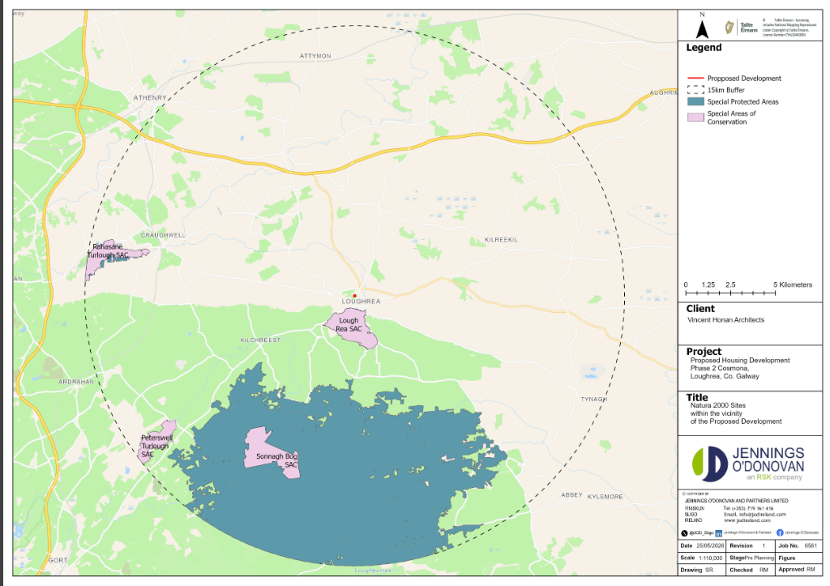
Figure 4.1: Project site showing the European SAC & SPA Sites

IN-COMBINATION EFFECTS
Planning Permission Applications
While effects on European Sites are not expected as a result of the construction and operation of the Project, the potential for cumulative effects on these designated sites due to other plans and projects acting in-combination with the Project are considered. The Galway County Council on-line planning application portal was used to search planning applications close to the Project (May, 2026). A five-year search timeframe was assessed; Retention, refused and withdrawn planning applications were excluded. Table 4.3 shows the planning applications in close proximity to the Project (circa 1Km).
Table 4.3: Planning applications in close proximity to the Project
Application Number | Development Description | Address | Decision | Application Number
211210 | of planning to include part-time childcare and afterschool use of part of Gaelscoil Riabhach National School approved under Pl/Ref. No. 15/1623. Gross floor space of work to be retained is 157 sqm. | COSMONA, | CONDITIONAL | 211210
21124 | for the construction of a sheltered public seating area and associated external works on the existing plaza at Loughrea Shopping Centre, Athenry Road and Rathruddy Road | COSMONA, | CONDITIONAL | 21124
212249 | construction of rear extension to existing dwelling house and all associated siye development works. Gross floor space of proposed works 58.8 sqm | Cuscarrick, | CONDITIONAL | 212249
21885 | for the construction of a Dwelling House and all associated site services. Gross floor space of proposed works: 128.27 sqm | Cuscarrick, | CONDITIONAL | 21885
211978 | for the amendments to the site boundary granted under planning ref.no. 18-775. Gross floor space of proposed works: 69.62 sqm | Loughrea, | CONDITIONAL | 211978
21930 | to convert an existing two storey house to 2. No Apartments with all associated services. Gross floor space of proposed works: 144 SQM | Pollroebuck, | CONDITIONAL | 21930
211788 | for the construction of a two storey and single storey office building (372 sqm) and all associated site works. Gross floor space of proposed works: 372 sqm | Cosmona , | CONDITIONAL | 211788
211616 | to demolish existing house, construction of 2 two-storey dwellings with one additional entrance and associated services (gross floor space demolition 215sqm; proposed 281sqm) | Monearmore, | UNCONDITIONAL | 211616
211988 | for (A) of existing dwelling house, domestic garden shed and associated services on a revised site with revised boundaries. (B) for extension to and conversion of attic for storage use and three ground floor windows on west elevation. Gross floor space of proposed works: 38.90 sqm. Gross floor space of work to be retained: 157.58 sqm | Caheronaun, | CONDITIONAL | 211988
212208 | for the development to existing hotel consisting of: 1. Construction of new hotel suite building adjacent to the existing Loughrea Hotel &b Spa which will form part of existing hotel complex, consisting of 18 new hotel suites, 2. Construction of new parking area adjacent to hotel, accessed from existing parking area, to provide additional parking spaces, 3. Retention permission for the demolition of derelict cottage on site, 4. To include all associated ancillary site works, services and utilities with connections to existing services on site. Gross floor space of proposed works: 541 sqm. Gross floor space of work to be retained: 93 sqm | Cosmona, | CONDITIONAL | 212208
2161 | for the change of use from medical centre to offices at Unit 5, Loughrea Shopping Centre, Athenry Road and Rathruddy Road, Loughrea, Co. Galway. Gross floor space of proposed works: 500 sqm | Cosmona Loughrea, | CONDITIONAL | 2161
21630 | to construct side and rear extensions to the existing house and a garden shed is also proposed to the rear garden. Gross floor space of proposed works: 64.5 sqm (extensions) & 24 sqm (shed) | Pollroebuck, | CONDITIONAL | 21630
21645 | for a single storey extension to the existing Museum building, opening up works involving two doors for linkage and circulation / connection to the existing building and associated external works at St Brendan's Cathedral, (a Protected Structure Reg. No. 317) Gross floor area of proposed works:86.6 sqm | Loughrea , | CONDITIONAL | 21645
21689 | to retain and complete an extension / alteration to a dwelling house under construction previously permitted 19/1602. Gross floor space of works to be retained: 10.30sqm | Cuscarrick , | CONDITIONAL | 21689
20928 | for the provision of a new exit / access door to the side of existing supermarket at Supervalu, Unit 1, Loughrea Shopping Centre, Athenry Road, Loughrea, Co. Galway. | Loughrea, | CONDITIONAL | 20928
22748 | for (1) demolition of existing derelict house (2) construction of a residential development consisting of an overall 13 no. units comprising of (a) 1 no. 4 bed detached house, (b) 4 no. 3 bed semi-detached houses & (c) 8 no. 2 bed houses in 2 blocks of 4 and all associated site works and connection to services and (3) new vehicular site access onto local road. Gross floor space of proposed works: 1292.8 sqm | Cosmona , | CONDITIONAL | 22748
23136 | for a change of use and for internal alternations to the 1st floor (405 sqm), from existing light industrial into office use, works include provision of offices, toilets and kitchen, minor elevation altercations to include the addition of 3 windows on the south end of the building on the 1st floor (5.4 sqm), addition of signage to the front and rear of the building and all related ancillary and associated site development works | Unit 2 Cottage Hill Commercial Park, Loughrea, Co. Galway | CONDITIONAL | 23136
2261256 | for a 30 metre high lattice telecommunications support structure together with antennae, dishes, associated telecommunications equipment and with ground cabinets within a fenced compound. | Cosmona, Athenry Road, Loughrea County Galway | CONDITIONAL | 2261256
22574 | to construct an extension at the front and rear of her dwelling. Gross floor space of proposed works: 58.11 sqm. | Moneamore , | CONDITIONAL | 22574
21857 | for (1) change of use of existing retail unit located on the ground floor of previously permitted building under planning reference No. 07/3052 & 08/2327 to use as Community Digital Hub, to include Café, community high speed broadband access, podcast studio, virtual conferencing rooms, event space, stage & exhibition area, digital work stations, business mentoring / training spaces, toilets and all associated storage and plant. (2) Replacement of 2 No. existing roller shutter doors located on the eastern elevation with new glazing. Gross floor space of proposed works: 610.15 sqm | Loughrea , | CONDITIONAL | 21857
22662 | for a development consisting of placement of a pay-to-use portable waste compactor for the acceptance of residual and food waste and a pay-to-use portable compactor for mixed dry recyclables. This activity requires the developers to possess a waste collection peremit/certificate of registration. Gross floor space of proposed works: 2x8sqm units. | Cosmona , | CONDITIONAL | 22662
2260644 | for Installation of solar photo-voltaic modules to topside of existing fuel Court Canopy of existing service station for the supply of electricity and all associated site development works. | Cuscarrick , | CONDITIONAL | 2260644
221261 | for the construction of a two storey and single storey office building (415 sqm) and all associated site works. | Cosmona , | CONDITIONAL | 221261
2260124 | of changes to dwellinghouse previously granted under pl. ref. no. 95/806 including the retention of the basement to a 2 bedroom apartment and all associated services. | Loughrea, | CONDITIONAL | 2260124
2260127 | construction of an extension consisting of adding a first floor to existing single storey dwelling, raising of the existing roof height, alterations to elevations, new windows to rear, new stone front boundary wall and all associated site development works. Gross floor space of proposed works 52 sqm. | Cuscarrick , | CONDITIONAL | 2260127
2261050 | for the demolition of ruinous building, construction of 3 storey building consisting of 2 no. retail units at ground floor level, 2 no. 1 bed apartments at first floor level, 2 no. 1 bed apartments at second floor level & all associated services & site development works. Gross floor space of proposed works 310.00sqm. | Loughrea , Loughrea, Co. Galway | CONDITIONAL | 2261050
2261057 | for the development consists of alterations to the existing dwelling house including the construction of a single storey extension to the rear along with associated boundary and site works. Gross floor space of proposed works 22.00 sqm. Gross floor space of work to be retained: 168.00 sqm. Gross floor space of any demolition: 9.00 sqm | Loughrea, Barrack Street, Co. Galway | CONDITIONAL | 2261057
21328 | for two storey extension & all associated services to rear of existing dwellinghouse previously granted under Pl. Ref. No. 31827, 44497 & 50116. Gross floor space of proposed works: 48.5 sqm | Pollroebuck, | CONDITIONAL | 21328
21430 | (a) the demolition of the remains of an existing building, (b) the construction of a two storey development consisting of a 2 bedroom apartment at first floor and a shop unit at ground floor. The proposed development also provides an access to the rear of the proposed building and the construction of a lean-to solid fuel store to the rear (c) and all associated site services. Gross floor space of existing building 70 sqm, proposed works 192 sqm and demolition 113 sqm | Bride Street Loughrea , | CONDITIONAL | 21430
2254 | for development at unit C & D. The development will consist of the following: 1) a change of use of existing restaurant unit to a bookmarkers office, 2) amalgamation of restaurant unit with existing adjacent bookmarkers office to form a single premises including all internal demolitions and alterations, 3) alterations to external signage to the exterior of the restaurant unit. Gross floor space of proposed works: 169.60 sqm | Cuscarrick , | CONDITIONAL | 2254
24115 | for the construction of two serviced dwelling houses and associated site works. Gross floor space of proposed works 128sqm x 2. | Loughrea, | UNCONDITIONAL | 24115
2360841 | for the development which will consist of the change of use of an existing ground floor industrial unit to residential use including the provision of 1no. 1 bedroom apartment, elevational alterations, construction of a bin storage area & all associated works. Area of proposed apartment 55 sqm | Castle Street Loughrea, Co. Galway | CONDITIONAL | 2360841
There were no other planning applications in the area at the time of writing (May 2026).
The AA Screening Assessment has shown there will be no likely significant effects to any European Site during the construction or operation of the Project. Works will be contained within the site; it is anticipated that there will be no in-combination impacts from any local planning applications.

screening assessment conclusion
It can be objectively concluded that there are no likely significant effects on any European Site as a result of the construction or operation of the Project at 12-unit residential development at Cosmona, loughrea, co. Galway Therefore, an Appropriate Assessment is not required.

references
Curtis, T.G.F. & McGough, H.N.(1988) The Irish Red Data Book 1: Vascular Plants. The Stationery Office, Dublin.
European Commission (2001) Assessment of Plans and Projects significantly affecting European Sites: Methodological guidance on the provisions of Article 6(3) and (4) of the Habitats Directive 92/43/EEC.
European Commission (2013) Interpretation manual of European Union habitats EUR 28. European Commission, DG Environment.
European Commission (2018) Managing Natura 2000 Sites: The Provisions of Article 6 of the ‘Habitats Directive’ 92/43/EEC.
European Union Birds Directive (1979) Council Directive 79/209/EEC of 2 April 1979 on the conservation of wild birds. Brussels: The Council of the European Communities.
European Union Habitats Directive (1992) Council Directives 92/43/EEC of 21 May 1992 on the conservation of natural habitats and of wild fauna and flora.
Fossitt, Julie A. (2000), ‘A Guide to Habitats in Ireland’, The Heritage Council, Kilkenny.
NPWS (2019) Conservation Objectives: Lough Rea SAC 000304. Version 1. National Parks and Wildlife Service, Department of Culture, Heritage and the Gaeltacht.
NPWS (2025) Conservation Objectives: Lough Rea SPA 004134. Version 1. National Parks and Wildlife Service, Department of Housing, Local Government and Heritage.
NPWS (2020) Conservation Objectives: Rahasane Turlough SAC 000322. Version 1. National Parks and Wildlife Service, Department of Housing, Local Government and Heritage
NPWS (2023) Conservation Objectives: Rahasane Turlough SPA 004089. Version 1. National Parks and Wildlife Service, Department of Housing, Local Government and Heritage.
NPWS (2022) Conservation Objectives: Slieve Aughty Mountains SPA 004168. Version 1. National Parks and Wildlife Service, Department of Housing, Local Government and Heritage.
NPWS (2019) Conservation Objectives: Sonnagh Bog SAC 001913. Version 1. National Parks and Wildlife Service, Department of Culture, Heritage and the Gaeltacht.
NPWS (2021) Conservation Objectives: Peterswell Turlough SAC 000318. Version 1. National Parks and Wildlife Service, Department of Housing, Local Government and Heritage
Office of the Planning Regulator (OPR) (2021). Appropriate Assessment Screening for Development Management. OPR Practice Note PN01.
Parnell, J. & Curtis, T. (2012) Webb’s An Irish Flora. Cork University Press, Cork.
Scannell, M J P and Synott, D M, 1987, Census Catalogue of the Flora of Ireland. Stationary Office, Dublin.
Scott Wilson, Levett-Therivel Sustainability Consultants, Treweek Environmental Consultants and Land Use Consultants (2006) Appropriate Assessment of Plans.
SNH, Marine Scotland Information, NatureScot https://marine.gov.scot/data-owners/naturescot-previously-snh

APPENDICES

APPENDIX I – – Flood Risk ASSESSMENT

APPENDIX II – DRAWINGS

