 |  | Finisklin Business Park,  Co. Sligo,  Ireland,  F91 RHH9 |  |  |    | +353 71 91 61416  info@jodireland.com


SCREENING FOR ENVIRONMENTAL IMPACT ASSESSMENT
6561: PROPOSED HOUSING DEVELOPMENT AT COSMONA PHASE 2, LOUGHREA, CO. GALWAY
May 2026 |  | Rev 00

DOCUMENT STATUS
Version | Purpose of document | Authored by | Reviewed by | Approved by | Review Date
00 | First issue - Draft | S. Roddy/  R. Mitchell | A. O’Grady | M. Garvey | 28/05/2026

APPROVAL FOR USE
D. Kiely |  | 28/05/2026
This document, and information or advice which it contains, is provided by JENNINGS O’DONOVAN & PARTNERS LIMITED solely for internal use and reliance by its Client in performance of JENNINGS O’DONOVAN & PARTNERS LIMITED’s duties and liabilities under its contract with the Client. Any advice, opinions, or recommendations within this document should be read and relied upon only in the context of the document as a whole. The advice and opinions in this document are based upon the information made available to JENNINGS O’DONOVAN & PARTNERS LIMITED at the date of this document and on current standards, codes, technology and construction practices as at the date of this document. Following final delivery of this document to the Client, JENNINGS O’DONOVAN & PARTNERS LIMITED will have no further obligations or duty to advise the Client on any matters, including development affecting the information or advice provided in this document. This document has been prepared by JENNINGS O’DONOVAN & PARTNERS LIMITED in their professional capacity as Consulting Engineers. The contents of the document does not, in any way, purport to include any manner of legal advice or opinion. This document is prepared in accordance with the terms and conditions of JENNINGS O’DONOVAN & PARTNERS LIMITED contract with the Client. Regard should be had to those terms and conditions when considering and/or placing any reliance on this document. Should the Client wish to release this document to a Third Party for that party's reliance, JENNINGS O’DONOVAN & PARTNERS LIMITED may, at its discretion, agree to such release provided that:
(a) JENNINGS O’DONOVAN & PARTNERS LIMITED written agreement is obtained prior to such release, and
(b) By release of the document to the Third Party, that Third Party does not acquire any rights, contractual or otherwise, whatsoever against JENNINGS O’DONOVAN & PARTNERS LIMITED and JENNINGS O’DONOVAN & PARTNERS LIMITED, accordingly, assume no duties, liabilities or obligations to that Third Party, and
(c) JENNINGS O’DONOVAN & PARTNERS LIMITED accepts no responsibility for any loss or damage incurred by the Client or for any conflict of JENNINGS O’DONOVAN & PARTNERS LIMITED’s interests arising out of the Client's release of this document to the Third Party.
PREPARED BY | PREPARED FOR
Jennings O’Donovan and Partners Ltd.  Finisklin Business Park,  Co. Sligo,  Ireland,  F91 RHH9  +353 71 91 61416  info@jodireland.com         | Galway County Council  Aras an Chontae,  Prospect Hill,  Galway.  091 509043  planning@galwaycoco.ie

table of Contents
1 INTRODUCTION 1
1.1 PURPOSE OF THIS STATEMENT 2
1.2 STATEMENT OF AUTHORITY 2
2 the proposed development and environmental sensitivities 3
2.1 the proposed development. 3
2.2 land, soils and flooding 1
2.3 biodiversity 5
2.4 air and climate 10
3 Galway county development plan 2022-2028 10
4 EIA screening 11
4.1 eu directive as amended and associated transposing regulations 11
4.2 legislative context and article 120 requirments 12
4.3 CRITERIA FOR DETERMINING WHETHER THE PROPOSED 179A HOUSING DEVELOPMENT AT COSMONA SHOULD BE SUBJECT TO AN ENVIRONMENTAL IMPACT ASSESSMENT 13
4.4 section 28 guidelines for environmental impact assessment 15
4.5 Sub threshold development and the Proposed Part 179A proposal 16
4.6 methodology 16
4.7 section 179a assessed against criteria 17
4.7.1 Characteristic of the proposed development 18
4.7.2 LOCATION OF THE PROPOSED DEVELOPMENT 32
4.7.3 CHARACTERISTIC OF POTENTIAL IMPACTS 33
4.8 INTER RELATIONSHIP WITH ABOVE FACTORS 35
5 CONCLUSION 35
6 REFERENCES 36
7 aPPENDICES 37
7.1 APPENDIX II – DRAWINGS 37

INTRODUCTION
Jennings O’Donovan & Partners Limited have been commissioned by Galway County Council to carry out an Environmental Impact Assessment Screening under (Directive 2011/92/EU), as amended by Directive 2014/52/EU under Article 6(3) for a Proposed Housing Development, consisting of 18 houses at Cosmona Phase 2, Loughrea, Co. Galway. The works hereafter in this report will be identified as ‘the Project’.
This report provides an Environmental Impact Assessment (EIA) screening for a Part 179A housing development consisting of an area of land measuring 0.65ha located at Cosmona, Loughrea, Co. Galway. The site location is shown below in Figure 1.1. The 179A measure was implemented to allow for accelerated delivery of social, affordable and cost-rental housing by local authorities by way of exemption from the local authority own development ‘Part 8’ process in the section 179 of the Planning and Development Act 2000, as amended (the Act) in strictly defined circumstances.
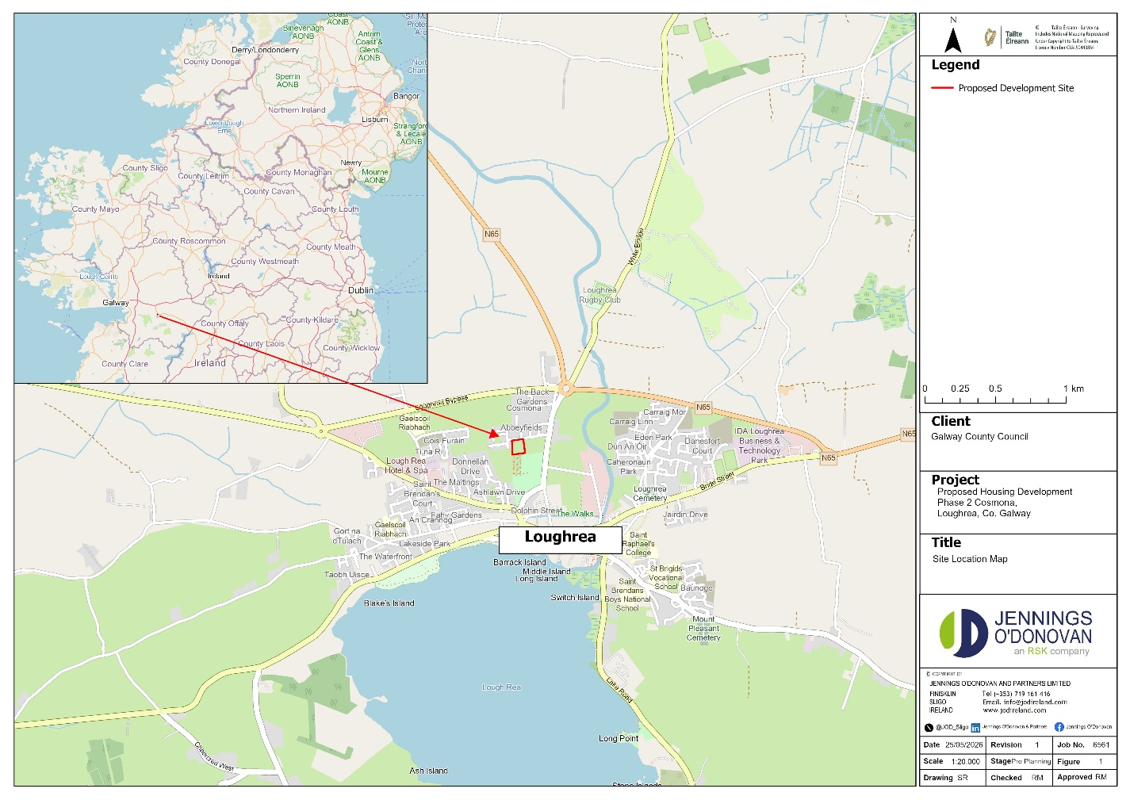
Figure 1.1: Site Location Map
The amendments to the Act and the Planning and Development Regulations 2001, as amended (the regulations) are balanced with the need to provide for the accelerated delivery of social and affordable housing while also ensuring proper planning and sustainable development by means of the introduction of a temporary time-bound exemption from the ‘Part 8’ process for the approval of local authority own development housing projects on local authority or State owned lands. This planning amendment will assist local authorities to accelerate housing delivery and is being utilised for this screening process.
This Part 179A process is being pursued by Galway County Council Housing Section.
This EIA Screening Report has been prepared to assess the potential impacts on the environment of the Project at the subject site. The full details of the scheme are as follows:
The proposal is for a residential development consisting of the construction of 18 no. new residential units. The development also includes 1,818m² of public open space.
The Project consists of 18 three-bedroom units, comprising two single-story and 16 two-story buildings. The total public open space of 28% provided is in accordance with the Urban Housing Policy.
This report is prepared with input from Jennings O’ Donovan & Partners Ltd (JOD) and Vincent Hannon Architects (VHA) so that the possible effect on the environment has been examined through the process of an EIA Screening and the most appropriate form of development delivered at this site.

PURPOSE OF THIS STATEMENT
The purpose of this EIA Screening Report is to determine whether or not an Environmental Impact Assessment Report (EIAR) is required for the Project and to identify any environmental issues that might arise. It is worth noting that this Project is below any threshold, and we do not consider an EIAR to be required.
This report is supported and informed by accompanying documentation including an Appropriate Assessment (AA) Screening Report prepared by JOD.

STATEMENT OF AUTHORITY
This EIA Screening Report has been prepared by qualified and accredited experts as follows:
Siobhán Roddy is an Environmental Scientist with a BSc. in Environmental Science and Technology from Dublin City University. Since joining JOD, she has gained extensive experience across various projects with a primary focus on the environmental sector. Siobhán’s key capabilities include the preparation of EIAR Chapters, EIA Screenings, and Construction Environmental Management Plans (CEMP), as well as the production of Appropriate Assessments (AAs), Natura Impact Statements (NIS), and Feasibility Studies. Her expertise further extends to technical GIS analysis using ArcGIS Pro, habitat mapping, and conducting field-based environmental and ecological surveys, providing a comprehensive approach to both data collection and environmental reporting.
Ryan Mitchell BSc. is an Environmental Scientist and Ecologist at Jennings O’Donovan & Partners Limited. He has a Bachelor of Science in Animal Conservation and Biodiversity from Greenwich University. His ecological experience includes Phase 1 Habitat surveys, report writing, preparing chapters for Environmental Impact Assessments, Appropriate Assessments, Natura Impact Statements and Construction Environmental Management Plans. In addition, he is an experienced Badger and Bat surveyor and carries out Preliminary Bat Roost Survey Assessment Reports and Bat Activity surveys. More recently, he has obtained a license for freshwater pearl mussel monitoring (Margaritifera margaritifera) with NWPS on a certified training course Phase 1 & Phase 2.
In addition, he is an experienced entomologist his fieldwork experience includes working with/for Buglife NI, Natural History Museum London, Oxford University and National Museums Northern Ireland. His most recent fieldwork (2024) includes conducting Common Standards Monitoring of Invertebrates for NEIA in Northern Ireland on ASSI sites, Marsh Fritillary surveys in both Northern Ireland and the Republic of Ireland. He has published 67 publications in peer reviewed journals on terrestrial invertebrates in Britain and Ireland such as added numerous species to the Irish list (20) and rediscovered a rare species of Sphaeoroceridae Minilimosina secundaria (Duda, 1918) which was thought to be extinct in Britain.
Andrew O’Grady is an environmental professional with 18 years’ experience of Environmental Impact Assessment (EIA) project management and planning compliance for wind farm, solar, mining and other power projects in a range of geographies. Mr. O’Grady has a BSc. in Geography and an MSc. in Environmental Resources Management.
David Kiely B.E., M.Sc., Eur.Ing., C.Eng., FIEI, MICE, F.RConsEI, is a Director of JOD who holds a BE in Civil Engineering from University College Dublin and MSc in Environmental Protection from IT Sligo. He is a Fellow of Engineers Ireland, a Chartered Member of the Institution of Civil Engineers (UK) and has over 40 years’ experience. He has extensive experience in the preparation of EIARs and EISs for environmental projects including Wind Farms, Solar Farms, Wastewater Projects, and various commercial developments.

the proposed development and environmental sensitivities

the proposed development.
Project Overview and Density
The Project at Cosmona Phase 2, Loughrea, Co. Galway consists of 18 two storey three-bedroom residential units on a site area of approximately 0.65ha and site development works. The housing mix is comprised of:
- Two 3-bedroom, single-story units (Type 3B 1S), each with an area of 92.8m².
- 16 3-bedroom, two-story units (Type 3B 2S), each with an area of 104m².
These are shown in Appendix 7.1: Drawings.
Site Context and Boundaries
The application site is a greenfield area located immediately west of Phase 1, which is currently under construction. The boundaries are defined as follows:
- Eastern Boundary: Adjoins Phase 1, providing primary vehicular and pedestrian access.
- Southern Boundary: Features an existing 2.6m high natural stone wall bordering a graveyard and associated car parking; this wall is to be retained.
- Western Boundary: Comprises existing concrete blockwork boundary walls to be retained, supplemented by new concrete blockwork boundary walls to be constructed.
Open Space and Amenity
The development provides both public and private open space in accordance with the Galway County Development Plan 2022-2028:
- Public Open Space: The design provides 1,818m² of public open space.
- Private Open Space: Dwellings are provided with rear gardens with a minimum depth of 11m, ensuring a 22m back-to-back distance between houses to maintain residential privacy.
Materials and Infrastructure
The Project utilises high-quality finishes including select grey slate/tile pitched roofs and select brick finish (Country Manor or equivalent). Access and drainage will be fully integrated with the infrastructure established in Phase 1.
Construction Management
The construction period is estimated at 12 months. To promote sustainability and minimise heavy vehicle movements, all suitable excavated soil will be re-used on-site for landscaping and site levelling.

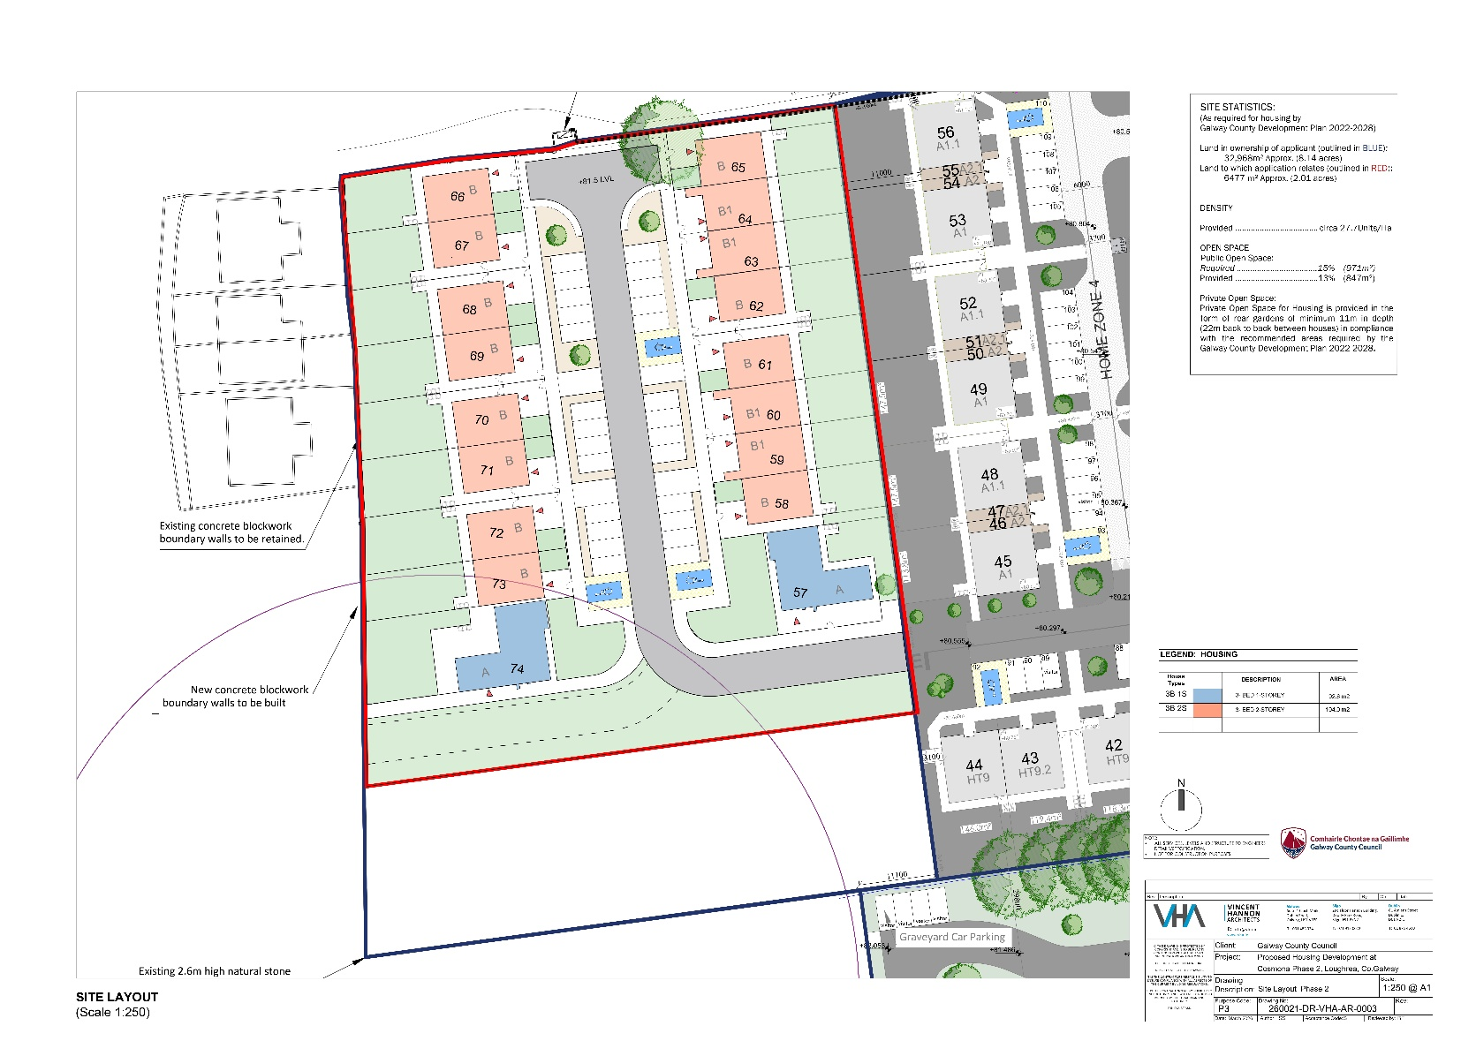

Figure 2.1: Site Plan for the new housing development at Cosmona, Loughrea Co. Galway

land, soils and flooding
The quaternary sediments at the site of the Project are classified as ‘Till derived from limestones.
The Project is located entirely within Waulsortian Limestones. This bedrock formation is described by the Geological Survey of Ireland as a ‘Massive unbedded lime-mudstone’.
The bedrock indicated is a locally important aquifer, (LI), with one spring / well drawing from within the vicinity of the site. The groundwater vulnerability was determined to be moderate to high. The EPA Maps indicate that the subsoil onsite is characterised as tills (diamictons). The soil type found onsite is classified as Mullabane, a well-drained mineral soil that belongs to the brown earths, the texture is ‘coarse loamy drift with limestones’. Corine 2018 denotes the project area as pastures.
The Project is located within the Water Framework Directive (WFD) wider catchment area of Galway Bay South East covering an area of 1,267.9km² and is located within the Kilcolgan_SC_010 WFD sub catchment (149.86km²).
The site overlies bedrock which is classified as a ‘Locally Important Aquifer - Bedrock which is Moderately Productive only in Local Zones’. The groundwater vulnerability of the site is classified as both moderate ‘M’ and high ‘H’. The Groundwater Dependent Terrestrial Ecosystems (GWDTE) Rahasane Turlough Ground waterbody which underlies the Project site currently has a water classification of ‘Good’.
The nearest watercourse is the order 2 Kilcogan River (Segment Code: 29_513) which lies approximately 440m east of the Project (Figure 2.2). The Kilcogan River flows in a westerly direction for approximately 35km before entering Galway Bay, part of Galway Bay Complex Special Area of Conservation (SAC) and Inner Galway Bay Special Protection Area (SPA). The River subsequently discharges into the Atlantic Ocean.

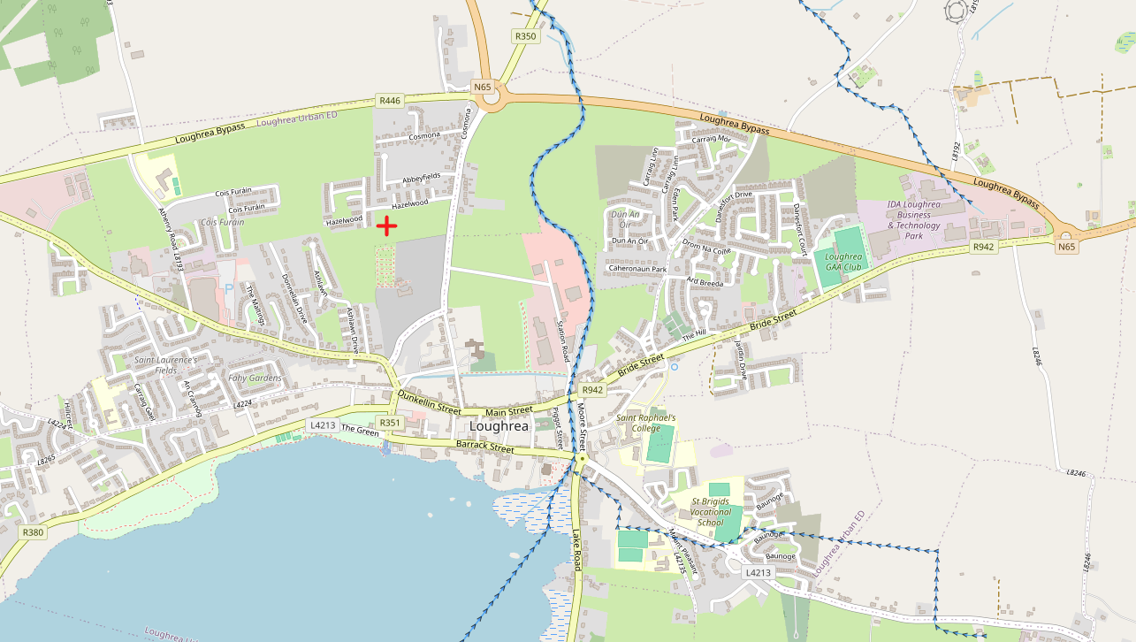
Lough Rea
Project Site
Kilcogan (Segment Code: 29_513)

Figure 2.2: EPA watercourses and waterbodies in the vicinity of the Project
The nearest downstream river monitoring station is White Mill N. of Loughrea (Station Code: RS29K010100). A Q-value of 3, corresponding to ‘poor’ water quality, was assigned in 2000.
Currently, the groundwater in the area has significant underlying pressures from agriculture and domestic wastewater (EPA Water Maps, accessed May 2026). The Project is within the Rahasane Turlough groundwater body for the abstraction of drinking water (Article 7- EPA Code IEPA1_WE_G_0100). The WFD latest status for the Rahasane Turlough GWB (2016-2021) is ‘Good’, indicating no change from the previous 2013-2018 and 2010-2015 records held. The site is not within a GSI public or group water scheme source protection area. The Project is within the Rahasane Turlough groundwater body for the abstraction of drinking water (Article 7- EPA code IEPA1_WE_G_0100).
The EPA Maps (Water) website was also accessed (May 2026) to examine the Project area and its environs for nitrate and phosphorus loading and Pollutant Impact Potential (PIP). PIP maps for Nitrogen (N) and Phosphorus (P) have been generated by the EPA to show the highest risk areas in the landscape for losses of N and P to waters. The PIP model estimates the annual nutrient losses from agricultural land at specific locations, using spatial data from farm management, soils and hydrogeology.
This model estimates loads at an annual temporal resolution.
The Project and immediate surrounding lands have a Phosphorus ranking of between 4 and 7 (7 is the lowest impact ranking). Pollution Impact Potential Nitrate (PIP N) for the lands within and surrounding the Project have a ranking of 7. The nature of the Project will generate a demand for water, but this is for residential use and is not considered significant. Adherence to best practice Construction and Environmental Management during the construction phase will see that the Project would not result in pollution of groundwater or any surface water. The lack of an overall ranking for these parameters likely reflects little fertiliser use on the Project land in the past, with low level or no stock. Overall, the Critical Source Areas Maps for the Project and adjacent lands do not indicate a site where either phosphorus or nitrates are a significant issue.
A Flood Risk Assessment Report (FRA) has been prepared by Jennings O’Donovan & Partners Limited for Galway County Council to assess the flood risk associated with the Project. The report was prepared in accordance with the report ’The Planning System and Flood Risk Management - Guidelines for Planning Authorities’ issued by the Department of Environment, Heritage and Local Government in November 2009.
Management of surface water for the Project has been designed to comply with the policies and guidelines outlined in the Greater Dublin Strategic Drainage Study (GDSDS) and with the requirements of the Galway County Council.
It is also noted that all wastewater will be pumped to an existing public sewer and will discharge into the public network at the south of the site. All sewer works will be designed and constructed in accordance with the following:
- Irish Water Code of practice for wastewater infrastructure, connections and developer services, design and construction requirements for self-lay developments July 2020 (revision 2), IW-CDS-5030-03.
- Irish Water Wastewater infrastructure standard details, connections and developer services, construction requirements for self-lay developments; July 2020 (revision 04), IW-CDS-5030-01.
In line with the Codes of Practice outlined above, it is considered that the Project will provide appropriate treatment of collected run-off, incorporate a SuDS treatment train approach, and present a low risk of pollutant release. The SuDS principles that influence the planning and design process, enabling SuDS to mimic natural drainage, are as follows:
- Storing runoff and releasing it slowly (attenuation);
- Harvesting and using rain close to where it falls;
- Allowing water to soak into the ground (infiltration);
- Slowly transporting (conveying) water across the surface;
- Filtering out pollutants; and
- Allowing sediments to settle by controlling water flow.
The proposed drainage scheme incorporates several of the above principles through the following measures:
- A proposed attenuation tank to store runoff and release it slowly to the upgraded culvert;
- Provision of public open space and green areas to allow rainfall to naturally infiltrate the ground;
- Strategic placement of gullies to maintain gentle road gradients and facilitate slow surface water conveyance; and
- Installation of a Class 1 petrol/oil interceptor to remove pollutants from the drainage system.
Groundwater will be pumped from excavations, as necessary, to facilitate the construction of foundations and rising walls. The volume of water to be pumped is expected to be limited and will not significantly impact the groundwater table. Pumps will remain operational until concrete has adequately cured. Appropriate site control measures will be implemented to see that hydrocarbons and chemicals do not enter groundwater or surface water, in accordance with best practice guidance, including the “Guidelines on Protection of Fisheries During Construction Works in and Adjacent to Waters” (IFI, 2016). Spill kits will be maintained on-site at all times, and personnel will be trained in their proper use.
The Catchment Flood Risk Assessment and Management (CFRAM) mapping predicts that fluvial flooding will not occur within the Project site for all modelled flood Annual Exceedance Probability (AEP) events. Therefore, the Project site is in Flood Zone C, as referenced in the Office of Public Works (OPW) Planning Systems and Flood Risk Management Guidelines for Planning Authorities and is considered to not be at risk of fluvial and tidal flooding.
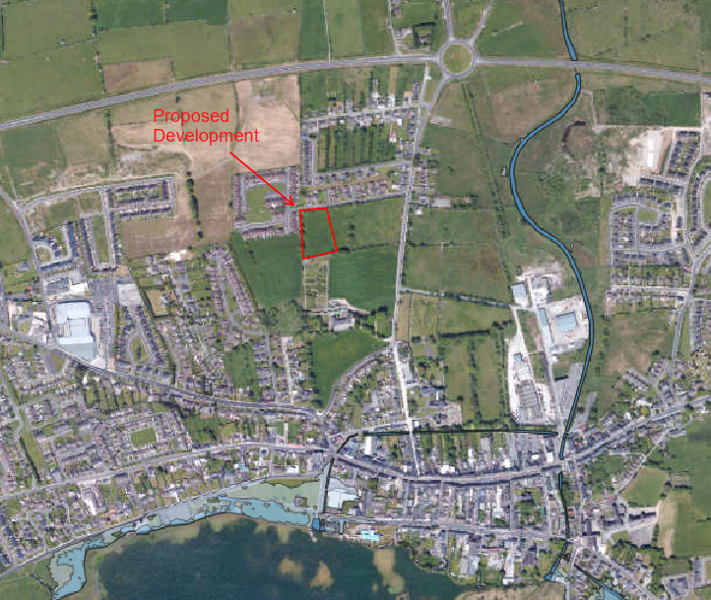
Figure 2.3: Flood Map for the Proposed Site (Source: FloodInfo.ie, 2026)
The Geological Survey of Ireland (GSI) Groundwater Flooding Probability Maps were also examined (May, 2026) to determine if there was an existing risk from groundwater flooding at the site. The groundwater flood mapping confirmed that the site is not at risk from groundwater flooding. In addition, there is no risk of tidal or pluvial flooding at this site.
As part of the Project design, groundwater will be pumped out of excavations (as necessary) to permit the construction of foundations and rising walls. The quantity of water which will be pumped out will be limited and is not expected to noticeably lower the groundwater table. Standard procedure includes keeping the pumps active until the concrete has cured. Site control measures will be in place to provide that hydrocarbons and chemicals are kept away from groundwater and surface water in line with best practice guidance including “Guidelines on protection of fisheries during construction works in and adjacent to waters, IFI 2016”. Spill kits are onsite at all times, alongside personnel trained in their use.

biodiversity
A site visit was carried out on May 6th, 2026, the weather was sunny and clear sky and the temperature was around 11 degrees Celsius. The survey consisted of traversing the entire Project site being conscious of any invasive species either overhanging the Project or rooted near/within the site.
Five habitats (according to Fossitt, 2000) were noted in the survey area, namely GS2: Dry Meadows and Grassy Verges, WL1: Tree line, WS1 Scrub, BL1 Stone Walls and Other Stonework and ED2 Spoil and Bare Ground. No Annex I habitat occurs within or adjacent to the Project.
No rare, threatened, or protected species of plants as per the Red Data Book (Curtis and McGough, 1988) were found. No species listed in the Flora Protection Order (2022) were found to be growing within or adjacent to the Project works.
GS2: Dry Meadows and Grassy Verges
The survey area consists of a large open field supporting predominantly semi-improved dry grassland vegetation (Figure 2.4) with areas of local disturbance and scrub encroachment. The site was previously inspected in 2023 and was confirmed at that time to comprise a continuation of the same grassy meadow habitat present across the wider area, characterised by relatively limited species diversity. Review of aerial imagery also confirms that this habitat was present prior to the construction of Phase 1 of the housing development, indicating that the site historically formed part of a larger continuous grassland field system. More recently, sections of the site have been subject to disturbance associated with the adjacent development works, including the temporary storage of topsoil within parts of the field.The southern portion of the site retains characteristics of a species-poor to moderately species-rich meadow, with a grass sward dominated by foxtail and sweet vernal grass. The grassland structure is variable across the site, with some sections appearing relatively intact while others show signs of disturbance, approximately 30% of the original grassland habitat remains in comparatively intact condition, while the remainder has become fragmented by Rubble and earth piles associated with the construction works of Phase 1. The herbaceous layer is composed of a mixture of meadow and ruderal species. Recorded flora include meadowsweet, cuckoo flower (Cardamine pratensis), creeping buttercup (Ranunculus repens), meadow buttercup (Ranunculus acris), common dock (Rumex obtusifolius), broad-leaved dock (Rumex obtusifolius), curly dock (Rumex crispus), creeping thistle (Cirsium arvense and hogweed (Heracleum sphondylium).
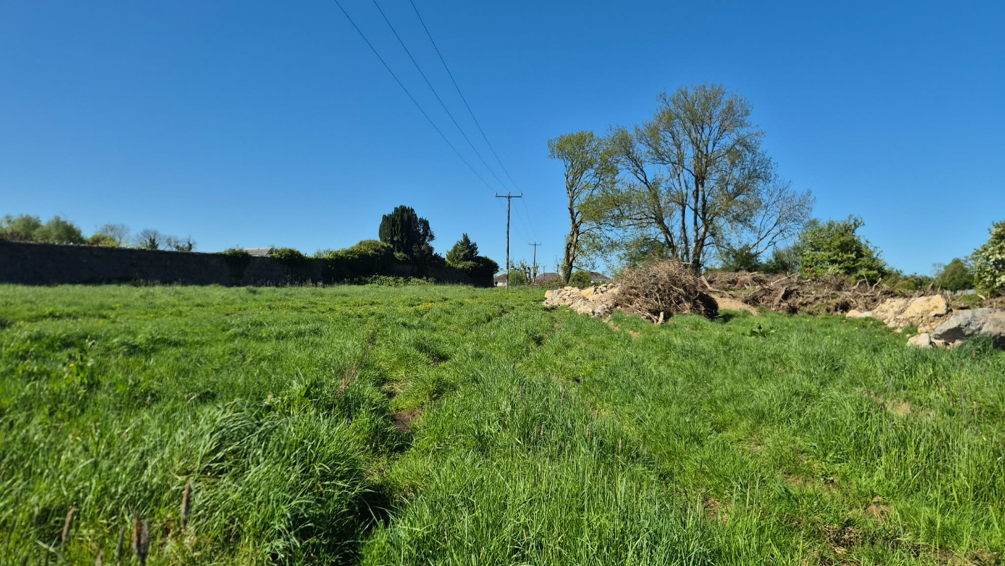Figure 2.4: The field meadow habitat located at Phase 2 some rubble and brash in the background of the image

ED2 Spoil and Bare Ground
The rubble and earth piles (Figure 2.5) between approximately 2–4m in height are distributed across parts of the field and appear to result from previous site disturbance or clearance activity. These features support early successional vegetation and patches of exposed substrate. Species recorded in the disturbed areas include silverweed (Argentina anserina), hairy bitter-cress (Cardamine hirsuta), eyebright (Euphrasia spp.) and ribwort plantain (Plantago lanceolata).

The exposed ground and loose substrate create additional microhabitats which may be of value to invertebrates, particularly ground-dwelling species. Two solitary bee species were noted onsite: Andrena scotica and Nomada marshamella, both of which are common species. No noticeable large aggregations of mining bee nests were recorded during the site inspection, and weather conditions were particularly favourable for observing invertebrate activity onsite.

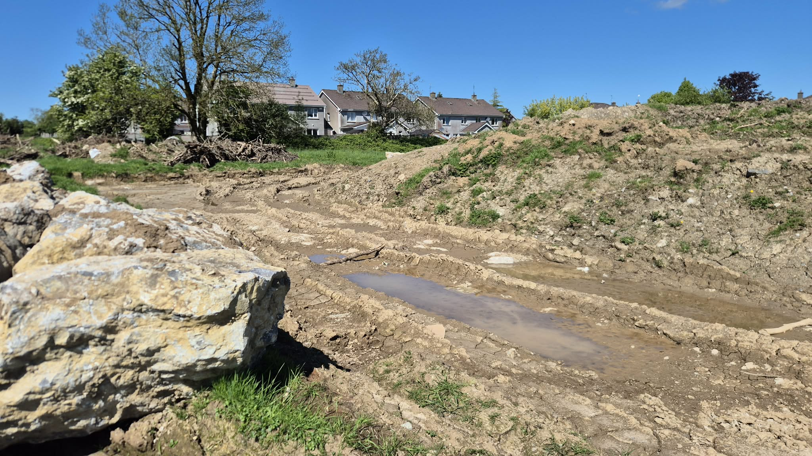
Figure 2.5: Areas of spoil and bare ground within the site boundary

WL2 Treelines
A small treeline (Figure 3.5) comprised by mature ash trees (Fraxinus excelsior) approximately 12–15m in height is present along parts of the site boundary. Dense ivy (Hedera spp) growth was noted both within the scrub layer and climbing over mature trees.

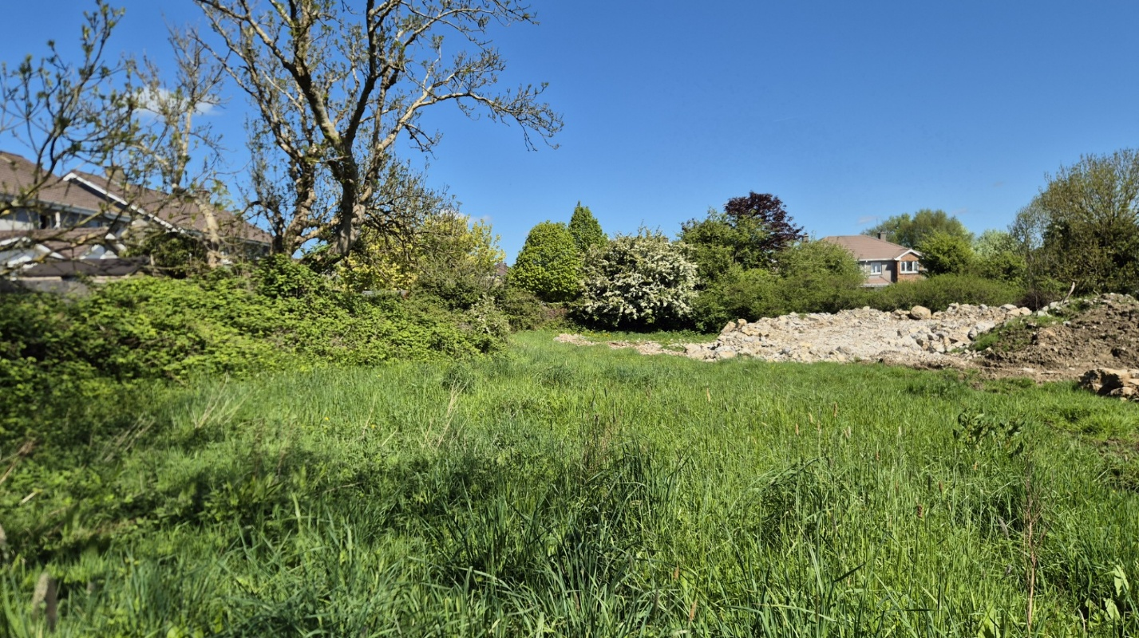
Figure 2.6: Ash tree line along the western perimeter of the field boundary

WS1 Scrub
Scrub vegetation (Figure 2.7) is well developed in places, particularly around the field edges and along the northern boundary. The scrub is dominated by bramble (Rubus fruticosus agg.) and hawthorn (Crataegus monogyna), typically reaching heights of 3–4m, with occasional blackthorn (Prunus spinosa) occurring within denser sections. Associated ground flora and climbers include nettle (Urtica dioica), bindweed (Calystegia sepium), ivy (Hedera spp), cleavers (Galium aparine), and lesser celandine (Ficaria verna).

The northern perimeter contains a particularly dense belt of scrub approximately 4m high and extending up to 10m deep in places. The scrub was dominated by blackthorn (Prunus spinosa), bramble (Rubus fruticosus agg.), nettle (Urtica dioica), broad-leaved dock (Rumex obtusifolius), cleavers (Galium aparine), ivy (Hedera spp), and hogweed (Heracleum sphondylium) beneath a treeline of ash (Fraxinus excelsior) and hawthorn (Crataegus monogyna) exceeding 5m in height.

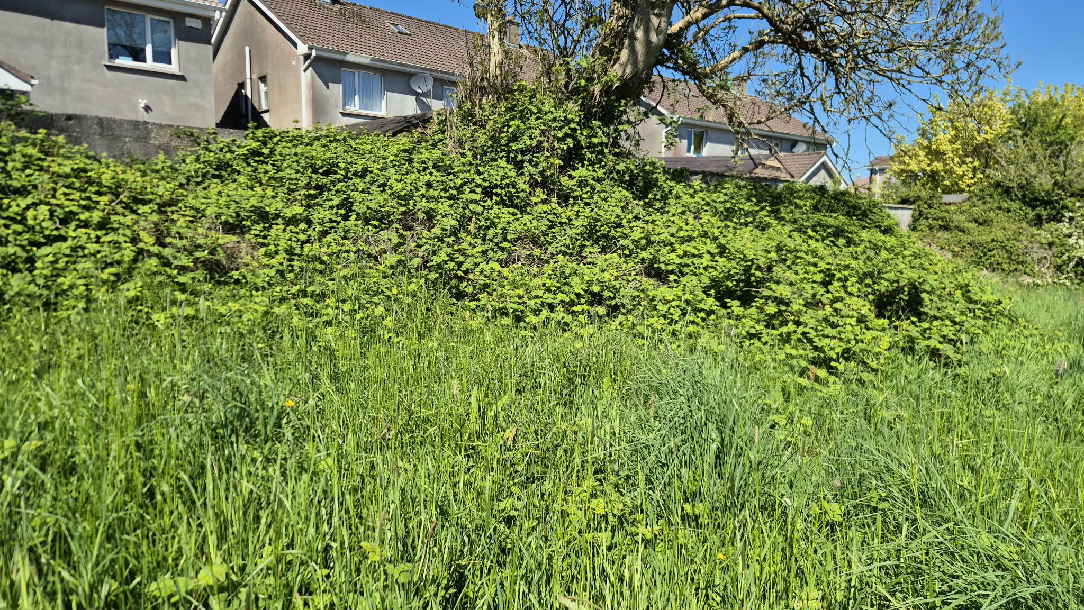
Figure 2.7: Area of scrub comprised of bramble along the western field boundary

BL1 Stone Walls and Other Stonework
The perimeter of the field contained walls demarcating the field boundary, including a small stone wall along the western perimeter and a single strand of barbed wire approximately 1.2m in height. The wall was comprised of large loose stones. Some vegetation was growing amongst the wall, including bramble (Rubus fruticosus agg.), cleavers (Galium aparine), and ivy (Hedera sp).

On the northern and some of the western perimeter there is a substantial breeze block brick wall approximately 2.5m high. The wall has occasional Ivy growth, though the vegetation cover was largely limited.

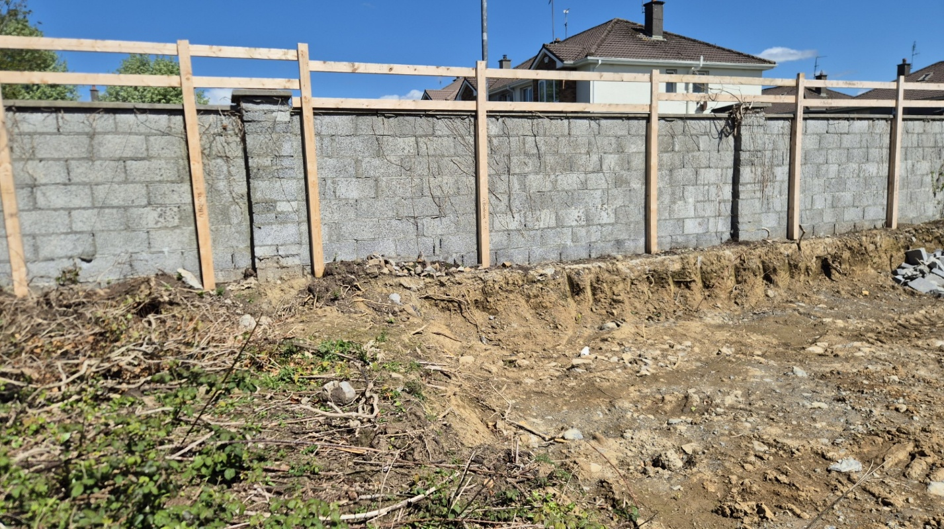 Figure 2.8: Area of exposed breezeblock wall along the northern perimeter
Invasive Species
No invasive alien species as listed on the Third Schedule of the European Communities (Birds and Natural Habitats) Regulations, 2011 (S.I. No. 477 of 2011) Part 1 or 2 or of Union Concern were recorded within the Project or its close environs (incorporating 7m in all directions, to allow for any Japanese knotweed root system).

air and climate
The EPA designate the area as Air Zone D: Rural Ireland. County Galway has one air quality monitoring station located in Galway City (53.2740 °N, -9.0485 °E). Particulate matter (PM10 and PM2.5) and nitrogen oxide are measured at the Galway city station. The monitoring station is located at Eyre Square, Galway.
In relation to the Project, the monitoring station is located approx. 45km west.
The EPA Air Quality site was accessed on 14th May 2026 and the following ratings noted:
1. The latest recording at Galway City air monitoring station 105. Eyre Square, Galway had an Air Quality Index for Health (AQIH) of 1 (Good) with latest PM2.5 average of 8.49 µg/m³, PM10 of 16.2 µg/m³ and NO2 of 15.9 µg/m³.
There is no significant impact on air pollution expected from the Project outside of potential temporary dust impact. Air and Climate are not likely to be significantly affected by the Project.

Galway county development plan 2022-2028
The Galway County Development Plan 2022–2028 has been consulted as the current statutory development plan for the county. Under this plan, Loughrea is identified as a Key Town within the County Settlement Hierarchy. Key Towns are defined as significant population centres that act as vital drivers for housing provision, service delivery, and sustainable regional growth. The county continues to experience significant housing demand, and this development at Cosmona (Phase 2) is designed to meet these needs on appropriately zoned and serviced land.
The Galway County Development Plan 2022–2028 sets out the Housing Strategy policies and objectives that guide the sustainable delivery of housing across the county, including:
Strategic Housing Policies
It is the policy of Galway County Council to:
- PWS 1 (Settlement Hierarchy): Support the development of Loughrea as a Key Town, ensuring it remains a focus for population and employment growth through the delivery of high-quality residential environments.
- H 1 (Housing Supply): Facilitate the sustainable delivery of housing in accordance with the Core Strategy and the Housing Strategy to meet the projected requirements of the county.
- H 3 (Social and Affordable Housing): Ensure the implementation of Part V of the Planning and Development Act 2000 (as amended), providing social and affordable housing as a core component of residential schemes to foster inclusive communities.
Strategic Housing Objectives
It is an objective of Galway County Council to:
- HS 1 (Housing Strategy): Implement the provisions of the Galway County Housing Strategy and Research Observatory 2022–2028.
- HS 2 (Universal Design): Promote inclusive housing by ensuring that new developments, such as the single-story and two-story units proposed at Cosmona, are designed to be accessible and adaptable for all members of society, including older persons and people with disabilities.
- HS 4 (Residential Density): Achieve sustainable residential densities in Key Towns; the proposed density of 27.7 units per hectare at this site aligns with the goal of compact, efficient land use on serviced suburban lands.
- HS 5 (Open Space Standards): Ensure the provision of high-quality public and private open space; this scheme provides 847m² of public open space and private rear gardens with a minimum depth of 11m to meet regional amenity standards.

EIA screening

eu directive as amended and associated transposing regulations
The primary objective of the EIA Directives is to ensure that projects which are likely to have significant effects on the environment are subject to an assessment of their likely effects.
Directive 2014/52/EU amending Directive 2011/92/EU on the assessment of the effects of certain public and private projects on the environment came into effect on May 16th, 2017.
The European Union (Planning and Development) (Environmental Impact Assessment) Regulations 2018 (S.I. No. 296 of 2018) transpose the requirements of Directive 2014/52/EU, amending previous Directive 2011/52/EU, on the assessment of the effects of certain public and private projects on the environment (the EIA Directive) into planning law with effect from 1st September 2018. The regulations amend the Planning and Development Regulations 2001.
Directive 2014/52/EU does not make any amendments to the list of projects set out in the two annexes to the 2011 Directive. In the Irish legislation, Annexes I and II are broadly transposed by way of the Planning and Development Regulations 2001, as amended, in Schedule 5 Parts 1 and 2, with national thresholds added to certain Part 2 classes of development.
Schedule 5 Part 1 projects require EIA if the stated threshold set therein has been met or exceeded or where no thresholds are set.
Schedule 5 Part 2 projects meeting or exceeding national thresholds set out therein, or where no thresholds are set, require EIA.
Schedule 5 Part 2 Sub-threshold projects require screening for EIA, except in cases where the likelihood of significant effects can be readily excluded.
The new Annex II A, is transposed into the Planning and Development Regulations 2001 as amended by the insertion of schedule 7A – “information to be provided by the applicant or developer for the purposes of screening sub-threshold development for environmental impact assessment.”
Art 92 of the Planning and Development Regulations 2001 as amended provides that;
“sub-threshold development” means development of a type set out in Part 2 of Schedule 5 which does not equal or exceed, as the case may be, a quantity, area or other limit specified in that Schedule in respect of the relevant class of development”.

legislative context and article 120 requirments
The Planning and Development Regulations 2001–2025 (as amended) provide the statutory framework for Environmental Impact Assessment (EIA) Screening in Ireland. The current version of the regulations incorporates all updates up to the most recent Unofficial Consolidation (January 2026).
The primary mechanism for local authority sub-threshold EIA screening is set out under Article 120 of the Regulations (as amended by S.I. No. 296/2018 — European Union (Planning and Development) (Environmental Impact Assessment) Regulations 2018).
Article 120(1)(a) dictates that:
"Where a local authority proposes to carry out a subthreshold development, the authority shall carry out a preliminary examination of, at the least, the nature, size or location of the development."
Article 120(1)(b) further states that where the local authority concludes, based on such a preliminary examination, that:
- (i) There is no real likelihood of significant effects on the environment arising from the proposed development, it shall conclude that an EIA is not required;
- (ii) There is significant and realistic doubt in regard to the likelihood of significant effects on the environment arising from the proposed development, it shall prepare, or cause to be prepared, the information specified in Schedule 7A for the purposes of a screening determination; or
- (iii) There is a real likelihood of significant effects on the environment arising from the proposed development, it shall conclude that the development would be likely to have such effects and prepare, or cause to be prepared, an Environmental Impact Assessment Report (EIAR) in respect of the development.
Accordingly, the requirement to submit Schedule 7A information is triggered if a preliminary examination leaves significant and realistic doubt regarding environmental impacts.
Article 120(1B) clarifies that where the local authority prepares Schedule 7A information, it shall be accompanied by any further relevant information, and may include a description of any features or mitigation measures envisaged to avoid or prevent what might otherwise be significant adverse environmental effects.
Finally, the Regulations dictate that any person who considers that a local authority's proposed development would be likely to have significant environmental effects may apply directly to An Bord Pleanála (now An Comisiún Pleanála (ACP)) for a formal screening determination. This application must be submitted within 4 weeks beginning on the date of publication of the site notice.

CRITERIA FOR DETERMINING WHETHER THE PROPOSED 179A HOUSING DEVELOPMENT AT COSMONA SHOULD BE SUBJECT TO AN ENVIRONMENTAL IMPACT ASSESSMENT
The proposed residential development at Cosmona, Loughrea, Co. Galway is consistent with the statutory planning framework for the area. It does not contravene the policies, objectives, or Core Strategy of the Galway County Development Plan 2022–2028, nor does it conflict with the local housing strategy or the site's residential zoning status.
All local authority housing development projects seeking to utilise the planning exemption under Section 179A of the Planning and Development Act 2000 (as amended) must satisfy strict environmental criteria. Specifically, the Section 179A exemption does not apply to any development that requires a mandatory Environmental Impact Assessment (EIA) or an Appropriate Assessment (AA).

Consequently, to legally progress under the Section 179A framework, the sub-threshold development must be rigorously screened for both EIA and AA in accordance with the precautionary principle, demonstrating that there is no real likelihood of significant effects on the environment or any European (Natura 2000) site.
Schedule 7 Screening Criteria

In accordance with the Planning and Development Regulations 2001–2025 (as amended), Schedule 7 specifies the criteria for determining whether a development should be subject to an EIA.
The three core areas of assessment are detailed below:
1. Characteristics of the Proposed Development
The characteristics of the proposed development must be considered, having particular regard to:
(a) The size and design of the whole of the proposed development;
(b) Cumulation with other existing development and/or development the subject of a consent for proposed development for the purposes of Section 172(1A)(b) of the Act and/or development the subject of any development consent for the purposes of the Environmental Impact Assessment Directive by or under any other enactment;
(c) The nature of any associated demolition works;
(d) The use of natural resources, in particular land, soil, water, and biodiversity;
(e) The production of waste;
(f) Pollution and nuisances;
(g) The risk of major accidents and/or disasters which are relevant to the project concerned, including those caused by climate change, in accordance with scientific knowledge; and
(h) The risks to human health (for example, due to water contamination or air pollution).
2. Location of the Proposed Development
The environmental sensitivity of geographical areas likely to be affected by the proposed development must be considered, with particular regard to:
(a) The existing and approved land use;
(b) The relative abundance, availability, quality, and regenerative capacity of natural resources (including soil, land, water, and biodiversity) in the area and its underground;
(c) The absorption capacity of the natural environment, paying particular attention to the following areas:
  - (i) Wetlands, riparian areas, river mouths;
  - (ii) Coastal zones and the marine environment;
  - (iii) Mountain and forest areas;
  - (iv) Nature reserves and parks;
  - (v) Areas classified or protected under legislation, including Natura 2000 areas designated pursuant to the Habitats Directive and the Birds Directive;
  - (vi) Areas in which there has already been a failure to meet the environmental quality standards laid down in legislation of the European Union and relevant to the project, or in which it is considered that there is such a failure;
  - (vii) Densely populated areas;
  - (viii) Landscapes and sites of historical, cultural, or archaeological significance.
3. Types and Characteristics of Potential Impacts
The likely significant effects on the environment of the proposed development must be considered in relation to criteria set out under paragraphs 1 and 2, with regard to the impact of the project on the factors specified in paragraph (b)(i)(I) to (V) of the definition of an ‘Environmental Impact Assessment Report’ in Section 171A of the Act, taking into account:
(a) The magnitude and spatial extent of the impact (for example, geographical area and size of the population likely to be affected);
(b) The nature of the impact;
(c) The transboundary nature of the impact;
(d) The intensity and complexity of the impact;
(e) The probability of the impact;
(f) The expected onset, duration, frequency, and reversibility of the impact;
(g) The cumulation of the impact with the impact of other existing and/or proposed development; and
(h) The possibility of effectively reducing the impact.

section 28 guidelines for environmental impact assessment
The Guidelines for Planning Authorities and An Bord Pleanála on carrying out Environmental Impact Assessment (August 2018) were issued under Section 28 of the Planning and Development Act 2000 (as amended). These guidelines replaced the previous 2013 edition, and planning authorities are statutory bound to have regard to them when performing their planning functions.
The Guidelines provide the following key definitions essential to the screening process:
- Screening: The process of determining if a development of a class prescribed in Part 2 of Schedule 5 to the Regulations—which does not equal or exceed a specified threshold—is likely to have significant effects on the environment and should be subjected to a mandatory EIA.
- Source–Pathway–Target Model: A conceptual model used to identify the source of likely significant impacts, the environmental factors potentially affected, and the route (pathway) along which those impacts may travel from the source to the receiving environmental receptors.
The Guidelines dictate that for all sub-threshold developments listed in Schedule 5, Part 2, where no EIAR is submitted, a screening determination must be undertaken by the competent authority unless a preliminary examination conclusively finds that there is no real likelihood of significant environmental effects.
This preliminary examination is carried out by the competent authority using professional expertise, site context, and the Source–Pathway–Target risk assessment model, having full regard to the evaluation criteria set out under Schedule 7 of the Regulations.

Sub threshold development and the Proposed Part 179A proposal
Sub-threshold projects listed in Schedule 5, Part 2 of the Regulations require screening for EIA, except in cases where the likelihood of significant effects on the environment can be readily excluded at the preliminary examination stage.
Schedule 5, Part 2 outlines the discretionary thresholds determined by Ireland (in line with Annex II of the EIA Directive) which, if met or exceeded, trigger a mandatory EIA. Relevant thresholds under Class 10 (Infrastructure Projects) include:
(a) Industrial estate development projects where the area would exceed 15 hectares.
(b)(i) Construction of more than 500 dwelling units.
(b)(ii) Construction of a car park providing more than 400 spaces, other than a car park provided as part of, and incidental to the primary purpose of, a development.
(b)(iv) Urban development which would involve an area greater than 2 hectares in the case of a business district, 10 hectares in the case of other parts of a built-up area, and 20 hectares elsewhere.
Having regard to the statutory thresholds above, this application proposes the construction of 18 dwelling units on a total application site area of $0.65\,\text{hectares}$ ($6,477\,m^2$). The associated residential parking is entirely incidental to the primary purpose of the housing scheme and falls significantly below the 400-space threshold.
Therefore, because the Project falls substantially below both the 500-unit and the 10-hectare built-up urban area limits, the application is definitively classified as a sub-threshold development for which a preliminary EIA screening examination is appropriate.

methodology
The following screening has had regard to the following:
• Planning and Development Act 2000 as amended
• Planning and Development Regulations 2018 (as amended)
• Planning and Development (Housing) and Residential Tenancies Act 2016 (as amended)
• Directive 2011/92/EU
• Directive 2015/52/EU
• Directive 2014/52/EU of 16 April 2014 amending Directive 2011/92/EU
• Transposition of 2014 EIA Directive (2014/52/EU) in the Land Use Planning and EPA Licensing
• Directive 2015/52/EU
• Systems – Key Issues Consultation Paper (2017; DoHPCLG)
• Preparation of guidance documents for the implementation of EIA directive (Directive 2011/92/EU as amended by 2014/52/EU) – Annex I to the Final Report (COWI, Millieu; April 2017)
• The European Union (Planning and Development) (Environmental Impact Assessment) Regulations 2018 (S.I. No. 296 of 2018)
• Draft Guidelines on the information to be contained in Environmental Impact Assessment Reports, Environmental Protection Agency, 2017
• Environmental Impact Assessment of Projects: Guidance on Screening, European Commission, 2017
• Guidelines for Planning Authorities and An Bord Pleanála on carrying out Environmental Impact Assessment August 2018, DoHPLG.
• Environmental Impact Assessment (EIA) Guidance for Consent Authorities regarding Subthreshold Development 2003, DoHPLG.
• Interpretation of definitions of project categories of Annex I and II of the EIA Directive (EU, 2015)
• Circular Letter: PL 05/2018 27th August 2018 Transposition into Planning Law of Directive 2014/52/EU amending Directive 2011/92/EU on the effects of certain public and private projects on the environment (the EIA Directive) and Revised Guidelines for Planning Authorities and An Bord Pleanála on carrying out Environmental Impact Assessment.
• Circular Letter: PL 10/2018 22 November 2018 Public notification of timeframe for application to An Bord Pleanála for screening determination in respect of local authority or State authority development.
• Office of the Planning Regulator, OPR Practice Note PN02 Environmental Impact Assessment Screening, June 2021.

section 179a assessed against criteria
The ‘Environmental Impact Assessment (EIA) Guidance for Consent Authorities Regarding Sub-Threshold Development’ groups criteria for deciding whether or not a proposed development would be likely to have significant effects on the environment under three main headings (with sub-headings) which correspond to the updated Schedule 7 are outlined in Section 4.3 above. The Project will be assessed under these headings hereunder, namely Section 4.7.1, 4.7.2 and 4.7.3.

Characteristic of the PROJECT
The characteristics of the Project, in particular:
The proposed residential development will consist of 18 units in total comprising of Two 3-bedroom, single-story units (92.8m² each); and 16 3-bedroom, two-story units (104m² each).
The application site area relates to Phase 2 of the wider development and encompasses approximately 0.65{hectares} (6,477m²).
- cumulation with other existing development and/or development the subject of a consent for the Project for the purposes of section 172(1A)(b) of the Act and/or development the subject of any development consent for the purposes of the Environmental Impact Assessment Directive by or under any other enactment.

application site
There are no historical planning applications or conflicting active consents directly within the redline boundary of this Phase 2 site. Galway County Council is utilising the Section 179A framework under the Planning and Development (Section 179A) Regulations 2023 to facilitate the accelerated delivery of these needed social housing units. Crucially, this development functions as the immediate second phase to Phase 1 (consisting of 56 housing units), which is located immediately to the east and is currently under construction. The proposed 18 units will seamlessly integrate into Phase 1, directly utilising its established internal road networks, pedestrian linkages, and service/drainage infrastructure.

wider area
The accompanying AA Screening Report explicitly evaluated whether the construction and operation of the Project could result in adverse impacts on European Sites. While direct impacts were excluded, the potential for cumulative, in-combination environmental effects with other local plans and projects was thoroughly assessed.
The Galway County Council online planning portal was reviewed to identify granted planning applications within a 1,000-meter radius of the subject site over a five-year search window. Applications relating to re-submissions, retentions, refusals, or withdrawals were excluded to ensure data relevance.
In the wider surrounding area of Loughrea, planning permissions predominantly consist of domestic alterations, minor residential extensions, and small-scale commercial developments. Aside from the active construction works on the adjacent Phase 1 residential scheme, no major strategic infrastructure projects or large-scale industrial developments were identified within the 1,000-meter zone. Consequently, there is no real likelihood of significant cumulative or in-combination environmental impacts occurring between the proposed Cosmona Phase 2 project and other approved projects.
Table 4.1 Planning applications in close proximity to the Proposed Development.
Planning Application Number | Development Description | Development Address | Decision
211210 | of planning to include part-time childcare and afterschool use of part of Gaelscoil Riabhach National School approved under Pl/Ref. No. 15/1623. Gross floor space of work to be retained is 157 sqm. | Cosmona, Loughrea, Co. Galway | CONDITIONAL
21124 | for the construction of a sheltered public seating area and associated external works on the existing plaza at Loughrea Shopping Centre, Athenry Road and Rathruddy Road | Cosmona, Loughrea, Co. Galway | CONDITIONAL
212249 | construction of rear extension to existing dwelling house and all associated site development works. Gross floor space of proposed works 58.8 sqm | Cuscarrick, Loughrea, Co. Galway | CONDITIONAL
21885 | for the construction of a Dwelling House and all associated site services. Gross floor space of proposed works: 128.27 sqm | Cuscarrick, Loughrea, Co. Galway | CONDITIONAL
211978 | for the amendments to the site boundary granted under planning ref.no. 18-775. Gross floor space of proposed works: 69.62 sqm | Loughrea, Co. Galway | CONDITIONAL
21930 | to convert an existing two storey house to 2. No Apartments with all associated services. Gross floor space of proposed works: 144 SQM | Pollroebuck, Loughrea, Co. Galway | CONDITIONAL
211788 | for the construction of a two storey and single storey office building (372 sqm) and all associated site works. Gross floor space of proposed works: 372 sqm | Cosmona, Loughrea, Co. Galway | CONDITIONAL
211616 | to demolish existing house, construction of 2 two-storey dwellings with one additional entrance and associated services (gross floor space demolition 215sqm; proposed 281sqm) | Monearmore, Loughrea, Co. Galway | UNCONDITIONAL
211988 | for (A) of existing dwelling house, domestic garden shed and associated services on a revised site with revised boundaries. (B) for extension to and conversion of attic for storage use and three ground floor windows on west elevation. Gross floor space of proposed works: 38.90 sqm. Gross floor space of work to be retained: 157.58 sqm | Caheronaun, Loughrea, Co. Galway | CONDITIONAL
212208 | for the development to existing hotel consisting of: 1. Construction of new hotel suite building adjacent to the existing Loughrea Hotel &b Spa which will form part of existing hotel complex, consisting of 18 new hotel suites, 2. Construction of new parking area adjacent to hotel, accessed from existing parking area, to provide additional parking spaces, 3. Retention permission for the demolition of derelict cottage on site, 4. To include all associated ancillary site works, services and utilities with connections to existing services on site. Gross floor space of proposed works: 541 sqm. Gross floor space of work to be retained: 93 sqm | Cosmona, Loughrea, Co. Galway | CONDITIONAL
2161 | for the change of use from medical centre to offices at Unit 5, Loughrea Shopping Centre, Athenry Road and Rathruddy Road, Loughrea, Co. Galway. Gross floor space of proposed works: 500 sqm | Cosmonaloughrea, Loughrea, Co. Galway | CONDITIONAL
21630 | to construct side and rear extensions to the existing house and a garden shed is also proposed to the rear garden. Gross floor space of proposed works: 64.5 sqm (extensions) & 24 sqm (shed) | Pollroebuck, Loughrea, Co. Galway | CONDITIONAL
21645 | for a single storey extension to the existing Museum building, opening up works involving two doors for linkage and circulation / connection to the existing building and associated external works at St Brendan's Cathedral, (a Protected Structure Reg. No. 317) Gross floor area of proposed works:86.6 sqm | Loughrea, Co. Galway | CONDITIONAL
21689 | to retain and complete an extension / alteration to a dwelling house under construction previously permitted 19/1602. Gross floor space of works to be retained: 10.30sqm | Cuscarrick, Loughrea, Co. Galway | CONDITIONAL
20928 | for the provision of a new exit / access door to the side of existing supermarket at Supervalu, Unit 1, Loughrea Shopping Centre, Athenry Road, Loughrea, Co. Galway. | Loughrea, Loughrea, Co. Galway | CONDITIONAL
22748 | for (1) demolition of existing derelict house (2) construction of a residential development consisting of an overall 13 no. units comprising of (a) 1 no. 4 bed detached house, (b) 4 no. 3 bed semi-detached houses & (c) 8 no. 2 bed houses in 2 blocks of 4 and all associated site works and connection to services and (3) new vehicular site access onto local road. Gross floor space of proposed works: 1292.8 sqm | Cosmona, Loughrea, Co. Galway | CONDITIONAL
23136 | for a change of use and for internal alternations to the 1st floor (405 sqm), from existing light industrial into office use, works include provision of offices, toilets and kitchen, minor elevation altercations to include the addition of 3 windows on the south end of the building on the 1st floor (5.4 sqm), addition of signage to the front and rear of the building and all related ancillary and associated site development works | Unit 2 Cottage Hill Commercial Park, Loughrea, Co. Galway | CONDITIONAL
2261256 | for a 30 metre high lattice telecommunications support structure together with antennae, dishes, associated telecommunications equipment and with ground cabinets within a fenced compound. | Cosmona, Athenry Road, Loughrea, County Galway | CONDITIONAL
22574 | to construct an extension at the front and rear of her dwelling. Gross floor space of proposed works: 58.11 sqm. | Moneamore , Loughrea, Co. Galway | CONDITIONAL
21857 | for (1) change of use of existing retail unit located on the ground floor of previously permitted building under planning reference No. 07/3052 & 08/2327 to use as Community Digital Hub, to include Café, community high speed broadband access, podcast studio, virtual conferencing rooms, event space, stage & exhibition area, digital work stations, business mentoring / training spaces, toilets and all associated storage and plant. (2) Replacement of 2 No. existing roller shutter doors located on the eastern elevation with new glazing. Gross floor space of proposed works: 610.15 sqm | Loughrea, Loughrea, Co. Galway | CONDITIONAL
22662 | for a development consisting of placement of a pay-to-use portable waste compactor for the acceptance of residual and food waste and a pay-to-use portable compactor for mixed dry recyclables. This activity requires the developers to possess a waste collection peremit/certificate of registration. Gross floor space of proposed works: 2x8sqm units. | Cosmona , Loughrea, Co. Galway | CONDITIONAL
2260644 | for Installation of solar photo-voltaic modules to topside of existing fuel Court Canopy of existing service station for the supply of electricity and all associated site development works. | Cuscarrick, Loughrea, Co. Galway | CONDITIONAL
221261 | for the construction of a two storey and single storey office building (415 sqm) and all associated site works. | Cosmona , Loughrea, Co. Galway | CONDITIONAL
2260124 | of changes to dwellinghouse previously granted under pl. ref. no. 95/806 including the retention of the basement to a 2 bedroom apartment and all associated services. | Loughrea, Co. Galway | CONDITIONAL
2260127 | construction of an extension consisting of adding a first floor to existing single storey dwelling, raising of the existing roof height, alterations to elevations, new windows to rear, new stone front boundary wall and all associated site development works. Gross floor space of proposed works 52 sqm. | Cuscarrick, Loughrea, Co. Galway | CONDITIONAL
2261050 | for the demolition of ruinous building, construction of 3 storey building consisting of 2 no. retail units at ground floor level, 2 no. 1 bed apartments at first floor level, 2 no. 1 bed apartments at second floor level & all associated services & site development works. Gross floor space of proposed works 310.00sqm. | Loughrea, Loughrea, Co. Galway | CONDITIONAL
2261057 | for the development consists of alterations to the existing dwelling house including the construction of a single storey extension to the rear along with associated boundary and site works. Gross floor space of proposed works 22.00 sqm. Gross floor space of work to be retained: 168.00 sqm. Gross floor space of any demolition: 9.00 sqm | Loughrea, Barrack Street, Co. Galway | CONDITIONAL
21328 | for two storey extension & all associated services to rear of existing dwellinghouse previously granted under Pl. Ref. No. 31827, 44497 & 50116. Gross floor space of proposed works: 48.5 sqm | Pollroebuck , Loughrea, Co. Galway | CONDITIONAL
21430 | (a) the demolition of the remains of an existing building, (b) the construction of a two storey development consisting of a 2 bedroom apartment at first floor and a shop unit at ground floor. The proposed development also provides an access to the rear of the proposed building and the construction of a lean-to solid fuel store to the rear (c) and all associated site services. Gross floor space of existing building 70 sqm, proposed works 192 sqm and demolition 113 sqm | Bride Street Loughrea, Co. Galway | CONDITIONAL
2254 | for development at unit C & D. The development will consist of the following: 1) a change of use of existing restaurant unit to a bookmarkers office, 2) amalgamation of restaurant unit with existing adjacent bookmarkers office to form a single premises including all internal demolitions and alterations, 3) alterations to external signage to the exterior of the restaurant unit. Gross floor space of proposed works: 169.60 sqm | Cuscarrick , Loughrea, Co. Galway | CONDITIONAL
24115 | for the construction of two serviced dwelling houses and associated site works. Gross floor space of proposed works 128sqm x 2. | Loughrea, Co. Galway | UNCONDITIONAL
2360841 | for the development which will consist of the change of use of an existing ground floor industrial unit to residential use including the provision of 1no. 1 bedroom apartment, elevational alterations, construction of a bin storage area & all associated works. Area of proposed apartment 55 sqm | Castle Street, Loughrea, Co. Galway | CONDITIONAL
2360465 | to construct a standalone sports building consisting of 2 No. dressing rooms, storage, toilet and shower facilities with connections to services and all associated site works. Part of the proposed development is within the curtilage of the protected structures (RPS No.s 321, 322 & 3495) as defined by Part IV of the 2000 Planning & Development Act | Baunoge, Farranalynch, Loughrea, Co. Galway | CONDITIONAL
24185 | for minor amendments to housing development previously permitted under Pl. Ref. No. 19/727. The development will consist of change of plans from permitted 9 number residential units as follows- 4 no. 2 bedroom terrace dwellings, 1 no. 3 bedroom terrace dwelling, 1 no. 5 bedroom ground floor 'assisted living' unit, 2 no.2 bedroom duplex apartments and 1 no. 3 bedroom duplex apartment to 9 no. residential units as follows - 5 no. 2 bedroom terrace dwellings, 1 no. 4 bedroom ground floor 'assisted living' Unit, 3 no.2 bedroom duplex apartments, new public footpath, and all associated site development works. Gross floor space of proposed works 882.20sqm | Loughrea, Co. Galway | UNCONDITIONAL
24192 | for (A) the demolition of the existing building formerly the FCA Barracks, (B) the construction of a residential development consisting of the provision of 8 number residential units as follows - 2 no. 2 bedroom terrace dwellings, 2 no. 3 bedroom terrace dwellings, 1 no. 5 bedroom ground floor 'assisted living' Unit, 2no.2 bedroom duplex apartments and 1 no. 3 bedroom duplex apartment together with all associated landscaping, site works (including the reinstatement of the existing moat) and connection to existing services fronting onto both Dolphin Street and Abbey Street. The site contains elements of the Loughrea town defences with form part of national monument RMP No. GA105-150. Ministerial Consent C000921 by the Minister for Culture, Heritage and the Gaeltacht has issued pertaining to this application under Section 14 of the National Monuments Act 1930 as amended by Section 5 of the National Monuments (Amendment) Act 2004. Gross floor space of proposed works: 893.47 sqm. Gross floor space of any demolition: 391.5 sqm | Loughrea, Co. Galway | UNCONDITIONAL
2260376 | for the revisions to front elevation of existing 2 storey mid terrace dwelling, removal of chimney, extension to rear, internal alterations and all associated site development works. Gross floor area of extension: 42sqm | Loughrea, Co. Galway | CONDITIONAL
2260531 | 1. the removal of the temporary outdoor seating area to the rear of existing public house, 2. construct new first floor storage area over a new permanent outdoor dining area to the rear of the public house. Gross floor space of proposed works 92.30sqm. | Loughrea, Co. Galway | CONDITIONAL
2260578 | (a) demolition of rear single storey extension, (b) construction of a two storey extension to the side of existing dwelling (c) elevational changes to existing dwelling and all associated site services (Gross floor demolition 21sqm; proposed works 155.90sqm | Cosmona , Loughrea, Co. Galway | CONDITIONAL
2361310 | for the construction of a 2-storey terrace consisting of 2no. 2 bed & 1no. 3 bed units & all associated site services & site development works. A Natura Impact Statement will be submitted with this application. Gross floor space of proposed works: 244 sqm | Loughrea, Pigott's Street, Co. Galway | CONDITIONAL
2361311 | change of use of the ground floor from retail/shop to Class 2(c) offices & all associated site services. Protected structure RPS 1284 | Main Street, Loughrea, Co. Galway, H62YT20 | CONDITIONAL
2360797 | for: (1) to demolish an existing garage & rear extension & (2) to construct an extension to the existing dwellinghouse & (3) to make alteration to an existing dwellinghouse | Donnellan Drive Loughrea, Co. Galway, H62 X372 | CONDITIONAL
2360423 | for change of use from retail shop to café | Main St. Loughrea, Co. Galway, H62 YD76 | CONDITIONAL
2260899 | of variations to existing service station building as constructed (as granted previously - 20/1735), along with retention permission for variations of all associated site layout and development works including services as constructed, this is also to include variations to forecourt site development works and overall site layout, to include revised forecourt canopy, lighting, building-and-site signage, substation, outbuildings, parking, EV charging points and all associated services as constructed to same, previous planning reference no. 20/1735. Gross floor space of work to be retained 125.00 sq m. | Athenry Road Cosmona, Loughrea, Co. Galway | CONDITIONAL
2261007 | minor amendments to housing development previously permitted under Pl. Ref. No. 19/727. The development will consist of change of plans from permitted 9 number residential units as follows- 4 no. 2 bedroom terrace dwellings, 1 no. 3 bedroom terrace dwelling, 1 no. 5 bedroom ground floor 'assisted living' unit, 2 no.2 bedroom duplex apartments and 1 no. 3 bedroom duplex apartment to 9 no. residential units as follows - 5 no. 2 bedroom terrace dwellings, 1 no. 4 bedroom ground floor 'assisted living' Unit, 3 no.2 bedroom duplex apartments, new public footpath, and all associated site development works. Gross floor space of proposed works 882.20sqm | Loughrea, Loughrea, Co. Galway | CONDITIONAL
2461243 | for: (a) demolition of existing rear extension to dwelling, (b) construction of a new two storey extension to rear of dwelling, (c) changes to front elevation and (d) all associated site services. Gross floor space of proposed works: 86.56 sqm. Gross floor space of any demolition: 13.42 sqm | Loughrea, No. 14 Mount Carmel Crescent, Co. Galway | CONDITIONAL
2460868 | for alterations and extension to existing semi detached dwelling, including provision of parking area to front of site with all associated site works. Gross floor space of proposed works: 65.00 sqm | Cosmona, No.9 Liam Mellows Terrace, Loughrea, Co. Galway | CONDITIONAL
2461055 | for change of use of first floor of existing Montessori/Pre School from residential to full day childcare use. Gross floor space of proposed work: 123.60 sqm | Monearmore, Cosmona Loughrea, Co Galway | CONDITIONAL
2460496 | to construct a housing development. The Development will consist of 33 No. dwelling units; 2 by 1 bedroom units, 3 by 2 bedroom units, 13 by 3 bedroom units, and 15 by 4 bedroom units, terraced detached and semi detached units. The proposed development will also include access via the existing Abbeyfields estate road, foul sewer, surface water and mains water connections to existing services pedestrian connectivity to existing footpath network. Provision of communal open space, private open space, bicycle parking, public lighting, landscape plan together with all associated services and siteworks. Gross floor space of proposed works: 3,696.00 sqm | Cosmona, Loughrea, Co Galway | CONDITIONAL
2360265 | for the change of use of ground floor unit from office to retail with revised shop front & signage. Gross floor space of work to be retained: 80 sqm | Bride Street, Loughrea, Co. Galway | CONDITIONAL
2360266 | for: 1. renovation of existing derelict outbuilding to 1no. 3 bed dwelling (121sq.m), demolition of substandard rear extension and construction of rear first floor cantilever. 2. Demolition of substandard side extension, renovation & construction of extension to existing dwelling (124sq.m). 3. Construction of new dwelling house (147sq.m) 4. Upgrade to existing entrance, road and path 5. Landscaping, connection to existing services and all associated site development works | Danesfort Rd, Caheronaun, Loughrea | CONDITIONAL
2461295 | for amendments to previously permitted housing development granted under Pl. Ref. No. 22/748. The development will consist of; (1) Extension to the area of the housing estate permitted under Pl. Ref. No. 22/748 by 140sqm, (2) Variation/omission of Condition no. 2 of Pl. Ref. No. 22/748, (3) Demolition of existing shed, (4) Construction a block of 3 no. 2 bed two storey terraced houses and (5) Connection to access and services permitted under Pl. Ref. No. 22/748, together with all associated site works. Gross floor area of proposed works: 229.80sqm (3 x 76.60 = 229.80sqm) | Cosmona, Loughrea, Co. Galway | CONDITIONAL
2460531 | for: 1) partial demolition of an existing toilet, utility, home office & garage & 2) the construction of a structure containing a toilet, utility, home office & store. Gross floor space of proposed works: 36.50 sqm. Gross floor space of any demolition: 24.80 sqm | Cuscarrick, Loughrea, Co. Galway | CONDITIONAL
2360688 | (1) of the insertion of an automatic opening vent (AOV) over an internal stairs, (2) full permission to install a new external stairway to the rear of building & all ancillary works | St. Joseph's Convent, Mount Carmel, Cosmona Loughrea | CONDITIONAL
2461741 | construction of a dwelling house, connection to services and all associated site services. Gross floor space of proposed works: 138 sqm | Loughrea, Bohercom, Co. Galway | CONDITIONAL
2460551 | the construction of a single storey, discount foodstore with ancillary off-license sales area. Construction of surface level car parking spaces, including electrical vehicle (EV) charging spaces and pre-wiring other spaces to accommodate future EV parking; cycle stands; trolley bay canopy; hard and soft landscaping and boundary treatments including retaining structures; ESB substation building; site lighting; mechanical plant area; roof mounted photovoltaic panels; all advertising signage including a “flagpole” sign at the entrance. Vehicular access and egress for the foodstore is from the R350 which will require works to the existing stone wall on the west side of the R350 a new footpath and land reserved for a cycle path along the east side of the site; on site drainage infrastructure including SUDS measures; connection to existing watermain; and construction of foul drain connection from the application site to an existing foul drain at Hazelwood to the north. All other works required to complete the development. The application is accompanied by a Natura Impact Statement. A Protected Structure, RPS reference 330 on its attendant grounds. Gross floor space of proposed works: 2,326.50 sqm | Cosmona & Loughrea, Gallows Hill (R350) | CONDITIONAL
2461400 | to construct a front and rear extension to include internal alterations and extensions to ground and first floors also external alterations to roof and elevations to existing Dwellinghouse. Gross floor space of proposed works: 52 sqm (extension) | Cosmona, Galway Road, Loughrea | CONDITIONAL
2361131 | (1) to construct a warehouse unit including ancillary office space & delivery area (2) use of 2no. existing site entrances onto existing roadway servicing Cottage Hill  Commercial Park (3) connection to existing services (4) hard & soft landscaping (5) provision for car parking, bicycle parking, bin stores & lighting, together with all associated site works & services | Gorteenabohogy, Loughrea, Co. Galway | CONDITIONAL
2360346 | for single storey prefabricated building containing a classroom for afterschool facilities and all associated site development works to rear of existing creche facility and also retention of a one storey prefabricated building containing staff room and all associated services | Bride Street, Loughrea, Co. Galway | CONDITIONAL
2360223 | for the construction of: (a) Four number, 4 bedroom dwelling houses incorporating under dwelling domestic garages, (b) new gated vehicular and pedestrian access to the site from Danesfort road, (c) proposed landscaping, car parking and all associated site services. Gross floor space of proposed works: 704.00 sqm | Caherwalter, Loughrea, Co. Galway | CONDITIONAL
2460720 | of alterations to first floor level (residential) to provide for 2no. apartments (1no. 1 bed and 1no. 3 bed), together with retention of single story ground floor extension (commercial) to southern elevation. Gross floor space of work to be retained: 156.00 sqm | O Kelly House, Castle Street Loughrea, Co. Galway | CONDITIONAL
2460756 | for (a) the construction of a two storey extension to the rear of existing dwelling, (b) conversion of part of the attached storage shed into the dwelling (c) and all associated site services. Gross floor space of work to be retained: 49.97 sqm | Barrack Street, Loughrea, Co. Galway | CONDITIONAL
2461605 | for a change of plans to the previously granted standalone sports building granted under pl. ref. no. 23/60465. The changes include a reduction in the floor area from 161.5m2 to 92.7m2 and associated changes to the plans and elevations. Permission is also being sought for a change in the site boundaries to that granted under pl. ref. no. 23/60465 and all associated site works. Part of the proposed development is within the curtilage of the protected structures (RPS No.s 321, 322 & 3495) as defined by Part IV of the 2000 Planning & Development Act. | Loughrea Baunoge & Farranalynch, St. Raphael's College, Loughrea, Co. Galway | CONDITIONAL
2560271 | of an element of 215mm high block wall to part of eastern boundary of the site | Cosmona, Loughrea Shopping Centre, Athenry Road | CONDITIONAL
2560309 | for the erection of signage on the west facing elevation and all associated site services | Cosmona, Loughrea Shopping Centre, Loughrea | CONDITIONAL
2560720 | for change of use of a commercial unit to a residential building and all associated site services | Dunkellin Street, Loughrea, Co. Galway | CONDITIONAL
2561139 | of two semi-detached houses with reduced floor plans previously granted under 18/904 | Loughrea, Loughrea Td, Co Galway | CONDITIONAL
2560347 | for (a) the removal of the existing roof, (b) construction of a first-floor extension and new roof & (c) renovation of the existing dwelling and all associated site services. Gross floor space of proposed works: 68.88 sqm(extension), 74.41 sqm(H) | Loughrea, Castle Street, Co. Galway | CONDITIONAL
2560781 | for a two storey school building, consisting of classrooms, SEN classroom, technology room and all associated rooms with a gross floor area of 422m2, as well as an external store (gross floor area of 50sqm), with external secure play area and all associated site works. This development is within the curtilage of protected structures RPS 321, 322 & 3495 | Loughrea Farranalynch & Baunoge, St. Raphael’s College, Co. Galway | CONDITIONAL
2560783 | for the construction of a Granny Flat to the rear of the existing Dwelling House and all associated site services. Gross floor space of proposed works: 67 sqm | Loughrea, Mount Carmel Crescent, Co. Galway | CONDITIONAL
2561366 | for partial demolition of existing domestic garage and construction of a modular accommodation unit for a family member, with connection to existing site services and associated site works | Pollroebuck, Loughrea, Co Galway | CONDITIONAL
2560982 | for (a) the demolition of a single storey extension to the rear of the dwelling, (b) the construction of a new two storey extension to the rear of the dwelling, and (c) all associated site services. Gross floor space of works to be retained: 30.17 sqm | Loughrea, Moore Street, Loughrea, Co. Galway | CONDITIONAL
2560983 | for (a) the demolition of a single storey extension to the rear of the dwelling (b) the construction of a new two storey extension to the rear of the dwelling and (c) all associated site services. Gross floor space of work to be retained: 35.78 sqm | Loughrea, Moore Street, Co. Galway | CONDITIONAL
2561529 | for change of use of a retail unit granted under 18/775 & 21/1978 to a residential unit | Loughrea, Pigott's Street, Co. Galway | CONDITIONAL
2561599 | for construction of a three storey building comprising a commercial unit at ground floor and one 3-bedroomed apartment at first and second floor | Loughrea, Dunkellin Street, Co Galway | CONDITIONAL
2561622 | of an extension to the existing dwelling house | Cosmona, Donnellan Drive, Co Galway | CONDITIONAL
2561693 | for extension to side of existing commercial garage and vehicle test centre (east elevation) and all associated site development works | Cuscarrick, Loughrea, Co. Galway | CONDITIONAL
2561846 | for the change of use of the ground floor commercial unit to residential use, creating one overall complete residential dwelling of the current building and all associated site services | Loughrea, Barrack Street, Co. Galway | CONDITIONAL
2560425 | of a dwelling house, septic tank, percolation area and all associated site services on revised site boundaries to that previously granted planning permission under planning reference no. 35759. Gross floor space of work to be retained: 148.27 sqm (revised boundaries only) | Cosmona, Loughrea, Co. Galway | CONDITIONAL
2560033 | to construct a new single storey extension to the rear of existing dwelling house & minor alterations to existing dwelling house, associated landscaping, connection to public sewer and all associated site works and services. Gross floor space of proposed works: 86.20 sqm(house) & 230.70 sqm(extension) | Cosmona, Athenry Road Loughrea, Co.Galway | CONDITIONAL
2660173 | for extension to previously permitted housing development granted under Pl. Ref. No's 22/748 & 24/61295. The development will consist of; construction of 6 no. two-storey terraced houses in 2 blocks (5 no. 4-bedroom and 1 no. 3-bedroom houses); relocation of sewage pumping station to comply with Uisce Éireann requirements and connection to access and services permitted under Pl. Ref. No's 22/748 & 24/61295, together with all associated site works | An Cheapach Liath, Cosmona, Loughrea | CONDITIONAL
2660187 | is sought for a residential development to comprise of (a) 43 new residential units comprising of 20 no. 4 bed semi-detached houses, 17 no. 3 bed terraced houses and 6 no. 2 bed terraced houses (b) provision of all ancillary site works including parking, private and communal open spaces, public realm landscaping, public lighting, surface water and foul drainage services and connections to public mains, as well as all other associated site works. A natura impact statement (NIS) has also been prepared for inclusion in the application | Caheronaun, Loughrea, Co. Galway | N/A
2561869 | for the construction of a two-storey extension to the rear of existing dwelling house and all associated site services | Loughrea, No. 10 Dolphin Street, Co. Galway | CONDITIONAL
2561924 | to 1. Demolish existing derelict house (Plot 2) along with existing shed to rear of site (Plot 3). 2. Permission to complete new 4 bed dwelling house to (Plot 2) and new 3 bed dwelling house to (Plot 3) as approved under planning application PL Ref:23/60266 and 3. connection to existing services along with all associated site works | Caheronaun, Danesfort Road Loughrea, Co. Galway | CONDITIONAL
2660012 | for the demolition of a one/two storey retail building including ancillary storage yard, car parking and external works and the construction of 21 No. dwellings (1 No. 1bed, 5 No. 2bed, 10 No. 3bed and 5 No.4 bed, total area approximately 2,262M²) in 5 No. two storey blocks and all associated site works, including conservation repair works to boundary walls (Protected Structure 'The Old Barracks' Galway Co. Co. Ref. No.1252) and watercourse embarkment (Protected Structure 'The Mill Race' Galway Co. Co. Ref. No. 3487) within the Architectural Conservation Area of Loughrea. A Natura Impact Statement (NIS) will be submitted to the Planning Authority with this application | Loughrea Cuscarrick, The Green Fairgreen Td., Loughrea | N/A
2560244 | for the construction of a dwelling house, connection to services and all associated site services. Gross floor space of proposed works: 109.94 sqm(house) | Loughrea, Moore Street, Galway | CONDITIONAL
2660231 | for the construction of a domestic garage/storage shed and all associated site services | Cosmona, Loughrea, Co. Galway | CONDITIONAL
2660335 | for (i) the extensive renovation of the existing dwelling at No.2 Mount Carmel Road and the construction of a single-storey extension to the rear of the refurbished dwelling. (ii) The extensive renovation of the existing dwelling at No.3 Mount Carmel Road and the construction of a single-storey extension to the rear of the refurbished dwelling. (iii) The demolition of the existing dwelling at No.4 Mount Carmel Road and the construction of a new replacement dwelling with the addition of a single-storey extension to the rear of the new dwelling | Loughrea, Monearmore, No. 02 No. 03 & No. 04 Mount Carmel Road | CONDITIONAL
2660514 | for; 1. alterations to the orientation of units 13-15. 2. Minor alterations to general site works for units 1-5, 11-12 & 16-29 of the existing housing development under construction, previous planning ref no. 24/60496 | Cosmona, Cois Clochair, Loughrea | N/A
There were no other planning applications in the area at the time of writing (May 2026).
Having regard to the scale and nature of the permitted developments in the vicinity, the AA Screening Assessment concluded that there will be no significant in-combination or cumulative effects with local planning applications.
(a) The Nature of Any Associated Demolition Works
The subject site is currently a vacant, greenfield site. No existing building structures are located within the redline boundary, and therefore, no structural demolition works are required. The existing concrete blockwork boundary walls to the west and the 2.6m high natural stone wall to the south are to be retained and protected during construction.
(b) The Use of Natural Resources (Land, Soil, Water, and Biodiversity)
The primary use of natural resources will be the development of approximately 0.65 hectares of greenfield land. The site is bounded by the active Phase 1 residential construction to the east, an existing graveyard to the south, and established residential/built-up boundary walls to the west.
Other natural resources used will include standard construction materials typical for residential developments (timber, stone, brick, concrete). The scale and quantity of these materials will not be of a magnitude that would cause concern regarding significant effects on the environment. To minimise resource waste, all suitable excavated soil will be re-used directly on-site for landscaping and levelling.
The operational phase will generate a standard municipal demand for drinking water. This is purely for standard domestic residential use and is not considered significant. The storm and surface water drainage for the entire Project will be designed in accordance with Sustainable Urban Drainage Systems (SuDS) principles, matching the receiving infrastructure established in Phase 1, and complying with the *Recommendations for Site Development Works for Housing Areas*. Adherence to best-practice Construction and Environmental Management protocols during the construction phase will ensure the development does not result in the pollution of groundwater or surface water.
(c) The Production of Waste
During the operational phase, the 18 three-bedroom housing units will generate typical municipal household waste. Operational waste management will be the responsibility of individual occupiers and the local authority's collection services. Measures will be implemented to maximise recycling through the provision of dedicated domestic waste separation infrastructure.
During the construction phase, typical construction waste will be generated. This will be strictly managed under a project-specific Resource & Waste Management Plan (RWMP). Any construction waste materials that cannot be reused on-site will be segregated and disposed of off-site using authorised, licensed waste facilities and permitted waste contractors. The Project will fully comply with the *Best Practice Guidelines for the Preparation of Resource & Waste Management Plans for Construction & Demolition Projects* (EPA, 2021).
(d) Pollution and Nuisances
Noise, vibration, temporary artificial lighting, and localised dust arising from construction activities and construction traffic have the potential to create localised nuisances.
Minor noise and dust impacts may occur during the 12-month construction window. However, the use of standard plant machinery and construction traffic is typical for a suburban zoned site adjacent to an active building layer (Phase 1) and is not out of character for the area. Construction working hours will be strictly limited to standard times set by planning conditions. These minor impacts will be localised, temporary, and intermittent, leading to no long-term residual environmental impacts.
Proposed public lighting within the scheme has been designed to prevent light spill and adhere to best-practice environmental standards, including the *Institute of Lighting Professionals (ILP) Guidance Note 08/23 – Bats and Artificial Lighting*. Bat species are not qualifying interests for the local European Sites, and the retention of the southern stone boundary wall helps maintain local ecological screening.
Because the Project is purely for a small-scale, 18-unit residential scheme, there are no significant operational residues, industrial emissions, or chemical pollutants. Modern energy efficiency and low-carbon design standards will be integrated directly into the construction of the dwellings.
(e) The Risk of Major Accidents and/or Disasters
Standard, proven construction practices will be employed throughout the 12-month construction phase to mitigate the potential for major accidents or workplace disasters. The Project presents no unique or specific risks of major accidents arising from the substances or technologies utilised. Construction traffic will be managed safely via the Phase 1 access route for a temporary, defined period only. The site is not located in an area vulnerable to major natural disasters or significant flooding risks that could be exacerbated by climate change.
(f) The Risks to Human Health
The nature of the Project and its standard engineering provisions will not lead to any high-level risks to human health. The scheme utilises conventional construction methods at a minor scale (0.65) and does not require hazardous substances or complex technologies that could cause water contamination or significant air pollution.
The Project is located within the settlement boundary of Loughrea, which is designated as a Key Town under the Galway County Development Plan 2022–2028. Based on an average household size of 2.5 persons per unit, the proposed 18 three-bedroom dwellings will increase the local population by approximately 45 people. This minor population increase can easily be accommodated within the existing urban footprint, as Loughrea possesses a sufficiency of physical and social infrastructure (including schools, retail services, transport links, and community facilities) to sustainably support the Project.

LOCATION OF THE PROJECT
The location of the Project is described in section 2 above.
The environmental sensitivity of geographical areas likely to be affected by the Project, with particular regard to—
- (a) The Existing and Approved Land Use
The site is currently a vacant, greenfield site located within the settlement boundary of Loughrea. Once constructed, the operational phase will provide an important material asset for the area in the form of 18 high-quality residential units. While the local demand on water services, power, telecommunications, and transport infrastructure will increase marginally as a result of the Project, the cumulative impact on these material assets will not be significant. All service connections will integrate directly with the infrastructure established under Phase 1, which has been designed to accommodate these planned demand loads.
- (b) The Relative Abundance, Availability, Quality, and Regenerative Capacity of Natural Resources
The Project’s effect on the area's natural resources is minimal. The site is a small, semi-urban greenfield infill plot (0.65ha). Tree and hedgerow removal will be strictly limited, and the existing 2.6m high natural stone boundary wall to the south will be retained and protected. Any localised loss of vegetation will be fully offset by a comprehensive landscaping scheme within the provided 847m² of public open space, which will introduce native planting to enhance local biodiversity and ecological regenerative capacity. Furthermore, the sustainable strategy to re-use all suitable excavated soil directly on-site preserves the local soil resource and eliminates off-site disposal impacts.
- (c) The Absorption Capacity of the Natural Environment
The absorption capacity of the natural environment has been assessed with particular attention paid to the following specific areas:
- (i) Wetlands, riparian areas, river mouths: The proposal is not of a scale or location that would impact the absorption capacity of these features. There are no watercourses traversing the site boundary.
- (ii) Coastal zones and the marine environment: The site is situated inland within Loughrea and has no direct pathway to impact coastal or marine environments which are located over 35km west of the site.
- (iii) Mountain and forest areas: The site is located within a low-lying, urban-fringe residential environment; no mountain or forest areas will be affected.
- (iv) Nature reserves and parks: The site does not contain, adjoin, or impact any public nature reserves or dedicated parklands.
- (v) Areas classified or protected under legislation (including Natura 2000 areas): The accompanying Appropriate Assessment (AA) Screening Report confirms that, following a source-pathway-target risk evaluation, no significant effects are anticipated on any Natura 2000 sites (SACs or SPAs) or other nationally designated ecological sites.
- (vi) Areas with existing failures to meet EU environmental quality standards: There are no known or recorded environmental quality standard failures (such as air or groundwater baseline breaches) applicable to this site or its immediate surroundings.
- (vii) Densely populated areas: While Loughrea is a designated Key Town, the immediate surrounding area at Cosmona is a suburban expansion zone. Given the modest quantum of 18 units and a sustainable density of 27.7 units per hectare, the Project will not cause any adverse environmental or infrastructural stress due to population density.
- (viii) Landscapes and sites of historical, cultural, or archaeological significance: The site does not contain any recorded monuments or protected structures. However, it directly adjoins an existing graveyard to the south. To respect this site of cultural and local historical significance, the existing 2.6m high natural stone boundary wall will be fully retained and structurally protected throughout the construction phase. This wall provides an established, robust visual and physical buffer. As a standard precautionary measure for greenfield developments in historic settlements, a pre-construction archaeological assessment/monitoring brief may be conducted by a suitably qualified archaeologist if required by Galway County Council.

CHARACTERISTIC OF POTENTIAL IMPACTS
(a) the magnitude and spatial extent of the impact (for example, geographical area and size of the population likely to be affected)
The proposal encompasses an application site area of approximately 0.65 hectares. It transforms a vacant, greenfield site into a high-quality residential scheme consisting of 18 three-bedroom units (comprising two single-story and 16 two-story dwellings) along with associated access road infrastructure and landscaping. The scale of the Project will naturally extend the existing built footprint of the Cosmona area to the west of Phase 1. The spatial extent of any localised construction or operational impact will be strictly confined to the immediate environs of the subject site and will not significantly affect the wider residential population of Loughrea.
(b) the nature of the impact
The primary impact will be positive: the sustainable introduction of a specific housing mix (3-bedroom family and single-story accessible units) on appropriately zoned and serviced land. The development directly addresses an acute social housing shortage in the region and aligns with the core settlement strategy for Key Towns set out in the Galway County Development Plan 2022–2028. as identified above in Section 3.
(c) the transboundary nature of the impact,
Given the localised, sub-threshold scale of the proposed 18-unit residential development within County Galway, there is no potential for transboundary impacts with other jurisdictions.
(d) the intensity and complexity of the impact,
The intensity of the Project's impact is low. The proposal is an urban-fringe residential infill scheme of conventional construction and standard design. It does not introduce complex structural elements, hazardous industrial emissions, or unproven technologies that would warrant a mandatory Environmental Impact Assessment Report (EIAR).
(e) the probability of the impact
Should local authority approval be finalised under the Section 179A framework, the probability of the impact is high, as construction will proceed immediately to deliver the housing units within the estimated 12-month timeline.
(f) the expected onset, duration, frequency and reversibility of the impact,
The principal environmental nuisances (such as localised noise and dust) will be concentrated during the temporary, 12-month construction phase. Once construction is complete, these impacts cease entirely. The operational phase—the presence of the built structures and the resident population—will be permanent and long-term, representing a standard, planned urban development.
(g) the cumulation of the impact with the impact of other existing and/or permitted development,
The cumulative and in-combination impacts of the scheme alongside existing and permitted developments in the area have been fully evaluated. As detailed in Section 4.7.1.2, planning permissions within a 1,000-meter radius over the last five years consist predominantly of small-scale commercial and domestic works. The scheme's physical integration with the adjoining Phase 1 development (56 units) has been planned to prevent infrastructural or environmental overloading. No significant cumulative impacts are anticipated.
(h) the possibility of effectively reducing the impact.
Where potential minor impacts could occur, they will be effectively mitigated and reduced through standard engineering and design solutions:
- Visual and Landscape Changes: While the proposal will alter the existing greenfield footprint, any negative visual impact is reduced by a high standard of architectural design that is highly consistent with neighbouring structures. The scheme integrates private gardens, sympathetic brick finishes, and a dedicated 1,818m² public open space scheme incorporating native landscaping.
- Flood Risk Prevention: Floor levels for the proposed units will be constructed safely above predicted 100-year flood event levels, protecting the asset from potential future climate change risks.
- Foul Water and Storm Drainage: The impact on the local network will be minimised by connecting foul sewage directly to the coordinated infrastructure established in Phase 1, which has been scoped to meet the strict design standards of Uisce Éireann. Surface water storm drainage will be managed sustainably on-site using Sustainable Urban Drainage Systems (SuDS) principles in compliance with the Recommendations for Site Development Works for Housing Areas.
- Watermain Network: A secure, modern water supply network will be constructed in full accordance with the Uisce Éireann Code of Practice for Water Infrastructure.

INTER RELATIONSHIP WITH ABOVE FACTORS
The proposed Section 179A residential development has been systematically evaluated against the statutory criteria set out under Schedule 7 of the Regulations, in full accordance with the Environmental Impact Assessment (EIA) Guidance for Consent Authorities regarding Sub-Threshold Development. When analysing sub-threshold projects, it is vital to consider not only the individual environmental factors but also their interrelationships (e.g., the interaction between construction traffic, noise, and human health). Having reviewed the characteristics, location, and potential impacts of the scheme at Cosmona, it is concluded that the localised, minor impacts identified during the 12-month construction phase will not interact or cascade to create a significant environmental issue. Neither the individual effects nor their cumulative interactions will result in a likely significant effect on the environment. Furthermore, the supporting AA Screening Report for this Project has conclusively demonstrated that there will be no likely significant effects on any European (Natura 2000) Site during either the construction or operational phases. Because all construction works will be strictly contained within the 0.65ha site boundary and utilise integrated infrastructure, there is no risk of adverse in-combination or cumulative impacts arising alongside permitted local planning applications in Loughrea.

CONCLUSION
This EIA Screening Report has been prepared in relation to the proposed Section 179A residential development on lands situated at Cosmona, Loughrea, Co. Galway. In accordance with Article 120(1)(b) of the Planning and Development Regulations 2001 (as amended), a comprehensive preliminary examination has been conducted having regard to the following:
- Site Context and Sensitivity: The location, size, and nature of this 0.65ha greenfield site situated within an appropriately zoned, serviced urban setting has been assessed. The site is physically well-removed and ecologically disconnected from protected, European (Natura 2000), or environmentally sensitive sites.
- Sub-Threshold Status: The Project of 18 residential units falls substantially below the mandatory EIA thresholds specified in Part 2 of Schedule 5 of the Regulations (which sets limits of 500 dwelling units and 10 hectares for built-up urban areas).
- Scale and Integration: The modest scale and quantum of the residential development proposed, and its seamless physical and infrastructural integration with the adjoining Phase 1 development (56 units) currently under construction.
- Absence of Significant Effects: The evaluation of potential environmental interactions confirms that any localised effects, such as temporary construction noise or dust, will not be significant. Therefore, further detailed assessment in the form of an EIAR is not considered necessary or legally triggered.
- Appropriate Assessment Concurrence: An AA Screening Report has been prepared concurrently as part of the application. It concluded that the proposed scheme will not cause any direct, indirect, or cumulative impacts on any European Sites, and that a Stage 2 Appropriate Assessment is not required.
Based on the findings of this screening process, it is concluded that a sub-threshold EIAR is not required for the Project, as it clearly falls below the statutory thresholds of Schedule 5 and presents no real likelihood of significant effects on the environment.
Standard, best-practice construction and operational management measures will be strictly employed throughout the 12-month delivery window and subsequent occupation phase to see that the Project actively protects and maintains the quality of the surrounding local environment.

REFERENCES
- Department of Housing, Local Government and Heritage (2026). EIA Portal Map Viewer. Available at: https://www.housing.gov.ie
- Department of Housing, Planning and Local Government (2018). Guidelines for Planning Authorities and An Bord Pleanála on carrying out Environmental Impact Assessment. August 2018.
- Department of the Environment, Heritage and Local Government (2003). Environmental Impact Assessment (EIA) Guidance for Consent Authorities regarding Sub-Threshold Development.
- Environmental Protection Agency (2021). Best Practice Guidelines for the Preparation of Resource & Waste Management Plans for Construction & Demolition Projects. Wexford: EPA.
- Environmental Protection Agency (2022). Guidelines on the Information to be Contained in Environmental Impact Assessment Reports. Wexford: EPA.
- Environmental Protection Agency (2026). EPA Maps (Water, Catchments and Air Quality Index for Health). Available at: https://gis.epa.ie/EPAMaps/.
- European Union (2014). Directive 2014/52/EU of the European Parliament and of the Council of 16 April 2014 amending Directive 2011/92/EU on the assessment of the effects of certain public and private projects on the environment.
- Galway County Council (2022). Galway County Development Plan 2022–2028: Volume 1 (Core Strategy & Housing Strategy) and Volume 2 (Loughrea Settlement Plan).
- Geological Survey Ireland (2026). GSI Spatial Resources (Quaternary Sediments & Groundwater Flood Maps). Available at: https://dcenr.maps.arcgis.com.
- Government of Ireland (2000). Planning and Development Act 2000 (as amended). Dublin: Stationery Office.
- Government of Ireland (2001). Planning and Development Regulations 2001 (as amended). Unofficial Consolidation, January 2026. Dublin: Department of Housing, Local Government and Heritage.
- Government of Ireland (2018). European Union (Planning and Development) (Environmental Impact Assessment) Regulations 2018 (S.I. No. 296 of 2018). Dublin: Stationery Office.
- Government of Ireland (2023). Planning and Development (Section 179A) Regulations 2023 (S.I. No. 101 of 2023). Dublin: Stationery Office.
- Inland Fisheries Ireland (2016). Guidelines on Protection of Fisheries During Construction Works in and Adjacent to Waters. Dublin: IFI.
- Institute of Lighting Professionals (2023). ILP Guidance Note 08/23: Bats and Artificial Lighting in the UK. Rugby: ILP.
- National Biodiversity Data Centre (2026). Biodiversity Maps. Available at: https://maps.biodiversityireland.ie/.
- Office of Public Works (2026). National Flood Information Portal. Available at: https://www.floodinfo.ie/.
- Office of the Planning Regulator (2021). OPR Practice Note PN02: Environmental Impact Assessment Screening. June 2021.
- Uisce Éireann (2020). Code of Practice for Wastewater Infrastructure (Design and Construction Requirements for Self-Lay Developments). Rev 2, July 2020.
- Uisce Éireann (2020). Code of Practice for Water Infrastructure (Design and Construction Requirements for Self-Lay Developments). Rev 2, July 2020.

aPPENDICES

APPENDIX II – DRAWINGS

