Introduction
The aim of this submission is to address issues within the Garraun & Oranmore Strategic Metropolitan Area Plans. I will highlight numerous issues which I believe Galway County Council have failed to address.

Separate Metropolitan Plans
I firmly believe that the Garraun & Oranmore Metropolitan Area Plans are deeply flawed and need to be completely reassessed.
Unlike the other Metropolitan plans for Bearna, Claregalway and Briarhill, Oranmore & Garraun are interconnected as they are adjacent to each and will use the same infrastructure and services.
Garraun is directly adjacent to Oranmore and therefore I believe should be considered together with Oranmore. It is inconceivable that one cannot have an effect on the other with many shared facilities, infrastructure and amenities. I believe they must be considered together in terms of the impact on local traffic, facilities and other infrastructure. One of the key objectives within ‘Small Growth Towns’ section 4.4 Land use Zones is to consolidate town centres. Having one town centre in Oranmore and one at Garraun less than 2km apart surely is going against proper planning?

Section 1.2 Strategic Aims

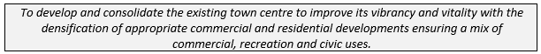
All potential residents of Garraun will be using Oranmore for retail, leisure and education purposes. Nothing within the Garraun or Oranmore plans provides for this?
For example, a single site for a school in the Garraun MASP which will probably be the Educate Together Secondary School relocating from Merlin Park will not provide a primary school solution for new residents of Garraun. With 3 primary schools already within Oranmore Village centre no new primary school will be built within the Garraun MASP according to department of Education guidelines due to proximity to the 3 existing schools of Oranmore . So how does the plan deal with this? Without joint up infrastructure hundreds of car dependent parents will travel from Garraun MASP to Oranmore village twice daily adding to the already gridlock town of Oranmore. You will experience the same issue for sporting activities, social gatherings etc. It is my opinion that a transport infrastructure plan needs to be delivered within the MASP plan of Oranmore and Garraun and Oranmore & Garraun need to be considered as one plan due to proximity unlike other MASP within County Galway.

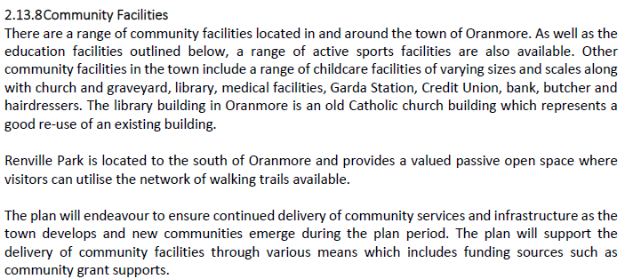

Flooding
It is still unclear from Galway County Councils plan how they are going to deal with flooding on the Coast Road and provide emergency access\egress in times of flooding?
Even at the current ‘Low Probability Coastal’ flooding (https://www.floodinfo.ie/map/floodmaps/) we know that the Coast Road will flood and be impassable numerous times during any given year.
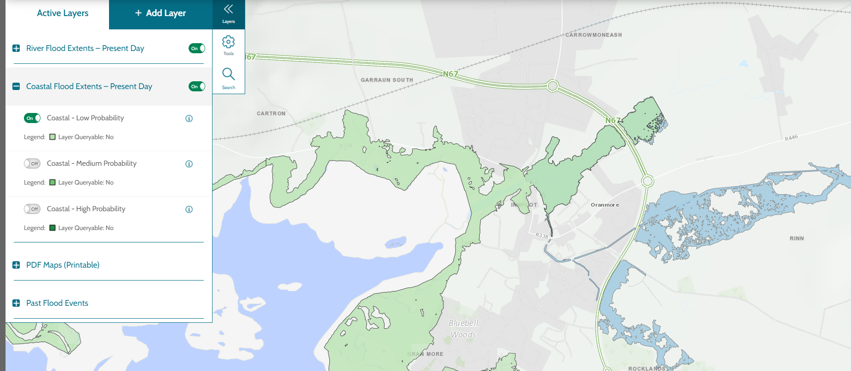
We have seen just last year where 100s of people were trapped at high tide in Oranmore train station as the exit was blocked.
There is no flood emergency response plan to manage what happens when the coast road floods? What happens to access to the railway station? Which is about to be expanded! Surely no future development can take place without addressing the Coast Road and the flooding issue? Galway County Council (Planning reference 21408 – Oranhill) are aware of Coastal flooding so why has this not been addressed here at the planning stage?

Infrastructure
Within the MASP for Oranmore and Garraun a Transportation Plan must be at its core. In my opinion you cannot continue to promote development without considering how transport and transportation infrastructure works within Oranmore and this should be based on evidence gathered within a Transportation Plan. This is even more true due to the change in culture required as we shift from car orientated to cycling and walking.
For example, with 3 primary schools within Oranmore Village centre no new primary school will be built within the Garraun MASP according to department of Education guidelines due to proximity. So how does the plan deal with this? Without joint up infrastructure hundreds of car dependent parents will travel from Garraun MASP to Oranmore village twice daily adding to the already gridlock town of Oranmore. You will experience the same issue for sporting activities, social gatherings etc. It is my opinion that a transport infrastructure plan needs to be delivered within the MASP plan of Oranmore and Garraun and Oranmore & Garraun needs to be considered as one plan due to proximity unlike other MASP within County Galway.
Oranmore itself is split into two different municipal and electoral districts. This means there is a democratic deficiency for the Oranmore and Maree community as a whole. It is absurd that one councillor can take an interest in part of the town and potentially not take the views of the other half. This results in a lack of joined up thinking and raises concerns that the draft county development plan for Oranmore may be based on a democratic vacuum. An example of this is the incomplete footpath on the Old Limerick Road which does not continue across the municipal council boundary while we acknowledge funding has now been secured to complete this path if won’t occur for years after the first section was completed. This highlights the need for paths, cycleways and active travel solutions to also be mapped out for the duration of the plan and not just single standalone projects.
The plan needs to show the current baseline of how infrastructure is currently laid out and what actions Galway County Council intend to complete to improve it. This should include proposed cycleways, walkways, greenways and not just new developments but also include improvement works needed.

Community Facilities
The community facilities within Oranmore are no longer acceptable for what Oranmore has become. We have sporting club having to move out from Oranmore due to land prices and no support from the council. All of these developments have and will contribute nothing but traffic as no one can get to these locations without the use of a car. While some will cycle it would be classed as extremely dangerous travelling through Oranmore Village and surrounding roadways as no proper infrastructure is in place for safe cycling or walking.
Galway County Council need to look urgently at adding amenity land to the currently plan in areas that can be serviced by footpaths and cycleway with streetlights from the village.
Our community playground again has been outgrown and urgently needs to be extended to accommodate the 100s of childing trying to use this facility daily.
Renville Park while it is a fantastic facility again suffers from no safe access for walker and cyclists forcing most families to commute by car. Adding to car parking issues and traffic issues. Again, as a matter of urgency a safe segregated walking and cycle route from Oranmore to Renville should be assessed.

Education
Currently all education facilities are within the town centre. Oranmore town has less than 100 meters of cycle lanes making it nearly impossible for any journeys to schools without having to use footpaths or unsafe roads.
A full infrastructure plan needs to be included within this metropolitan plan outlining all current infrastructure and future infrastructure to ensure proper joint up thinking takes place. Adding ad-hoc sections is not a plan!
As a matter of urgency land surrounding all schools within Oranmore should be rezoned to ensure for any future expansion of these facilities to cope with the population increase being proposed for Oranmore and Garraun.
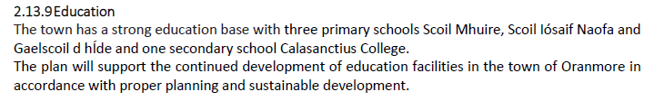

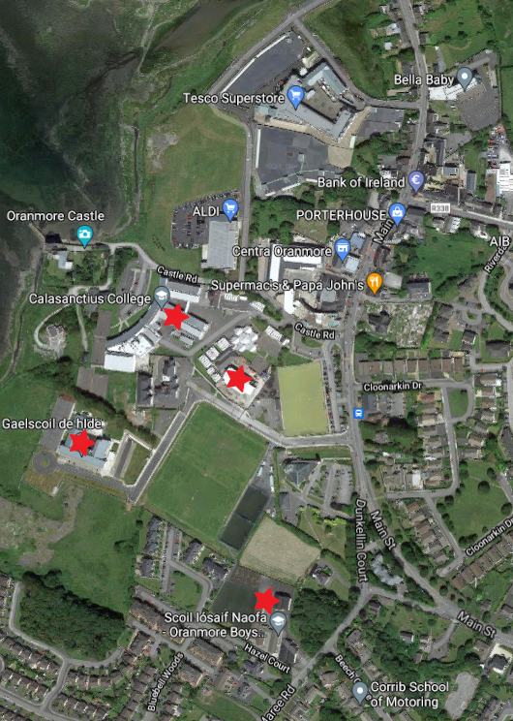

Biodiversity
The MASP plans at no point address Biodiversity and the current world crisis we are currently in.
There is no Biodiversity mapping or baselines included.
No goals or objectives specific to each town within the MASP?
No mitigation plans are evident for any developers who wish to deliver these plans.
How are Galway County Council reacting to Climate Change in these MASP towns?
What baseline are Galway County Council going to use to action climate objectives?

